图像处理实验报告
第 一 次

姓名
班级
学号
电话
Email
日期

- 对给定图像001.png进行直方图均衡化处理。画出原图及其直方图，以及直方图均衡化后的图像及其直方图。在word中贴出代码和结果图。
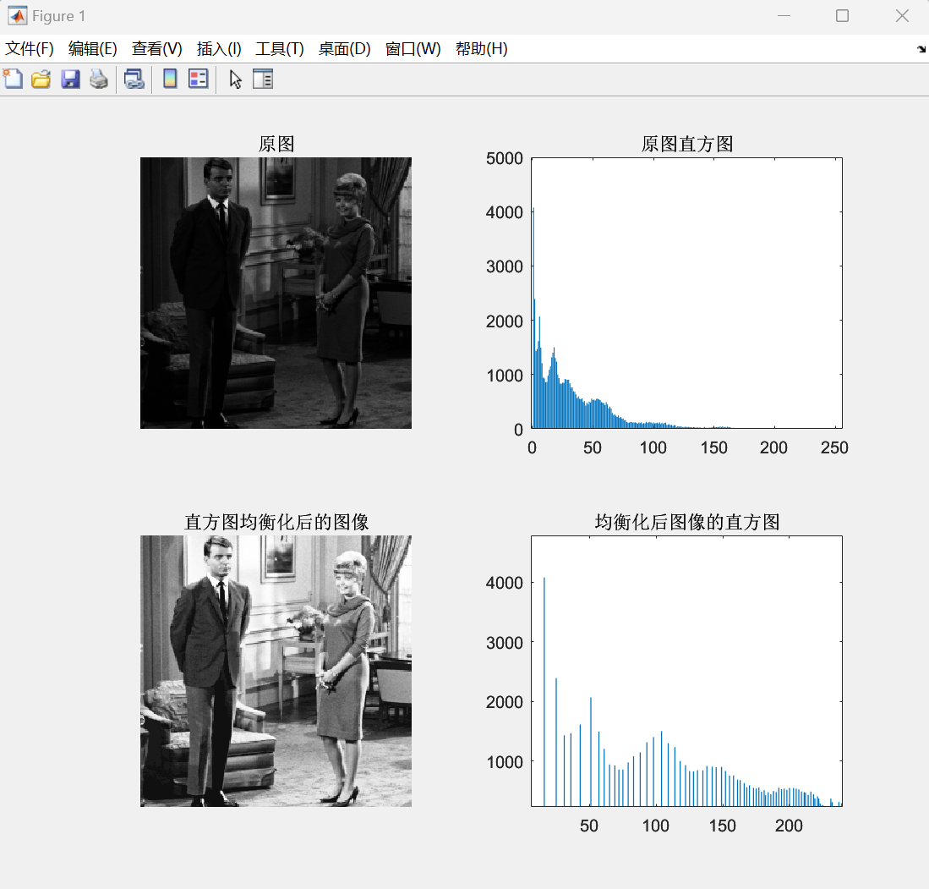
- % 读取图像
- img = imread('001.png');

- % 转换为灰度图像
- if size(img, 3) == 3
- img_gray = rgb2gray(img);
- else
- img_gray = img;
- end

- % 计算原图的直方图
- hist_original = zeros(1, 256);
- [rows, cols] = size(img_gray);
- for i = 1:rows
- for j = 1:cols
- pixel_val = img_gray(i, j) + 1; % 因为索引从 1 开始
- hist_original(pixel_val) = hist_original(pixel_val) + 1;
- end
- end

- % 计算累积分布函数（CDF）
- cdf = cumsum(hist_original) / (rows * cols);

- % 进行直方图均衡化
- img_eq = uint8(zeros(rows, cols));
- for i = 1:rows
- for j = 1:cols
- pixel_val = img_gray(i, j) + 1;
- img_eq(i, j) = uint8(255 * cdf(pixel_val));
- end
- end

- % 计算均衡化后图像的直方图
- hist_eq = zeros(1, 256);
- for i = 1:rows
- for j = 1:cols
- pixel_val = img_eq(i, j) + 1;
- hist_eq(pixel_val) = hist_eq(pixel_val) + 1;
- end
- end

- % 绘制原图及其直方图
- subplot(2,2,1);
- imshow(img_gray);
- title('原图');
- subplot(2,2,2);
- bar(0:255, hist_original);
- title('原图直方图');

- % 绘制均衡化后的图像及其直方图
- subplot(2,2,3);
- imshow(img_eq);
- title('直方图均衡化后的图像');
- subplot(2,2,4);
- bar(0:255, hist_eq);
- title('均衡化后图像的直方图');

- 对给定原图像original.bmp进行直方图匹配，匹配图像为reference.jpg，画出原图、匹配图像、原图匹配后的图像及其各自直方图。在word中贴出代码和结果图。
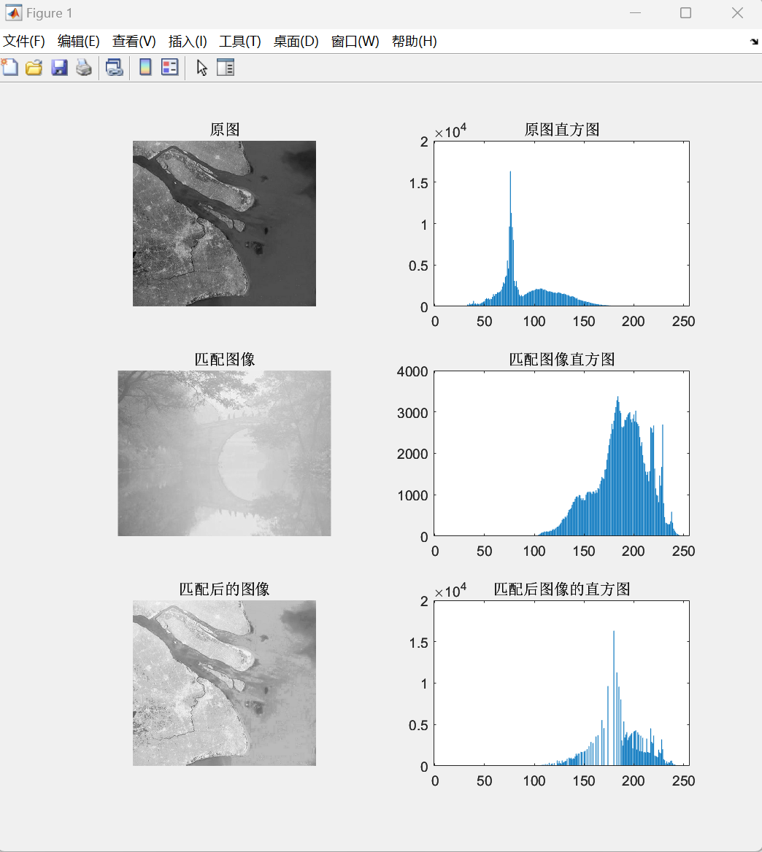
- % 读取原图像和参考图像
- original_img = imread('original.bmp');
- reference_img = imread('reference.jpg');

- % 转换为灰度图像
- if size(original_img, 3) == 3
- original_gray = rgb2gray(original_img);
- else
- original_gray = original_img;
- end

- if size(reference_img, 3) == 3
- reference_gray = rgb2gray(reference_img);
- else
- reference_gray = reference_img;
- end

- % 计算原图像和参考图像的直方图
- original_hist = zeros(1, 256);
- reference_hist = zeros(1, 256);

- [original_rows, original_cols] = size(original_gray);
- [reference_rows, reference_cols] = size(reference_gray);

- % 计算原图像直方图
- for i = 1:original_rows
- for j = 1:original_cols
- pixel_val = original_gray(i, j) + 1;
- original_hist(pixel_val) = original_hist(pixel_val) + 1;
- end
- end

- % 计算参考图像直方图
- for i = 1:reference_rows
- for j = 1:reference_cols
- pixel_val = reference_gray(i, j) + 1;
- reference_hist(pixel_val) = reference_hist(pixel_val) + 1;
- end
- end

- % 计算原图像和参考图像的累积分布函数（CDF）
- original_cdf = cumsum(original_hist) / (original_rows * original_cols);
- reference_cdf = cumsum(reference_hist) / (reference_rows * reference_cols);

- % 进行直方图匹配
- matched_img = uint8(zeros(original_rows, original_cols));
- for i = 1:original_rows
- for j = 1:original_cols
- pixel_val = original_gray(i, j) + 1;
- % 找到参考图像 CDF 中最接近原图像 CDF 当前值的位置
- [~, index] = min(abs(reference_cdf - original_cdf(pixel_val)));
- % 将原图像像素映射到参考图像的对应灰度值
- matched_img(i, j) = index - 1;
- end
- end

- % 计算匹配后图像的直方图
- matched_hist = zeros(1, 256);
- for i = 1:original_rows
- for j = 1:original_cols
- pixel_val = matched_img(i, j) + 1;
- matched_hist(pixel_val) = matched_hist(pixel_val) + 1;
- end
- end

- % 绘制原图、匹配图像、匹配后的图像及其各自直方图
- subplot(3, 2, 1);
- imshow(original_gray);
- title('原图');

- subplot(3, 2, 2);
- bar(0:255, original_hist);
- title('原图直方图');

- subplot(3, 2, 3);
- imshow(reference_gray);
- title('匹配图像');

- subplot(3, 2, 4);
- bar(0:255, reference_hist);
- title('匹配图像直方图');

- subplot(3, 2, 5);
- imshow(matched_img);
- title('匹配后的图像');

- subplot(3, 2, 6);
- bar(0:255, matched_hist);
- title('匹配后图像的直方图');

