DFB Smart Shop
Finalized System Architecture — Documentation Brief
Status: Interim-final — locked for the documentation update. A final revision follows once the build is complete.
Prepared for: the documentation team updating Chapter 3 (System Architecture and Technical Stack; Data Flow and AI Logic).
Why this document exists. The original manuscript names HTML5 + Tailwind + Firebase as the stack. The system is being built on React + Vite + MUI + Supabase + Vercel + Resend. The pattern the manuscript describes — a serverless app with client-side AI and a math-based price engine — is unchanged and still correct. Only the named technologies change.

1. System Architecture and Technical Stack
The system is built as a serverless web application. There is no custom backend server: data persistence, authentication, file storage, and email are delegated to managed cloud services, while the artificial-intelligence and pricing logic execute entirely on the client (the user’s browser). The stack is organized into four layers.
- 1. Presentation / Client Layer. A single-page web application built with React 19, Vite, and Material UI (MUI), in TypeScript. One responsive codebase serves three interfaces — the Admin (owner) dashboard, the Buyer (customer account) app, and the public Webshop — usable on phones and desktop browsers.
- 2. Client-side Intelligence. The visual search runs in the browser using TensorFlow.js with the pre-trained MobileNet model. The dynamic price estimator is a deterministic mathematical formula. Both execute on the device and need no server.
- 3. Backend-as-a-Service (BaaS). Supabase provides the PostgreSQL relational database, user authentication, and file storage for product images. The client talks to Supabase directly through its SDK, governed by Row-Level Security (RLS) policies. This replaces the Firebase Realtime Database named in the proposal; a relational model improves data integrity and is easier to document.
- 4. Serverless Functions & Email. A small set of serverless functions hosted on Vercel handle operations that require a secret key — chiefly sending transactional email through Resend. Supabase Authentication also delivers its login codes and password-reset emails through Resend via SMTP.
Hosting & delivery. The application is hosted on Vercel. The domain is registered through Namecheap, with DNS records pointing the domain to Vercel and authorizing Resend to send email on the domain’s behalf.
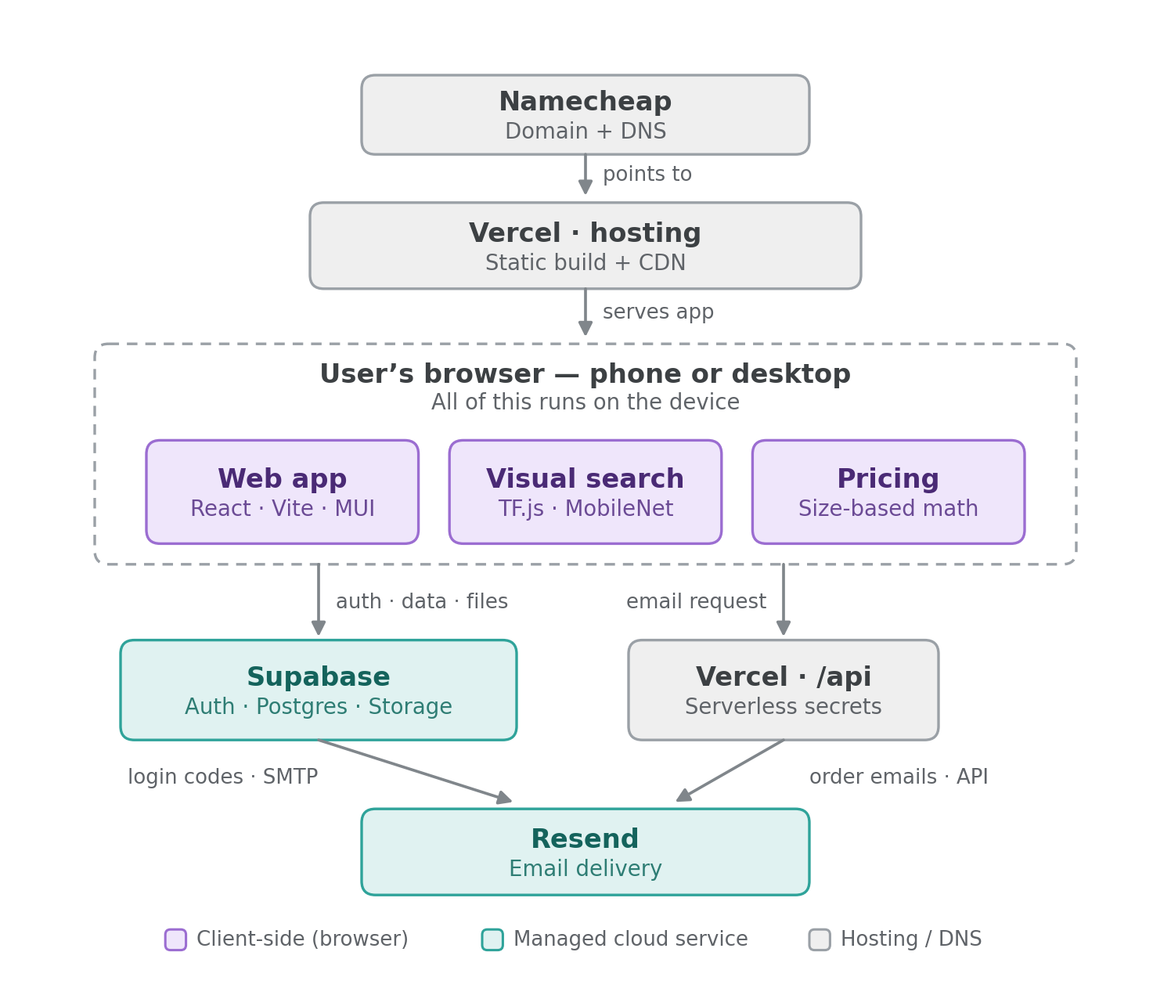
Figure A. Finalized system architecture.

Technical stack at a glance
Layer | Technology | Responsibility
Client / UI | React 19, Vite, MUI, TypeScript | Admin, Buyer, and Webshop interfaces (responsive)
Client AI | TensorFlow.js + MobileNet | In-browser visual search (image → category)
Pricing | JavaScript (deterministic formula) | Dynamic size-based price estimate
Database / Auth / Storage | Supabase | PostgreSQL + Auth + Storage, secured by RLS
Serverless logic | Vercel Functions (/api) | Secret-key operations (Resend email, admin tasks)
Email | Resend | Login codes (via Supabase Auth SMTP) + order emails
Hosting | Vercel | Static build + CDN + serverless functions
Domain / DNS | Namecheap (DNS may use Cloudflare) | Domain registration and DNS records

Why these choices (rationale for the defense)
- One host (Vercel), not two. Because the AI is client-side and Supabase is the data tier, the only server-side need is hiding the email API key — a single Vercel serverless function covers it. A separate backend host (e.g. Railway) would add cost and complexity for a workload that does not exist.
- Supabase over Firebase. A relational schema with real foreign keys and constraints is more robust and far easier to present in a manuscript than a JSON tree.
- Resend for email. Used both as the SMTP provider for Supabase Auth (reliable login codes / resets) and as the API the Vercel function calls for order notifications.

2. Data Flow and AI Logic
When a user submits a photo, the system runs a four-step pipeline. Steps 1–3 execute entirely in the browser; only step 4 reaches the cloud.
- Image pre-processing — the browser converts the uploaded or captured photo into an image tensor that TensorFlow.js can read.
- Classification — MobileNet performs inference and returns its top-5 predicted categories with confidence scores (e.g. “window screen”, “metal”).
- Keyword bridging — the app scans those five predictions for keywords such as glass, metal, or window. This is the actual “intelligence” of the system: it bridges MobileNet’s generic vocabulary to the shop’s catalogue, using the admin-set visual-search keywords stored on each product.
- Inventory matching — if a keyword matches, the system filters the Supabase product list and shows the relevant category of items.
So the AI’s real job is: photo → general category → keyword → filtered products.
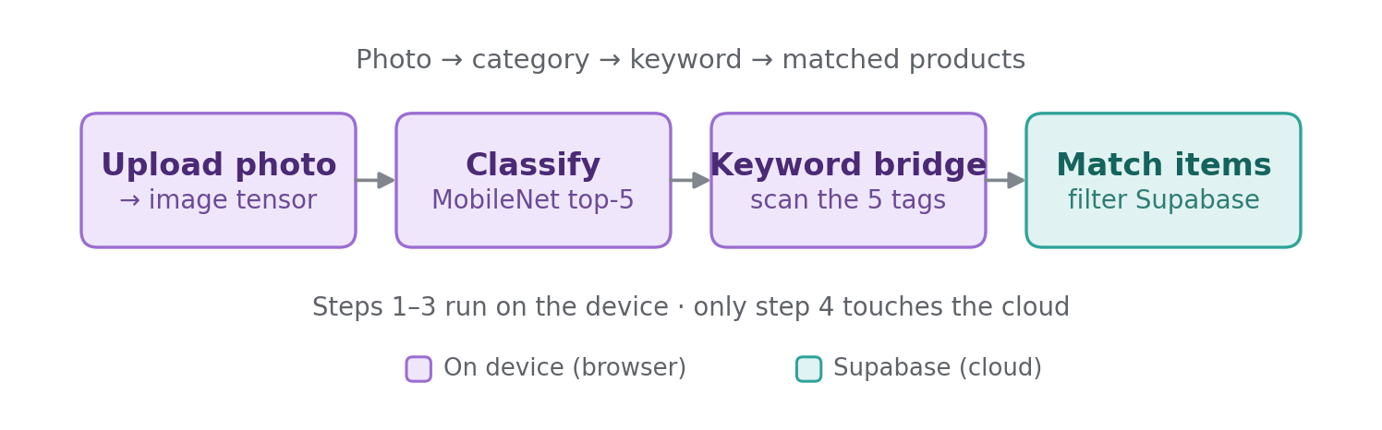
Figure B. Visual search data flow (updates the manuscript’s Figure 3.2).

The mathematical pricing model (unchanged)
Pricing is a deterministic formula evaluated in the browser — it is not machine learning:
unitPrice = P_base + (W × H × surfaceMultiplier) + ((W + H) × 2 × perimeterMultiplier)
With the manuscript’s defaults surfaceMultiplier = 1.5 and perimeterMultiplier = 2, this gives the published form:
Price = P_base + (W · H · 1.5) + ((W + H) · 2)
P_base is the material’s base price; the surface-area term reflects material cost and the perimeter term reflects framing/labour. Both multipliers are configurable from Admin → Settings, so the constants are justifiable rather than hard-coded. Each order line stores its computed unitPrice and lineTotal so historical orders keep their original pricing even if the multipliers change later.

What is not machine learning (state this plainly in the defense)
- Dynamic pricing is pure mathematics — no learning.
- Smart recommendations (“frequently bought together”) are rule-based, admin-curated pairings stored in the database — not a trained recommender.
- Visual search does category-level matching, not exact-SKU recognition. MobileNet is pre-trained on ~1,000 generic objects; it can tell “this is glass / a window” and route the user to that section, but it cannot identify a specific SKU. This suits the title’s “basic machine learning” framing and should be stated honestly.

3. Hosting, Domain, DNS, and Email
- Hosting: Vercel hosts the static build and the /api serverless functions.
- Domain: purchased from Namecheap.
- DNS — two acceptable options: (1) keep DNS at Namecheap and add Vercel’s web records plus Resend’s email records (SPF, DKIM, DMARC); or (2) delegate DNS to Cloudflare for a nicer dashboard and free analytics.
- If Cloudflare is used, set the Vercel records to “DNS only” (grey cloud), not proxied — proxying Cloudflare in front of Vercel stacks two CDNs and causes SSL/caching conflicts.
- Do not host on Cloudflare Pages. Host the frontend in exactly one place (Vercel). Cloudflare’s role, if any, is DNS only.
- Email: Resend delivers Supabase Auth login codes / resets via SMTP, and order notifications sent from the Vercel function via the Resend API. The email API key never reaches the browser.

4. Manuscript Change Map (old → new)
Use this to locate and update every affected statement in the manuscript.
Where in manuscript | Original wording | Replace with
Stack — Frontend | “HTML5 and Tailwind CSS” | “React 19 + Vite + Material UI (MUI), in TypeScript”
Stack — Logic Layer | “JavaScript (ES6+)” | “TypeScript (React components and hooks)”
Stack — AI Engine | “TensorFlow.js with MobileNet” | Unchanged — TensorFlow.js with MobileNet, client-side
Stack — Backend-as-a-Service | “Firebase Realtime Database” | “Supabase — PostgreSQL + Authentication + Storage (Row-Level Security)”
Data Flow, step 4 | “filters the Firebase product list” | “filters the Supabase product list”
Hosting / deployment | (not specified) | “Vercel hosting + serverless functions; Namecheap domain; Resend email”
Definition of terms | “Firebase: a Google-backed BaaS…” | “Supabase: an open-source BaaS providing a PostgreSQL database, authentication, and storage”
Pricing formula | Price = P_base + (W·H·1.5) + ((W+H)·2) | Unchanged — keep as written
Scope (offline dependency) | “sync with the Firebase database” | “sync with the Supabase database”
Note on the title. The manuscript title (“…with Mobile Application…”) refers to the mobile-responsive web app, not a separate native app. No native app is being built; the Buyer interface is the mobile-responsive experience.

5. Pending for the Final Revision (after build)
These will be confirmed and, if needed, corrected in the final pass:
- Confirmed Supabase table names and the entity-relationship diagram (ERD).
- Exact list of Vercel serverless endpoints (/api/*).
- Final DNS record set (Vercel + Resend) and whether Cloudflare is used for DNS.
- Production URL(s) and any environment-specific notes.

