Daniel Campos October 1st, 2013

RCS: Campod2 RIN:660996361

Machine Learning CS 4100

I worked on these problems with Zoe Konrad

Problem Set 6

1. Exercise 3.4 (200)
   1. Given  and  🡪 

So  and substituting in  

And then finally 

* 1.  and we multiply each by H and we get  which is  

Which goes to  by

* 1. Taking 3.3 c) we know 

in sample error 

* 1.  Which we then expand and multiply by the variance and get



* 1.  where = and  so 🡺🡺🡺

🡺

1. Problem 3.1 (200)
   1. 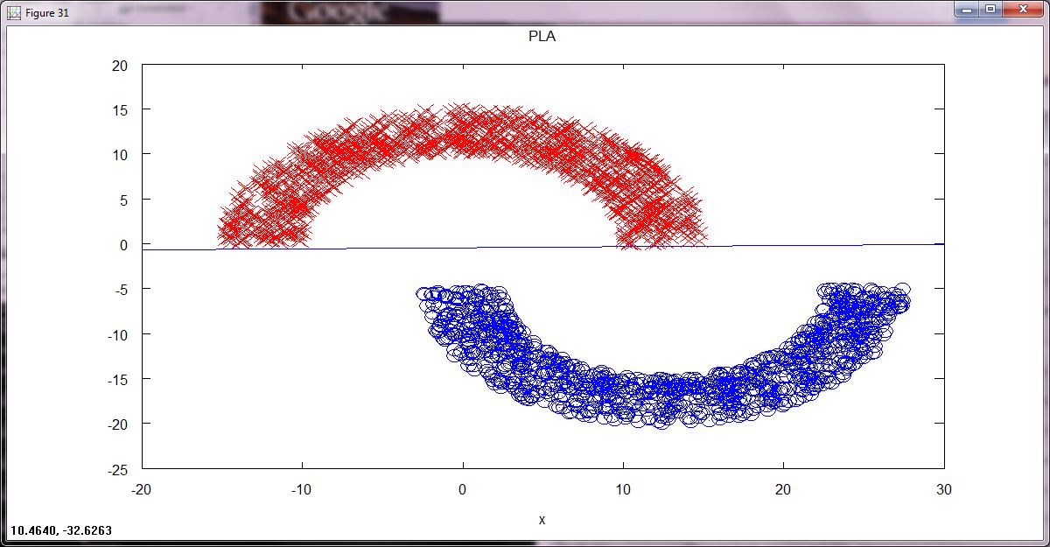

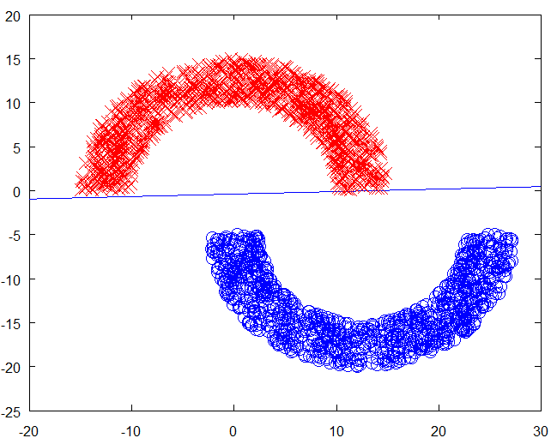

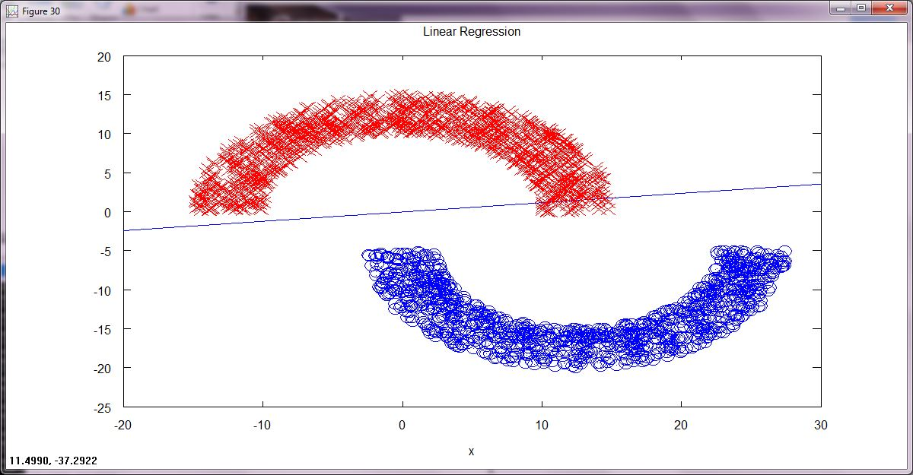

1. Problem 3.2 (200) 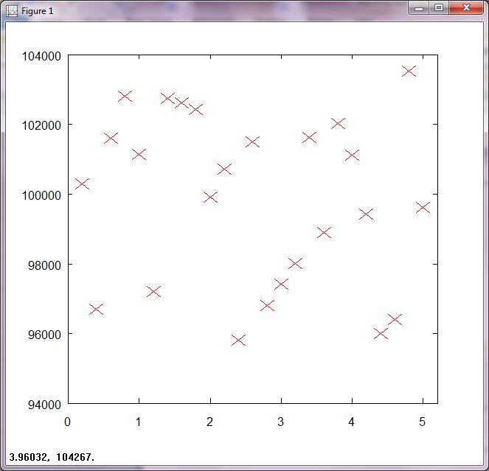

We notice as as sep increases the spread in PLA times get smaller. The interesting part is that though sep is increasing, the range of what it takes to finish it stays about constant, 94000-104000. This is probably due to the nature of PLA and the different sets of data. They will take similar amounts of times but every single time will very a little(10% max this case). I would have thought that as sep increases the pla would take substantially less time to run but this is not the case.

1. Problem 3.8 (200)
   1. 
      1. first we rewriteas 
      2. we rewrite it as 
      3. which we then write as
      4. 
      5. where the last term is always positive and minimized at h is h mean. The first term is the sum of the squared derivation about the H\*
      6.  which by definition of h\* is =0
      7. thus  is minimized when h=h\*
   2. Since we have found that h\* minimizes eout and the function is deterministic thus y=h\*(x) and thus (x) =0
2. Handwritten Digits Data (300)
   1. 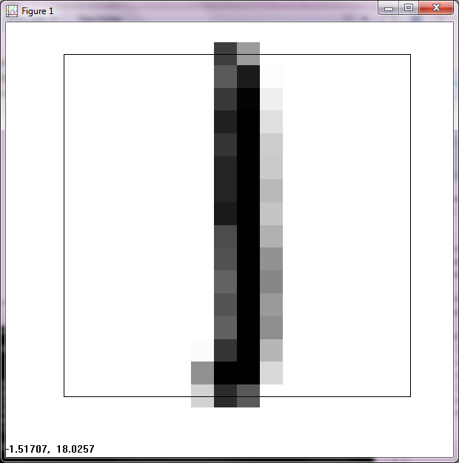

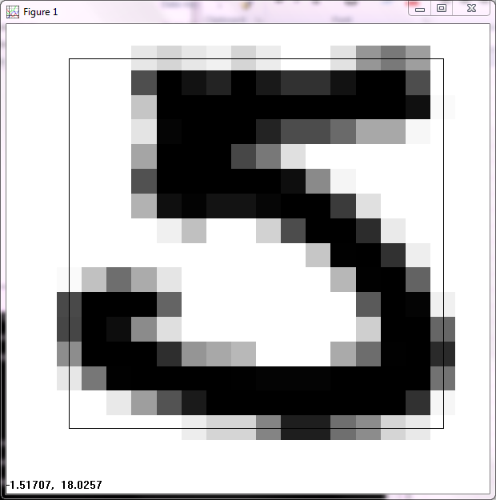

* 1. I am using the features of symmetry and average intensity. The mathematical definitions are as bellow

Average intensity: We do for all the points in the image we set x to mean of the greyscale and then multiply our sum = 0.5(1+x)

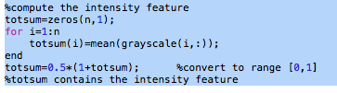

For symmetry

We flip the image horizontally and see how similar the image is and do so vertically to see how symmetric the image is.

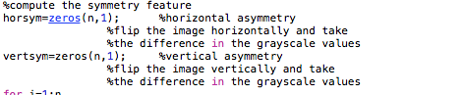

* 1. 

