# Final Release

For the final release of our project we have an .apk(the android deployment format) file and we will be submitting that to the Google play store for public usage. To install without the Google play store one must plug their Android phone into the computer and launch the software. No other steps are required

# Final Test Results

As stated in our plan, each member recruited 2 friends with android phones and ran through the test presented in Stakeholder 2, the results are bellow. Overall we passed most of our tests except for some issues with the search options that had not been previously addressed and we are now working on.

**Testing Iteration: 1.0 Date: April 25th, 2013**

**Tester:Jason Slingerland**

|  |  |  |
| --- | --- | --- |
| Test Case | Result (Pass/Fail) | Comments |
| Test Case 1 | Pass | Make feedback on button click more clear |
| Test Case 2 | Pass | Works |
| Test Case 3 | Pass |  |
| Test Case 4 | Pass |  |
| Test Case 5 | Pass | Works with gas |
| Test Case 6 | Pass |  |
| Test Case 7 | Pass | It works |
| Test Case 8 | Fail | Functionality not there |

**Other Comments/Recommendations:**

**Testing Iteration: 1.0 Date: April 24th, 2013**

**Tester:Colton Fisher**

|  |  |  |
| --- | --- | --- |
| Test Case | Result (Pass/Fail) | Comments |
| Test Case 1 | Pass |  |
| Test Case 2 | Pass |  |
| Test Case 3 | Pass | Error message kind of criptic |
| Test Case 4 | Pass | It takes a while but it works |
| Test Case 5 | Pass | Works with eat |
| Test Case 6 | Pass | Changed to refuel |
| Test Case 7 | Pass |  |
| Test Case 8 | Fail | Functionality not there |

**Other Comments/Recommendations:**

**Testing Iteration: 1.0 Date: April 26th,2013**

**Tester: Drew Mitchell**

|  |  |  |
| --- | --- | --- |
| Test Case | Result (Pass/Fail) | Comments |
| Test Case 1 | Pass |  |
| Test Case 2 | Pass |  |
| Test Case 3 | Pass |  |
| Test Case 4 | Pass |  |
| Test Case 5 | Pass |  |
| Test Case 6 | Pass |  |
| Test Case 7 | Pass |  |
| Test Case 8 | Fail | Functionality not there |

**Other Comments/Recommendations:**

**Testing Iteration: 1.0 Date: April 25th, 2013**

**Tester: Ben Governali**

|  |  |  |
| --- | --- | --- |
| Test Case | Result (Pass/Fail) | Comments |
| Test Case 1 | Pass |  |
| Test Case 2 | Pass |  |
| Test Case 3 | Pass |  |
| Test Case 4 | Pass | Make it faster |
| Test Case 5 | Pass |  |
| Test Case 6 | Pass |  |
| Test Case 7 | Pass |  |
| Test Case 8 | Fail | Functionality not there |

**Other Comments/Recommendations:**

**Testing Iteration: 1.0 Date: April 24th, 2013**

**Tester: John Barlett**

|  |  |  |
| --- | --- | --- |
| Test Case | Result (Pass/Fail) | Comments |
| Test Case 1 | Pass |  |
| Test Case 2 | Pass |  |
| Test Case 3 | Pass |  |
| Test Case 4 | Pass | Make it faster |
| Test Case 5 | Pass |  |
| Test Case 6 | Pass |  |
| Test Case 7 | Pass |  |
| Test Case 8 | Fail | Functionality not there |

**Other Comments/Recommendations:**

**Testing Iteration: 1.0 Date: April 22, 2013**

**Tester: Nick Laferiere**

|  |  |  |
| --- | --- | --- |
| Test Case | Result (Pass/Fail) | Comments |
| Test Case 1 | Pass |  |
| Test Case 2 | Pass |  |
| Test Case 3 | Pass |  |
| Test Case 4 | Pass | Make it quicker |
| Test Case 5 | Fail | I inputted all the options and it crashed |
| Test Case 6 | Pass | It worked |
| Test Case 7 | Pass | Done |
| Test Case 8 | Fail | Functionality not there |

**Other Comments/Recommendations:**

Make multiple categories work better

**Testing Iteration: 1.0 Date: April 24th, 2013**

**Tester: Eric McCabe**

|  |  |  |
| --- | --- | --- |
| Test Case | Result (Pass/Fail) | Comments |
| Test Case 1 | Pass |  |
| Test Case 2 | Pass |  |
| Test Case 3 | Pass |  |
| Test Case 4 | Pass |  |
| Test Case 5 | Pass |  |
| Test Case 6 | Pass |  |
| Test Case 7 | Pass |  |
| Test Case 8 | Fail | Functionality not there |

**Other Comments/Recommendations:**

**Make the search faster**

**Testing Iteration: 1.0 Date:April 23rd, 2013**

**Tester: Robert Lundin**

|  |  |  |
| --- | --- | --- |
| Test Case | Result (Pass/Fail) | Comments |
| Test Case 1 | Pass |  |
| Test Case 2 | Pass |  |
| Test Case 3 | Pass |  |
| Test Case 4 | Pass |  |
| Test Case 5 | Pass |  |
| Test Case 6 | Pass |  |
| Test Case 7 | Pass |  |
| Test Case 8 | Fail | Functionality not there |

**Other Comments/Recommendations:**

**Make the search results clearer**

# Best Practices

## Project Wiki

Here is a screenshot of our wiki. We organized the information by what portion of the development cycle it fell under and added information to it.

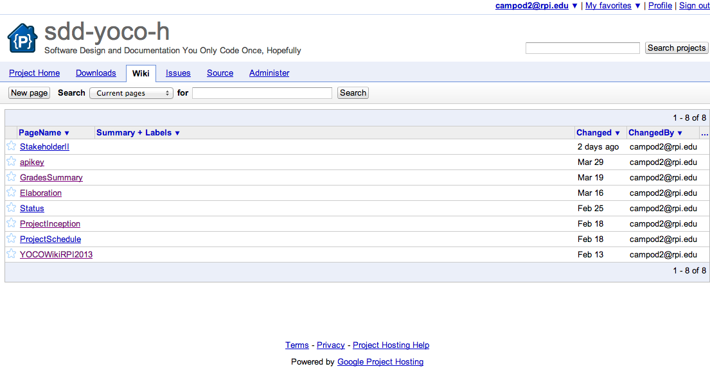

## Project Management Website

We used Google code to communicate, keep out code and use all the good features. Our website is bellow.

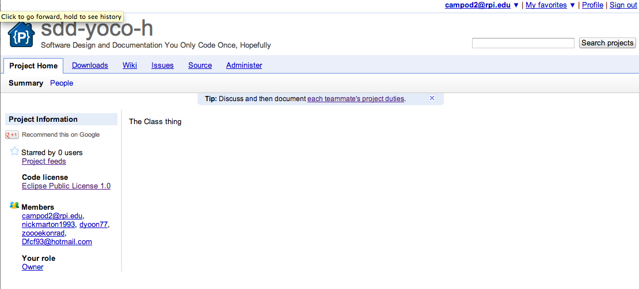

## Code Repository

We kept all of our packages online on Google code using the download section as a way to divide the application by its stages in case we wanted to see what we had done or go back to an older version.

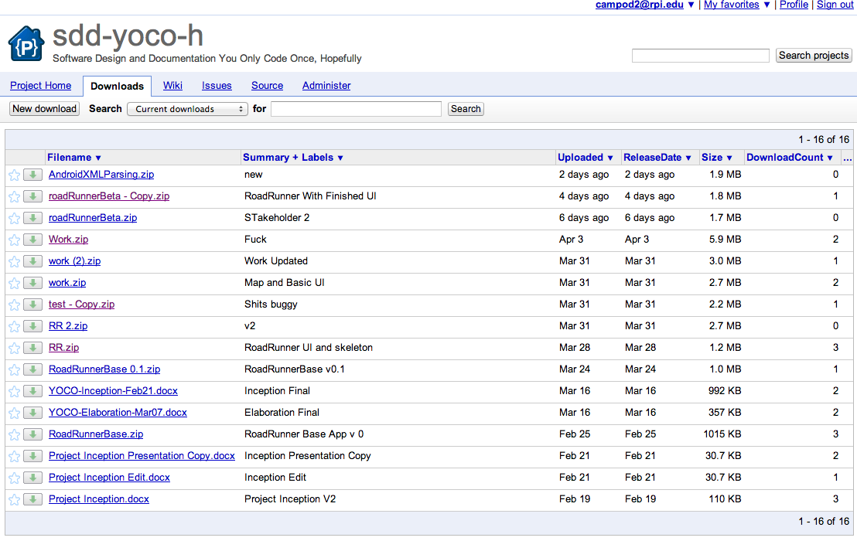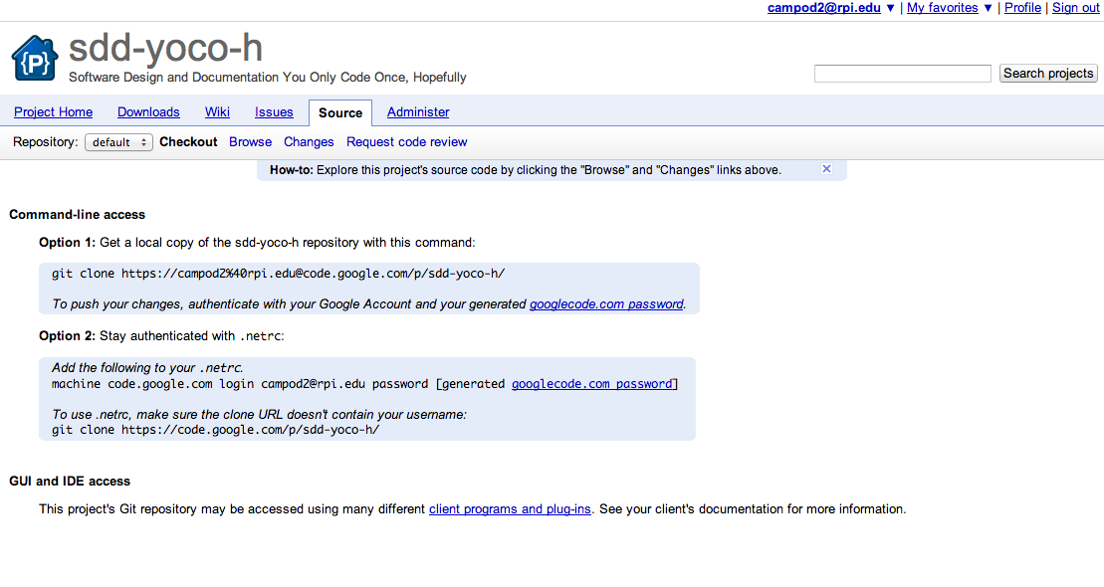

## Documented Coding Standards

Every team member kept a copy of the android coding standards and we tried to adhere to them as best we could. The standard is online but here are a few screenshots.

http://source.android.com/source/code-style.html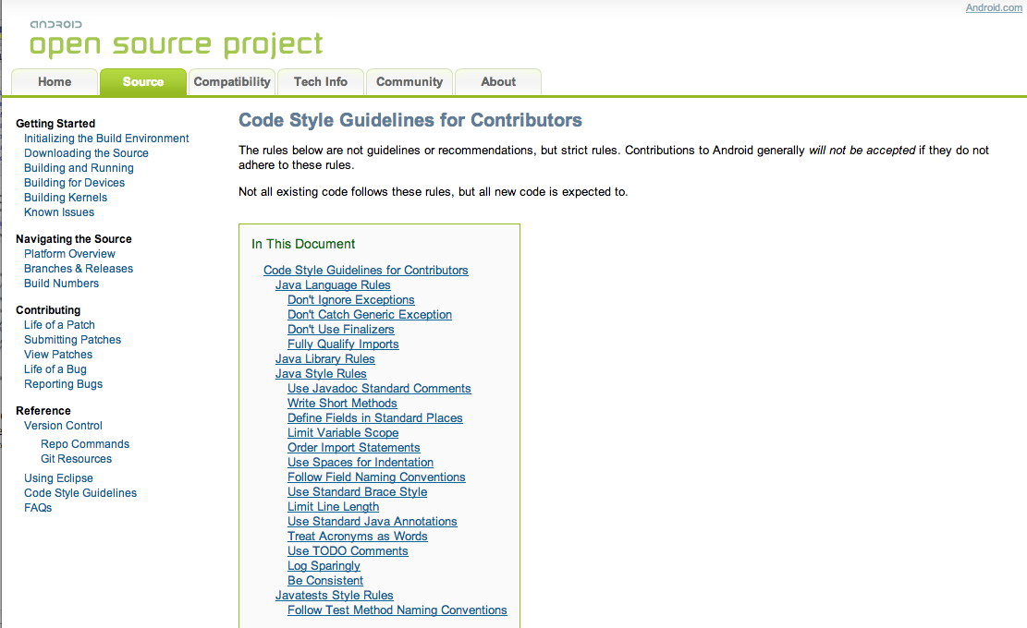

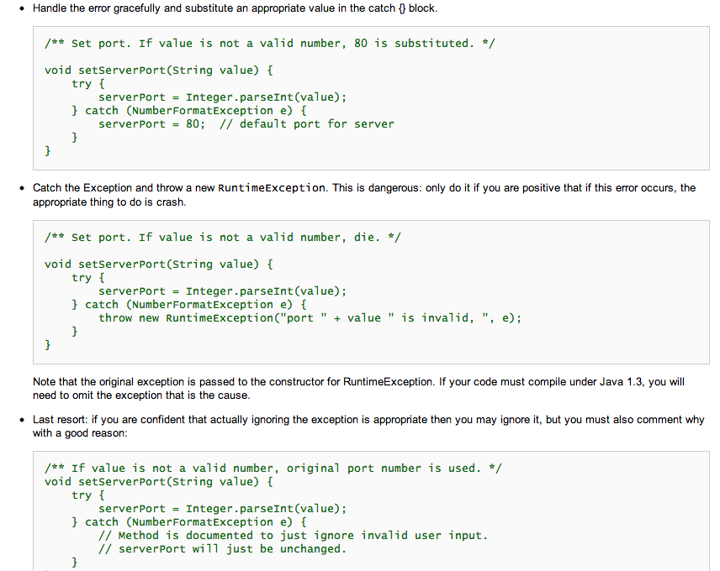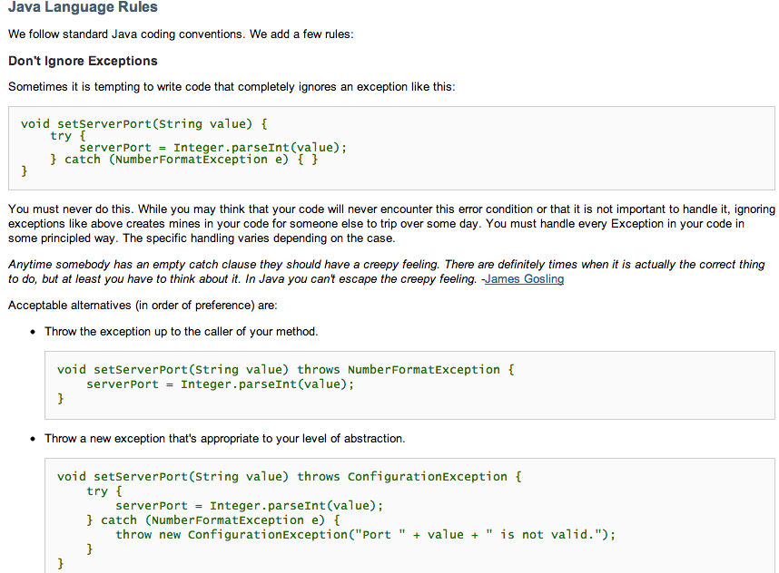Use of basic concepts of Object Oriented Design

Bug Tracking system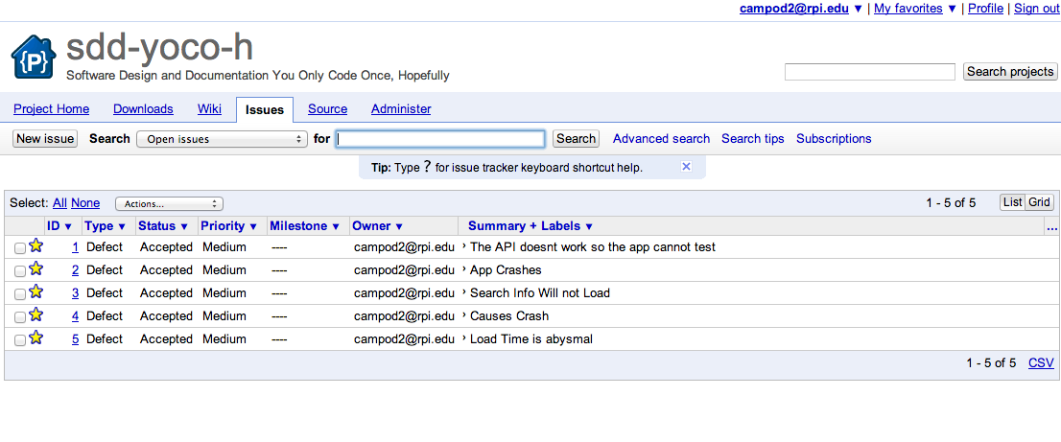

## Third Party Component or tool

We used Google places API and the MapQuest API. The MapQuest API is included in our software and the Google is used for the query. Bellow is a picture of our Google account to show that we are also using this third party component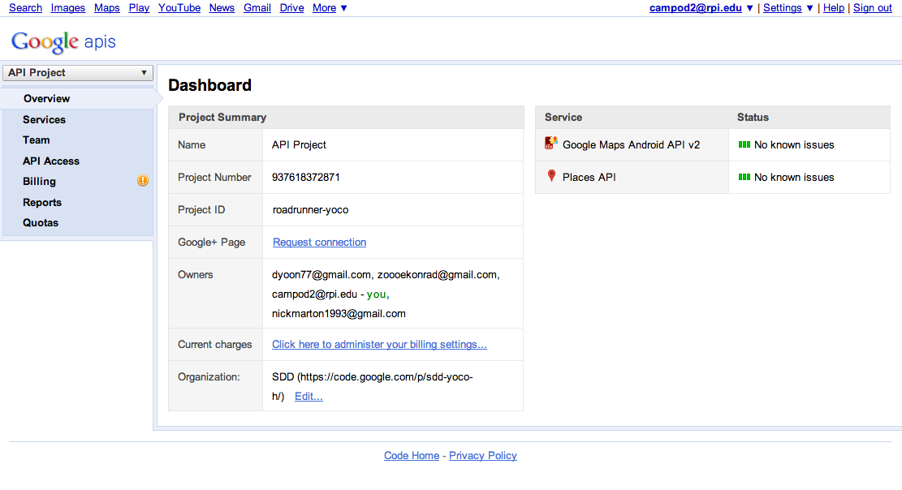

## Design Patterns

# Contribution Summary

## Daniel Campos:

## Daniel Yoon:

## Nick Marton:

## Zoe Konrad:

# Status Report

## Achieved:

Make UI simple and intuitive to use with user tests

Modify ascetics including custom images and button faces using logos

Made code better and searching quicker

## Risks:

Due to the size of search and the nature of the query it is really slow

### Plans:

Keep advancing the project and making it faster