Project Elaboration

Daniel Campos, Zoe Konrad, Nick Marton, Daniel Yoon

YOCO, Hopefully

7 March 2013

***Table of Contents***

Domain Model Diagram....................................................................................................2

Supplemental Specification................................................................................................3

Deployment Diagram.........................................................................................................4

Use Cases…………...........................................................................................................5

Work Breakdown Structure…............................................................................................8

Updated Project Schedule................................................................................................10

Contribution Summary.....................................................................................................13

Status Report....................................................................................................................13

Domain Model Diagram

The diagram below is a representation of the Domain Model that Team YOCO,H will be using in the development of our RoadRunner application. Users have a specific destination and location. They also have a search radius size, from one to four categories, and can have a specific search. The Places and location provides 0 or more detours to the Google maps, which in turn produces a singular trip.

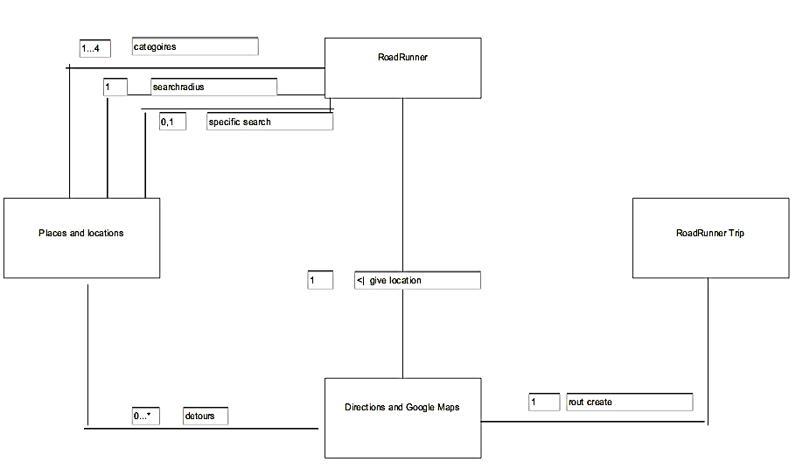

Supplemental Specification

|  |  |  |
| --- | --- | --- |
| Requirement # | Description | Priority |
| 1 | Google Navigation integration | M |
| 2 | Search along route | M |
| 3 | Search by category | M |
| 4 | Change search parameters | M |
| 5 | Search for specific | M |
| 6 | Results List | M |
| 7 | Travel notes | S |
| 8 | Travel statistics for entire trip | S |
| 9 | Gas refuel recommendations | C |
| 10 | Yelp or TripAdvisor ratings | W |
| 11 | Voice commands | W |
| 12 | Social Media Integration | W |

* MoSCoW priority scheme is followed.

Deployment Diagram

The deployment of the RoadRunner App project will occur in the Android Store. The app will run on the most recent version of Android, 4.2 but will support a lowest of 2.2. All the information received will be from Google Navigation and Google Places within the services of Google Maps. The app will also directly retrieve the user’s GPS location.

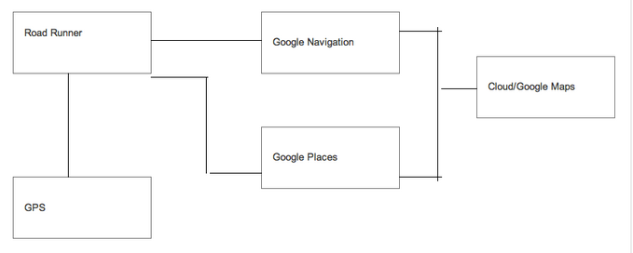

Use Cases

|  |  |
| --- | --- |
| Use Case Identifier | Description |
| UC1 | A User Plots Route to Their Final Destination |
| UC2 | A User Searches for Stop Options Coming up |
| UC3 | A User Searches for Stop Options by Specific Search Parameters |
| UC4 | A User Modifies their Search Parameters |
| UC5 | A User Plots A Route With Selected Stopover |
| UC6 | A User Reaches Their Stop and Continues to Destination |
| UC7 | A User Wants To Check The Trip Statistics |

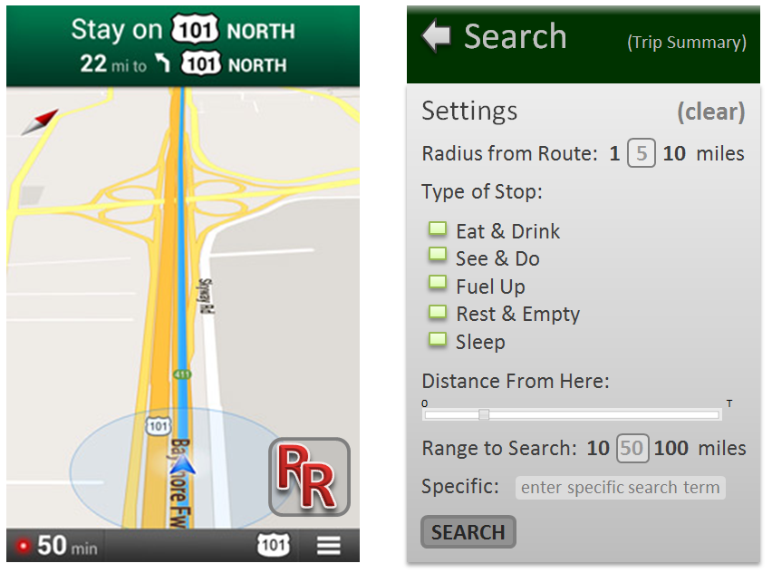

|  |  |
| --- | --- |
| Use Case 1: A User Plots Route to Their Final Destination | |
| Identifier | UC1 |
| Description | A user enters final destination for trip to plot the route from their current location |
| Actors | A Roadtripper |
| Preconditions | none |
| Flow of Events | 1. The user opens the app 2. App accesses the user’s location 3. App prompts the user to enter a final destination address 4. The user enters destination address 5. Displays map route and estimated travel statistics 6. User confirms route |
| Post-conditions | Navigation Map is displayed |

|  |  |
| --- | --- |
| Use Case 2: A User Searches for Stop Options Coming Up | |
| Identifier | UC2 |
| Description | A user searches for available stops along the way of route. Uses pre-set search conditions (5 mile radius, all categories, distance of 0, range of 10 miles 🡪 all stops within 5 miles of current location) |
| Actors | A Roadtripper |
| Preconditions | UC1 |
| Flow of Events | 1. The user clicks on the RoadRunner icon 2. Clicks Search |
| Post-conditions | Results List is displayed |

|  |  |
| --- | --- |
| Use Case 3: A User Searches for Stop Options by Specific Search Parameters | |
| Identifier | UC3 |
| Description | A user searches for available stops along the way of route. Sets their own search conditions from the options menu. |
| Actors | A Roadtripper |
| Preconditions | UC1 |
| Flow of Events | 1. The user clicks on the RoadRunner icon 2. Selects search parameters    1. Radius from Route: 1, 5, or 10 miles    2. Type of Stop: Eat & drink, see & do, fuel-up, rest & empty, and/or sleep    3. Specific Search Field: (optional) to search for a specific key word    4. Distance to Search from Here: slider from zero to total distance with tick marks at each 5%    5. Range of Search: 10, 50, 100 miles, or 200 miles 3. Clicks Search |
| Post-conditions | Results List is displayed |

|  |  |
| --- | --- |
| Use Case 4: A User Modifies Search Parameters | |
| Identifier | UC4 |
| Description | A user does not like options from Results List, choses to modify their search parameters and perform another search. |
| Actors | A Roadtripper |
| Preconditions | UC2 or UC3 |
| Flow of Events | 1. The user clicks Modify Search at the top of the Results List 2. Returns to Search menu and is able to change parameters as detailed in UC3 3. Clicks Search |
| Post-conditions | Results List is displayed |

|  |  |
| --- | --- |
| Use Case 5: A User Plots a Route to Selected Stopover | |
| Identifier | UC5 |
| Description | A user selects a stop from the Results List that they’d like to add to their trip |
| Actors | A Roadtripper |
| Preconditions | UC2 or UC3 |
| Flow of Events | 1. The user selects “Add” for a stop from the Results List 2. Displays map route and estimated travel statistics 3. User confirms route |
| Post-conditions | Navigation Map is displayed |

|  |  |
| --- | --- |
| Use Case 6: A User Continues to Final Destination | |
| Identifier | UC6 |
| Description | A user reaches their stopover location and wants to resume Navigation to final destination |
| Actors | A Roadtripper |
| Preconditions | UC5 and arrives at stopover |
| Flow of Events | 1. App prompts that user has reached their destination 2. User choses to “Continue to Final Destination” 3. Displays map route and estimated travel statistics 4. User confirms route |
| Post-conditions | Navigation Map is displayed |

|  |  |
| --- | --- |
| Use Case 7: A User Checks Trip Statistics | |
| Identifier | UC7 |
| Description | A user wants to view their trip statistics: distance traveled, number of stops, time taken, time remaining, miles remaining, etc. |
| Actors | A Roadtripper |
| Preconditions | UC1 |
| Flow of Events | 1. The user clicks the RoadRunner icon 2. User clicks on Trip Summary |
| Post-conditions | Trip Summary is displayed |

Work Breakdown Structure

1. Inception
   1. Team Formation
   2. Project Selection
   3. Inception Deliverable
      1. Vision Statement
      2. User Scenarios
      3. Project Schedule
      4. Contribution Summary
      5. Status Report
   4. Research Platforms and Development
2. Elaboration
   1. Deliverables
      1. Domain Model Diagram
      2. Supplemental Specification
      3. Deployment Diagram
      4. Use Cases
      5. Work Breakdown Structure
      6. Updated Project Schedule
      7. Contribution Summary
   2. Project Status
      1. Each User has a unrelated android app that they are learning on
      2. Research on implementation of Google maps understood and implementation understood.
3. Project Construction 1
   1. Deliverables
      1. Iterative Release
      2. Design Approach
      3. Sequence Diagrams
      4. Static Class Diagrams
   2. Project Status
      1. Basic RoadRunner App Design and Diagrams
      2. Basic Map Application (Specification #2)
      3. Nonfunctioning RoadRunner App empty shell
      4. Merged Map and RoadRunner App
      5. Basic user interface(non-working functionality)
      6. Basic settings adjustment(Specification #4)
      7. Basic design to display information but not working
      8. Ability to output all the locations along route of users choosing to a .txt file
      9. Trip Status Windows(Specification #8)
      10. Merge the Information and the nonfunctional user windows(Specification #2)
      11. Debug the results for accuracy and ease of use
4. Project Construction 2
   1. Deliverables
      1. Beta Release
      2. Code Review
      3. Testing Documents
   2. Project Status
      1. Functionality to divide and search all the locations on route based on specific parameter or categories(Specification #3)
      2. Bug Testing on backend to make sure that the category and search and functioning properly and fully
      3. Preset distance markers(Specification #3)
      4. Debug so that all the information is visible and correct.
5. Project Transition
   1. Deliverables
      1. Final Release
      2. Final Test Results
      3. Best Practices
      4. Peer Reviews
   2. Project Status
      1. Make UI simple and intuitive to use with user tests
      2. Modify ascetics including custom images and button faces using logos

Updated Project Schedule

*Research Learning and Basic Stage* (We will be learning and working on Base) Feb 21- Mar 7

a. Find the basic Google Maps and research how to extract the base function without altering whether it works or not (Feb 21-Feb 28)

b. Have each team member make a usable basic application so that they learn how to use the SDK.

c. Establish a clear view with sketches of what the app is going to do, how it will do so and why we want to do that.

Visible to Consumer: Functionality list of features and UI sketches

*Construction Phase* (Adding our major app functionality) Mar 8-May 6

*Development I* (Before Stakeholder Meeting #1) on April 6

1. Create a simple RoadRunner App that will serve as the holder/empty frame that we will put the maps functionality into (Mar 8-Mar 22)
2. Create a basic user interface from a design standpoint. Links and actions do not have to do anything (Mar 8-Mar 22) Extra week because of spring break
3. Merging of RoadRunner empty frame and Google Maps (Mar 8-Mar 22)
4. Create the windows to adjust the settings, display the different options to add to. In other words have the user interface but have it be empty and not usable (Mar 8-Mar 22) Extra week because of spring break
5. Create the functionality that will load all the locations along the route using Google places and outputs them to a .txt file so we can check if it is correct and that we are getting the results we are expecting (Mar 17-Mar 24)
6. Show the results from the previous task in the user windows we have created thus making them functional (Mar 24-Mar 31)
7. Debug the results to make sure they are working and display the information we want it to display (Mar 31-April 2)

Visible to Consumer: The roadrunner application with the working UI and the application windows working and created with the ability to see what items you will pass on route in a function ordered merely by how they appear.

*Development II* (Before Stakeholder Meeting #2) April 3-April 22nd

a. Work on backend to be able to divide and search amongst the information based on either a specific parameter or category etc. (April 3-April 10)

b. Test the effects of these backend changes to make sure they are functioning correctly and fix any issues we are having. (April 11-April 14)

c. Create the functionality for the user to look at all the items that will be at the preset markers (1, 5, 10 miles) ahead. (April 11-15)

d. Work on the progress meter so people can select a certain distance in that they want a stop and pre-program it from the beginning.(April 15-April 19)

e. Tweak the app so that it is not that buggy and displays the information as we want it to. (April 19-April 22)

Visible to Consumer: Have the look ahead presets working in the app as-well as the search preprogramed progress bar. Ability to search based on a certain parameters (hotels, food, etc).

*Development III* (Before the Final Presentation) April 23-May 6

a. Work through the UI to make sure that it is simple, easy to use and feels like a version of Google Maps with increased functionality. (April 23-April 30)

b. Modify the aesthetic parts of the application (E.G. logos, menu bar locations, display locations) to show the information as best we can and test it with people while getting their input. Do more changes based on the input so that our app is intuitive. (April 31-May 6)

Visible to Consumer: Modified UI that is easier and more intuitive to use with custom roadrunner logos and buttons that further emphasize the brand.

*Development IV* (While Presentations) May 6- We Present

1. Tweak the projects as presentation teach us issues in UI so we can present the best thing possible.

Visible to Consumer: A cleaner, better

|  |  |  |  |
| --- | --- | --- | --- |
| *Week* | *Class Deliverables* | *Project Goals* | *Learning Goals* |
| Feb 24- Mar 2 | N/A | Learning concept | Learn more Java, Map SDK. Learning to use UML and MOSCOW and use cases |
| Mar 3- Mar 9 | Elaboration (Thursday) | Finish elaboration. | Learn about any projects on Git with similar goals |
| Mar 10- Mar 16 | Spring Break | Improving the app, Catching up | Learn more UML and Java |
| Mar 17- Mar 23 | N/A | Have 50% of Sprint Goals | Done More Learning of java and base functions |
| Mar 24- Mar 30 | N/A | Have 85% of Sprint Goals Completed | Learn about bug management and tracking |
| Mar 31- Apr 6 | 6 Stakeholder Product Review #1 (Monday) | Have 100% sprint done. 25% of overall goals. User experience and testing scenarios | Learn about User Experience and GUI. Learn from other groups and do research |
| Apr 7- Apr 13 | N/A | 50% of Overall Goals Done | Learn about Bug management and field testing |
| Apr 14- Apr 20 | N/A | 75% of Overall Goals Done | Learning about updating (Google maps updates) |
| Apr 21- Apr 27 | Stakeholder Product Review #2 (Monday) | 80% of Overall Goals Done | Learn from other groups and do research |
| Apr 28- May 4 | N/A | 95% Overall Goals, create presentation | Learn about the aesthetic fixes |
| May 5 - End | All deliverables due (Monday) | Fine Tune Product and Presentation | Tweaking techniques |

Contribution Summary

*Daniel Campos*: Created Work Breakdown Structure. Updated Project Schedule.

*Zoe Konrad*: Did most of the Use Cases and worked on Specification. Sketches for the app interface.

*Nick Marton*: Created Domain Diagram and Deployment diagram along with specification. Created the base for UI.

*Daniel Yoon:* Created the Specification and worked on the Use Cases. Created the status report

Status Report

*Achieved:*

Finished Project Elaboration

Fixed the Inception based on input given

Every team member made separate applications to familiarize themselves with the SDK

Updated and changed the schedule

Finalized a unified vision for app: features, interface, etc.

Further researched competition and potential uses for app to prioritize needs

*Risks:*

Android development, mainly integrating Google Navigation, is harder than anticipated

*Plans:*

Work on Stakeholder Goals

Get a working app with basic features

Learn Java and XML