### Daniel Campos

11/06/2019

LING 550

# Project Part A: Transcriptions of Mystery Language KZ-62

## Mystery Language

### Consonants



The mystery language has voiced and voiceless stops at four places of articulation: bilabial [p, b], alveolar [t, d], palatal[c], and velar [k, ɡ]. It features voiced nasals in bilabial [m] and alveolar[n] articulation. The language also features voiced trill [r] along with approximate trill [ɹ] both occurring in the Alveolar. It features only one lateral which occurs as a palatal lateral approximate [ʎ]. Finally, the language feature a wide range of voiced and voiceless fricatives in the Labiodental [ f, v], alveolar[s, z], pharyxgeal[ħ] and the Glottal[h]. In our transcriptions the most common consonants are focused bilabial, alveolar, and palatal stops followed by alveolar fricatives.

### Vowels

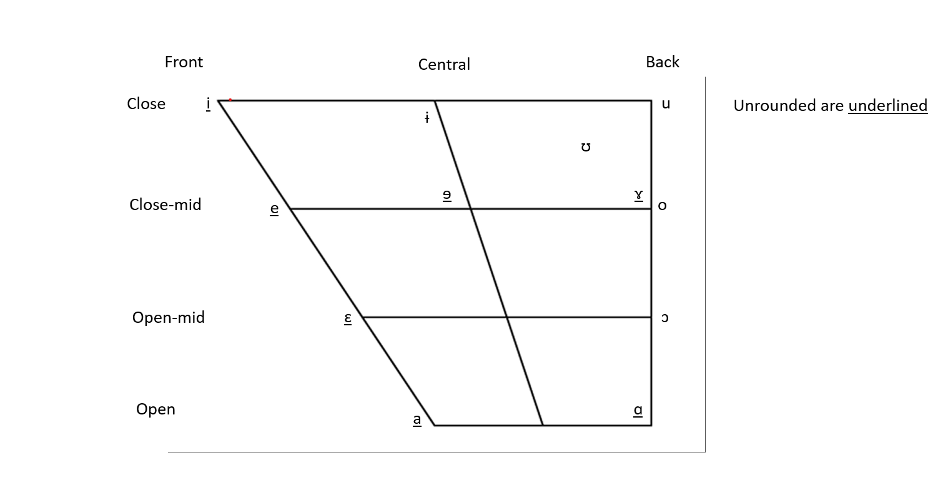

In our mystery language we have a varied use of vowels but relative to other language the inventory is small. The language has front unrounded vowels [i, e, ɛ, a] spanning from close to open, close to close-mid central unrounded vowels[ɨ, ɘ], and a combination of rounded and unrounded back vowels ranging from open to close [u, ʊ, ɤ, o, ɔ, ɑ]. This being said, in the sample audio files the core 5 vowels are by far the most common [a,e,i, o, u] and they make up the vowels in the majority of the common words. In this language the majority of the vowels have a distinction in range that matches our standard IPA notion but sometimes e will approximate a. The mystery language also present a wide array of diphthongs clustered starting primarily with [ i,a,o,e,u,ɤ]. See diphthongs below.

### Diphthongs

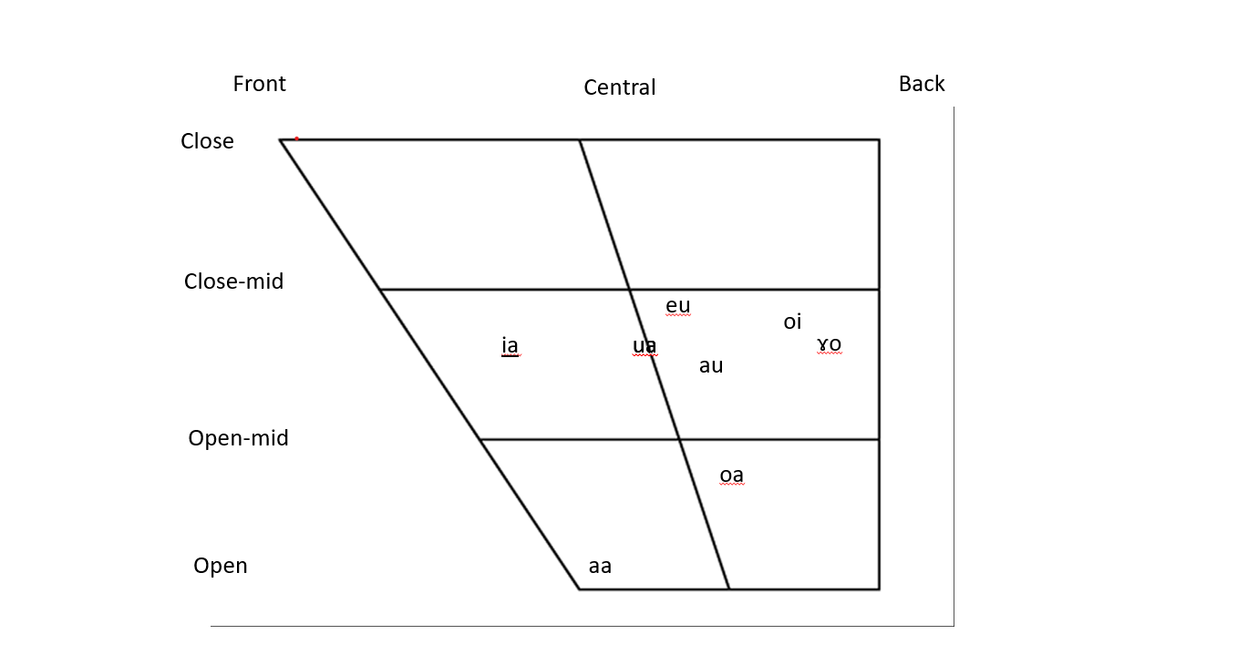

### Tone

This mystery language features a rich usage of lexical tone built around pitch accent and diversified pitches. Based on the samples, the pitch accent tends focused on [i,a] and is used to denote ownership over an object. Using a high or ascending pitch on the first vowel [i,a] in a word is used to convey ownership. If the high vowel or accent is on the second vowel than the phrase is simply a noun. Moreover, in the presence of triphthongs(oia), a high I is used to denote the difference between verbs (finish vs move), a descending o add emphasis to an expression (move! Or finish!) and a high final a makes the phrase be focused on another party (you move).

### Transcriptions of Recorded Passages

#### Consonants

|  |  |  |
| --- | --- | --- |
| ID | Word | Transcription |
| 1 | Field | pa.ra' |
| 2 | Elephant | ba.la' |
| 3 | Fish-sp | bau.bau |
| 4 | Flour | ta.'bau |
| 5 | Mouth | dada |
| 6 | Squirrel | nan'ɠa |
| 7 | Hare | gabla |
| 8 | Pair of tongs | ba |
| 9 | Axe | cala |
| 10 | Distance | batga |
| 11 | Trap-n | maba |
| 12 | Cloud | nana |
| 13 | Current | ralba |
| 14 | Spread out | rana |
| 15 | Back | fala |
| 16 | Grass-sp | vala |
| 17 | Tail | saba |
| 18 | Scorpion | zaba |
| 19 | Wasp-sp | hamza |
| 20 | Life | ian.ga |
| 21 | Pressure | ʎahana |
| 22 | Skin | wa.ga |
| 23 | Crack-n | wa.gǎ |
| 24 | Mud shelter | la.ga |
| 25 | Gift | maba |
| 26 | Filth | paga |
| 27 | Ibis-sp | bana |
| 28 | Truth | mana |
| 29 | Fish-sp | maza |
| 30 | Daughter in-law | fa.zi |
| 31 | To hide | vuana |
| 32 | Circumcision | can.da |
| 33 | Crab | halaga |
| 34 | News | pʰamuda |
| 35 | Circumcision | ca'da |
| 36 | Squirrel | nan.ɠa |
| 37 | Fog | hoboa |
| 38 | Hurt | kiak |
| 39 | Body | inu |
| 40 | Hurt the body | kiakinu |
| 41 | Child | biga |
| 42 | My | m |
| 43 | My child | big'm |
| 44 | Female in-law | azi |
| 45 | Female in-law respect form | t'azi |
| 46 | Bean | azi |
| 47 | Bean leaf | naːa |
| 48 | Bean eater | la:a |
| 49 | Frog-sp | pu.aani |
| 50 | Meet | bak |
| 51 | Respect | ma |
| 52 | Find | dada |
| 53 | Leak | na |
| 54 | Hug | ɹak |
| 55 | Be blind | ara |
| 56 | Existential | lʊ |
| 57 | Negation | niai |
| 58 | Press | iaħa |
| 59 | Call | taħa |
| 60 | Fig | wa |
| 61 | Nose | wɑ |
| 62 | Split | wɒ |
| 63 | Burn | la |
| 64 | Lift | na |
| 65 | Fish-sp | nateyɘgɤ |
| 66 | Cat-sp | nakeiyɘgɤ |
| 67 | Abundant | bazam |
| 68 | Yellow | ba |
| 69 | Scorpion | zaba |
| 70 | My scorpion | zak'm |
| 71 | Child | bi.ɠa |
| 72 | My child | bi.gm |
| 73 | Smallness | baga |
| 74 | Milk | pap.ba |
| 75 | My milk | pap.m |
| 76 | squirrel | ganɠa |
| 77 | Food | wa'a |
| 78 | My food | wal'm |
| 79 | To carry | ɹinq |
| 80 | To go up | he.na |
| 81 | To heal | bar.na |

#### Vowels

|  |  |  |
| --- | --- | --- |
| ID | Word |  |
| 1 | palm or sole of | di |
| 2 | burn | de |
| 3 | mouth of | da |
| 4 | drink | do |
| 5 | them | du |
| 6 | fish-sp | pʰai |
| 7 | virginity | wai |
| 8 | frog-sp | kau |
| 9 | grass-sp | deu |
| 10 | eye | ni.nu |
| 11 | bottom | ni'.nu |
| 12 | slave | be.ge |
| 13 | pangolin | be'la |
| 14 | elephant | bala |
| 15 | captive | balɑ |
| 16 | money | co.bo |
| 17 | relative | coo.la |
| 18 | magic | sula |
| 19 | herd | zulʊ |
| 20 | carry | ri |
| 21 | melt | re |
| 22 | spread out | rɑ |
| 23 | amuse | ro |
| 24 | leave without water | ru |
| 25 | cobra | dɤno |
| 26 | manioc-sp | bu.ni |
| 27 | millet-sp | bɤo.na |
| 28 | clean out or wink | ri |
| 29 | blind or singe | ra |
| 30 | slip something in | dɔ |
| 31 | hand of | se |
| 32 | cow of | za |
| 33 | snake of | d̈ä |
| 34 | dip | di |
| 35 | spy | bɛ |
| 36 | fil | bap |
| 37 | ugliness | bɔ |
| 38 | gather | bu |
| 39 | slither | rɛ |
| 40 | tree-sp | rɛga |
| 41 | polish | ro.no |
| 42 | glue | dni |
| 43 | rot-v | dna |
| 44 | lean | gnu |
| 45 | name-n | ɨa |
| 46 | name-of | ee |
| 47 | your sname | eeam |

#### Tone

|  |  |  |
| --- | --- | --- |
| ID | Phrase | Transcription |
| 1 | head | ka.lâ |
| 2 | my head | ká.li |
| 3 | axe | ka.lǎ |
| 4 | my axe | kǎ.li |
| 5 | breast | nú.nû |
| 6 | my breast | nù.nǔ |
| 7 | drumstick | ga.gam |
| 8 | my drumstick | ga.gaḿ |
| 9 | to wash | sua.na |
| 10 | wash n or gully | sǔa.na |
| 11 | you move | moia |
| 12 | you finish | moía |
| 13 | you moved | moià |
| 14 | you finished | moîà |
| 15 | move! | mŏiâ |
| 16 | finish! | mŏíâ |
| 17 | firefly | tikeːkeːru |
| 18 | child | bi.gaː |
| 19 | my child | bí.gm̆ |
| 20 | my brother or sister | bĭc.turutine |

## Second Language: Spanish from Mexico

For my second language I am presenting a phonetic inventory of Spanish from Mexico which is my country of birth/schooling. The Spanish is focused on more southern Mexico(Puebla/Mexico City area) but in some ways is quite anglicized. Mexican Spanish, specifically that which is based in Mexico City, is known in the Spanish speaking world as having the most plain and simple Spanish with regards to phonetics.

### Vowels

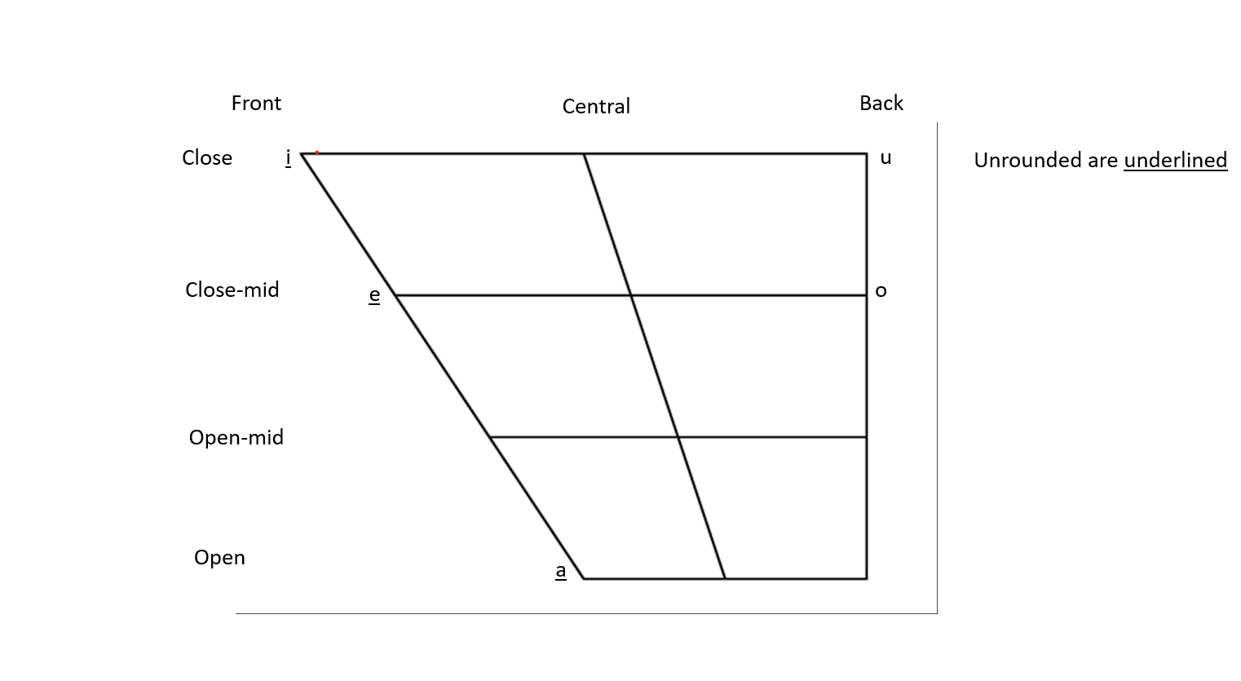

### Diphthongs

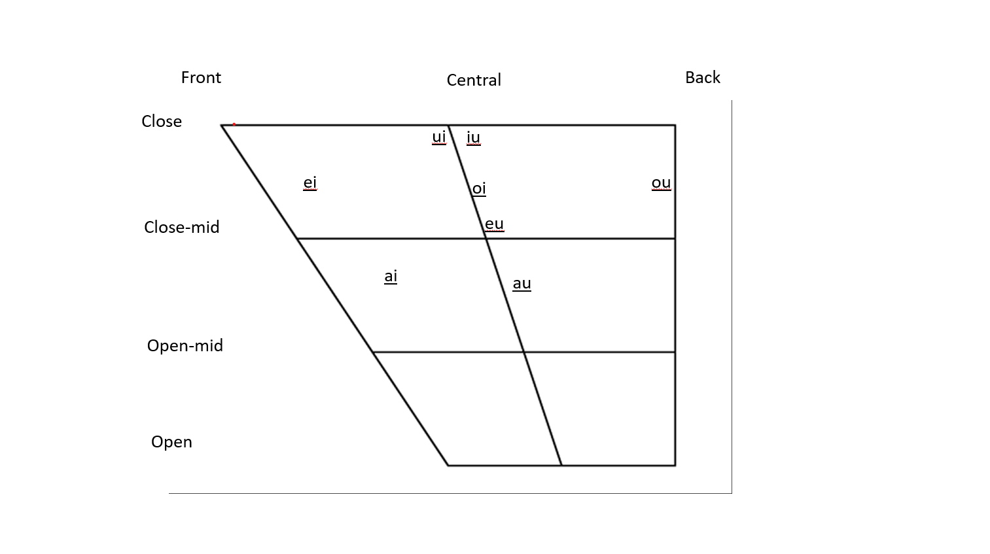

Mexican Spanish is relatively simple from a non diphthongal perspective. The inventory is built around a core of vowels [a,e,I,o,u] and most of the interesting parts of Spanish occur as diphthongs or triphthongs. It includes unrounded front vowels ranging from open to close and rounded back vowels close-mid to close. Based on my experience, the role of diphthongs in the langauge replaces how many other languages use central vowels. There is a heavy usage of diphthongs and triphthongs in the whole langauge. See examples below.

##### Vowel examples



Vowel Description • Vowel chart(s). This should be a chart of phonemes. Preferably place symbols in a trapezoid. Prepare separate charts for monophthongs and diphthongs (these can be placed side by side to save space). • A word list illustrating each vowel phoneme in the chart or charts. This is preferably a minimal set. A long list should have some structure. Divide words into groups and label the groups as to what they show. For example, there can be separate lists for monophthongs and true diphthongs

### Consonants

The language has voiced and voiceless stops at four places of articulation: bilabial [p, b], alveolar [t, d], and velar [k, ɡ]. It features voiced nasals in bilabial [m], alveolar[n], and palate-alveolar[ɲ] articulation. The language also features voiced trill [r] along with a voiced flap [ɾ] both occurring in the Alveolar. It features only approximate laterals which occur as a palatal lateral approximate [ʎ] and alveolar[l]. Finally, the language feature a wide range of voiced and voiceless fricatives in the Labiodental [f] alveolar[s, z]. Something of note is how Spanish does not have a v and instead, most words that include a v are pronounced phonetically as a b. This causes Spanish learners of English as a L2 to have different understanding of words such as Volvo(Mexican Spanish pronunciation would be bolbo) or Venezuela(benezuela).

##### Consonants Example

