EGR 362 Problem Set #9 Due March 28, 2003

The problems below are taken from Lindner’s text, “Introduction to Signals and Systems.”

12.1.1 Suppose the impulse response function of a proof-mass actuator is given by 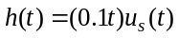. Find the output if the input is 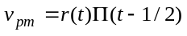

12.1.3 Suppose that the impulse response of a system is
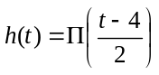
Find the step response of the system.

Note: In problem 12.1.1 u_{s}(t) is the unit step function.
In problem 12.1.3 r(t) is the unit ramp function. (r(t) = t for all t > 0, otherwise r(t) = 0)

