File ‘dtfs_ex.m’

% A script to demonstrate the Discrete-Time Fourier Series
% for a sawtooth with period N = 3.

% Define the periodic wave in the sample domain.
% Let x(n) be the samples of the wave. Let xp be a finite set of
% samples that defines the fundamental period of sample values from
% Sample number zero to sample number N-1 where N is the period.

xp = [0, 1, 2]; % The fundamental period of x(n)
N = length(xp); % The fundamental period

% Now make a plot from sample number Nmin to sample number Nmax

Nmin = -4;
Nmax = +8;

% Set up the vector of sample numbers, suitable for making plots

n = Nmin:Nmax; % A row vector of sample numbers
x = mod(n,N); % x has the same size as n. x is also
% full of sample numbers in the fund. period.

for i = 1:length(n), % Replace the values in x with values
x(i) = xp(x(i)+1); % from the fundamental period.
end

figure(1);
stem(n, x);
title('Sample Domain -- x(n) vs. n');
xlabel('Sample number, n');
ylabel('x(n)');

% Now find the Discrete-Time Fourier Series of xp
disp('These are the F.S. coeficients');
[ck,k] = dtfs(xp)

ckm = abs(ck);
cka = angle(ck);

figure(2);
stem(k, ckm);
title('Magnitude of ck vs. k');
xlabel('Harmonic number, k');

figure(3);
stem(k, cka);
title('Angle of ck vs. k');
xlabel('Harmonic number, k');

% And finally, synthesize the sample-domain signal from
% the Fourier Series coefficients.

[xs, ns] = dtfs(conj(ck));
xs = abs(N*(xs));

figure(4);
stem(ns, xs);
title('Synthesized fundamental period in sample domain');
xlabel('Sample number, n');

Result of executing file ‘dtfs_ex.m’

» dtfs_ex
These are the F.S. coeficients

ck =

1.0000
-0.5000 + 0.2887i
-0.5000 - 0.2887i

k =

0 1 2

»

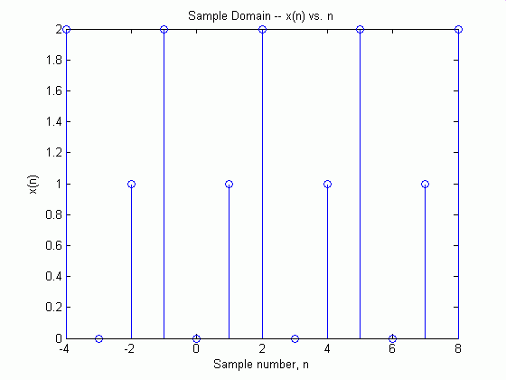
Figure 1

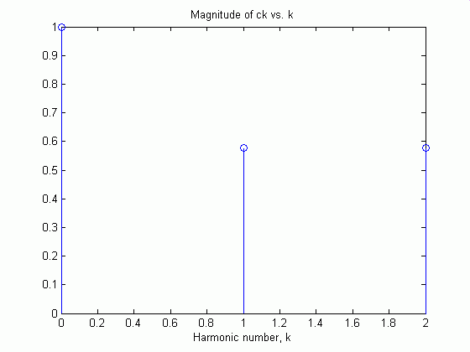
Figure 2

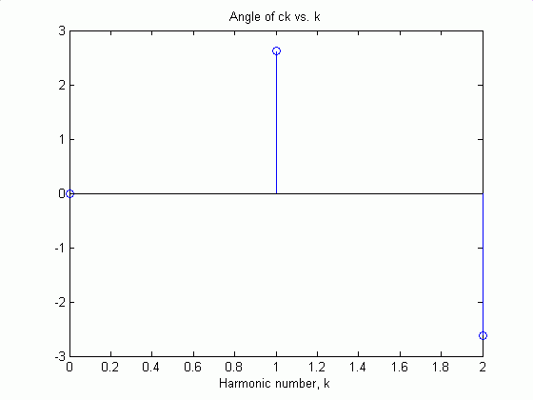
Figure 3

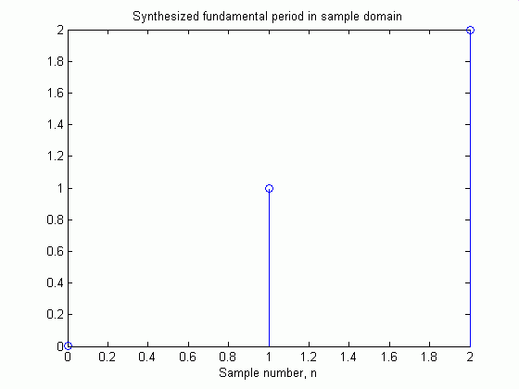
Figure 4

