Engineering Department
EGR 204 Latches and Flip-Flops Spring 2005, Lab 6

OBJECTIVES:
- To observe the differences between latches, and flip-flops
- To learn how latches and buffers are used in the Port 2 input and output circuits on the Fox Kit.

EQUIPMENT NEEDED
- One Fox Kit microprocessor trainer with matching numbered power supply, assorted
jumper wires, and a logic probe
- The following TTL integrated circuits:
Quantity | Type | Description
1 | ’00 | Quad 2-input NAND
1 | ’74 | Dual D-Flip-Flop
1 | ’373 | Octal D-latch

THE NAND LATCH
Wire up a NAND latch as shown in Figure 1. Suggested pin numbers are shown in parenthesis. Fill in the Table 1 by applying the inputs in the order shown. For each line, identify the function of the inputs and the state of the latch. The last several lines of the table suggest that you try to switch from the ill-conditioned function directly to the latched function. Try it several times (attempting to turn the two switches simultaneously) and observe the results.
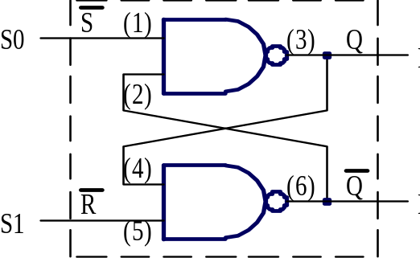
Figure 1. A NAND latch.

Function | 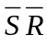 | 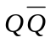 | State
 | 0 1
 | 1 1
 | 1 0
 | 1 1
 | 0 1
 | 0 0
 | 1 1
 | 0 0
 | 1 1
Table 1. Results of operating the NAND Latch

D-LATCH AND D-FLIP-FLOP
Add circuitry to the breadboard as shown in Figure 2 by wiring up the ’373 latch and the ’74 flip-flop. (The NAND Latch shown in Figure 2 should already be wired.) In the lower left corner of the Fox Kit is a red push-button labeled PB1. About two inches up and one inch to the right of the push button is a small gold contact in which a jumper wire may be inserted. It provides a debounced output from the push-button that is ideal for manually creating a clock signal. Try touching a logic probe to the contact while operating the button to see how it works. Which logic state (1 or 0) corresponds to pushing and holding the button down? You can control the other inputs with switches and observe the results on LED’s.
Table 2 shows “truth tables” (so-called in some data specification sheets, but they are not really “truth tables”) for the latch and flip-flop. Your task now is to figure out by experiment what the symbols in the tables mean. These tables describe how the latch and flip-flop work. The meanings of L, H, and X in the tables are obvious. What do the arrows, bars, and subscript zeros signify? Does it matter if you change a D input while you hold the push-button down? Devise switch sequences to make the following happen:
- Can you make both Q and = 1? (Do the tables show that it is possible?)
- Can you make both Q and = 0?
- Which outputs change when you press the push-button and which change when you release the button? Do the tables predict this behavior?
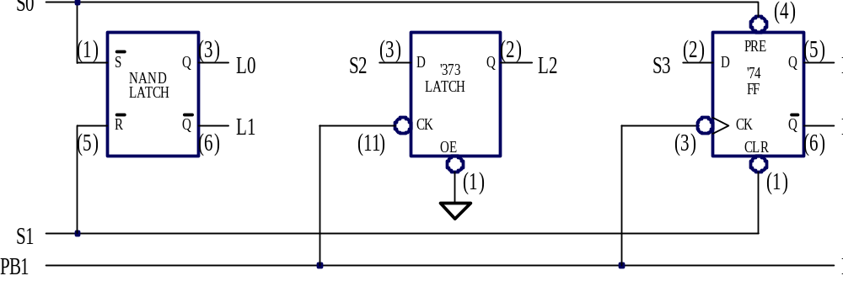
Figure 2. A circuit to demonstrate a NAND latch and JK flip-flops.
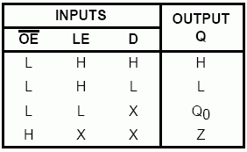  (a) ’373 octal D-latch | 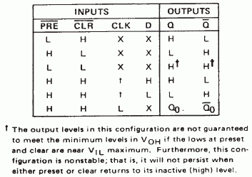  (b) ’74 dual D flip-flop
Table 2. “Truth tables” for types ’373 octal D-latch and ’74 dual D flip-flop.

PORT 2 OF THE FOX KIT
The Port 2 LEDs on the Fox Kit are driven by D-latches. The purpose of this section of the handout is to explain how these latches work in the context of these ports. In the next section you will do some experiments to solidify your understanding of these ports. Figure 4 shows a complete schematic of Port 2, both the switches and the LEDs. The LED’s are driven by type 4042 D-latches. These particular latches were chosen because the default logic level at an unused input can be set via pull-down resistors (R9, a group of eight 100-kΩ resistors in Figure 4.) to be equal to logic-0. (This technique does not work effectively with 74xx series parts.) The truth table and pinout for the 4042 chip is shown in Figure 3. Note that there are actually 4 latches in each chip.
Do not build the circuit shown in Figure 4. It is already built for you on the green PC board of the Fox Kit! The various signals shown along the left-hand side of Figure 4 are labeled on the lower area of the breadboard on the Fox Kit. The various switches and LED’s shown on the right-hand side of Figure 4 are installed and labeled on the green part of the circuit board near the breadboard area. Each chip shown in Figure 4 (U15, U16, U18, U19) is mounted in a labeled socket on the green area of the bread board. You can probe the pins of these chips with a logic probe if you so desire, thus each wire shown in Figure 4 is available at a chip pin. All the pin numbers are shown in Figure 4 just outside of the block diagram of each chip.
Observe on Figure 4 that the “Polarity” inputs (pin 6) of each 4042 latch are tied high. This makes the “Clock” input positive true meaning that when the Clock input is logic-1 the latch is transparent. On a falling edge of “Clock,” and as long as “Clock” is low, the data is latched. Also on Figure 4, observe that the “Clock” input to each D-latch (pin 5 on each 4042 chip) defaults to logic “1” by means of 100 kΩ resistors connected to +5 V. These resistors provide weak logic-1 levels that can be overridden by any signal connected to P2XCL or P2YCL. This enables each latch to be transparent by default. You must connect something to P1XCL and/or P2YCL to latch data.
Considering now the part of Port 2 (Figure 4) connected to the switches, note that each switch is connected to a pull-up resistor of 10 kΩ and to an input of a ’367 chip. All the pull-up resistors are in one package marked R17 and located on the Fox Kit just above the switches. Find this package of resistors on the Fox Kit and see what it looks like. The resistors apply a weak logic-1to the inputs of the '367 chip, unless a switch is closed to short out the logic-1 and thereby apply a strong logic-0.
The type '367 integrated circuit is a tri-state buffer. Figure 5 shows that pin 1 controls four outputs (pins 3, 5, 7, 9). Find these pins again on Figure 4, part U18. These signals (S4, S5, S6, S7 on Figure 6) will be high impedance (Hi-Z) if pin 1 is high, or if P2YEN is low, since there is an inverter between the P2YEN terminal and pin 1. The input to P2YEN defaults to logic high (as is standard for any 74xx type part.) In a similar fashion, P2XEN controls four other bits, this time involving U18 and U19.

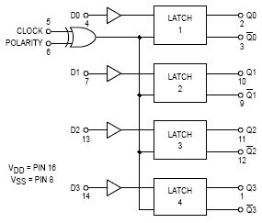 | 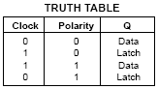
Figure 3. Pin assignments and truth table and for the 4042 CMOS D-latch.

Figure 4. Port 2 of the Fox Kit. (This circuit is pre-built for you on the Fox Kit.)
Devise experiments of your own to demonstrate what P2XCL and P2YCL do. How could PORT 2 be used to capture data that is only momentarily present and display it continuously for a long time? Devise similar experiments to demonstrate what P2XEN and P2YEN do. How can PORT 2 be used to output a byte of data only for a brief moment when the data is needed, and otherwise be disconnected?

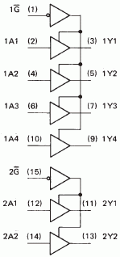
Figure 5. The ’367 schematic from a data sheet. Pin numbers are in parenthesis.

TWO EXPERIMENTS WITH I/O ADDRESSING
The need to select data from many available sources often occurs in digital equipment. This experiment reduces this task to its bare essence. Imagine two devices, each of which has a four-bit output. Let switches S0, through S3 of Port 2 represent the data output of one of these devices and assign this device the address of 0. (Only one bit of address is needed if we have only two devices to select from.)
The other device will of course be the other four switches on Port 2 and it will have the address of 1. Suppose further that we wish to display the data from either of these devices on LED’s L0 through L3, depending on the state of a push-button. A circuit to do this can be made by connecting the jumpers listed in Figure 8a. You will need to invert PB1 which can be done by using one NAND gate from the ’00 chip. (Disassemble the circuit of Figure 2 first.)

Selection of data |  |  |  |  | Routing of data
FROM | TO |  |  |  |  | FROM | TO
PB1 | P2YEN |  |  |  |  | PB1 | P2YCL
PB1 (or P2YEN) | Inverter input |  |  |  |  | PB1 (or P2YCL) | Inverter input
Inverter output | P2XEN |  |  |  |  | Inverter output | P2XCL
S0 - S3 | L0 - L3 |  |  |  |  | S0 - S3 | L0 - L3
S4 - S7 | L0 - L3 |  |  |  |  | S0 - S3 | L4 - L7
(a) (b)
Figure 8. Circuit to demonstrate selection and routing of data by addressing.
Build a circuit by connecting the listed jumpers.
Rather than select data from one of several sources, sometimes it is necessary to route data to one of several devices. Once again, addresses can be used, as the following experiment demonstrates. In this case four bits of data from S0 - S3 will be directed to either L0 - L3 or L4 - L7. When a set of four LED’s is not addressed it displays the last data that was addressed to it. Disconnect the circuit of Figure 8a and connect the circuit of Figure 8b. After the circuit is connected, operate the switches while you watch the LED’s. Then press the button and hold it down while you operate the switches again.

