Engineering Department
EGR 204 Sequential Logic Design Problem Spring 2005, Lab 7

OBJECTIVE:
- To design a sequential logic circuit from a written description of its desired operation.
- To recognize, consider, and select from a variety of design options.

EQUIPMENT NEEDED
- 1 FOX kit microprocessor trainer with matching numbered power supply and a logic probe
- A selection of assorted TTL logic gates, possible embellishment of the project with LED’s etc.

INTRODUCTION
In class we discussed a formal procedure for designing sequential logic circuits. In practice there are many variations possible. In addition there are practical matters such as design short-cuts and power-on reset considerations. The engineer finds a large variety of options to consider even for simple sequential circuits.
Choose one of the design problems described later in this handout, or, with approval of the instructor, devise your own design problem. Present your design in a formal report. Imagine that your goal in writing the report is to give your design to a team of students from next year’s class. You will want to include in this report anything they will need to know to quickly understand the design and wire up and demonstrate the circuit. Suppose also that next year’s team has about three other reports besides yours, all presenting different designs of the same project. Your report must be written to advocate your design as the one next year’s team should be most interested in. You should begin by establishing certain goals for your design, then justify the goals in comparison to other possible goals and finally show how you achieved your goals and what alternatives you considered and rejected.
You will not need to include in the report anything in the course textbook, this lab handout, data manuals, (or equivalent information from the Web) or material covered in lecture. Your readers can be assumed to have the same resources you do. On the other hand, you may want to refer to some of this material to justify a decision or identify a non-obvious source.

POWER ON RESET
The flip-flops you use must be controlled when power is applied. The /PRE and /CLR inputs are usually used for this purpose. Some flip-flops only have a /CLR input. If it is a JK flip-flop and what you really want is a /PRE input, just interchange the roles of J and K and of Q and /Q. In other words, consider the flip flop set when the output labeled /Q is 1. Then to make it set this way, either activate K and clock the chip or let /CLR = 0. Either method will actually make /Q = 1 so that the flip-flop can be considered set.
The FOX kit provides a /RESET signal which is held low for a time after the power is applied and whenever the RESET push-button on the keypad is pressed. You can find the /RESET signal near the top of the breadboard area. Use this signal as necessary to control your state machine on power up.

ALTERNATIVE COMBINATIONAL LOGIC STRUCTURES
You may implement the combinational portions of your state machine any way you like. You may use all NAND gates in circuits derived conventionally from Karnaugh-maps if you wish, but other options might reduce your design effort. You may use multiplexers for example. Another option is to run the state variable number (possibly augmented by the input variables) into a decoder, then OR (or in case of negative true outputs, NAND) the outputs of the decoder as needed to produce next state and output logic. In essence, the decoder provides all the minterms for you. Just sum them as needed.

ONE-HOT STATE ASSIGNMENT
A technique that can save design time but results in extra electronics is called one-hot state assignment. With this technique the only state numbers that are used are states that have exactly one logic 1 in the state number, for example 0001, 0010, 0100 and 1000 as illustrated in Figure 1. This means that as many flip-flops are needed as there are states. In this example there are four states and so only two flip-flops could have been used had the states been conventionally numbered (00, 01, 10, 11).
One-hot state assignment is often advantageous when there are a significant number of inputs compared to the minimum number of flip-flops that could be used. For example: If there are 5 inputs and 16 states then four is the minimum number of flip-flops that could be used. (log₂(16) = 4) Four is less than five (the number of inputs), suggesting that one-hot state assignment may save design time.
One-hot state assignment can result in great simplification of the next-state and output logic in the right situation. If Karnaugh maps are used to design the next state logic, although they are large, they are almost entirely full of don’t cares due to all the unused states. Actually, Karnaugh maps are not even needed and the logic can be designed simply by inspecting the flow chart. The next state equations for the example in Figure 1 are:
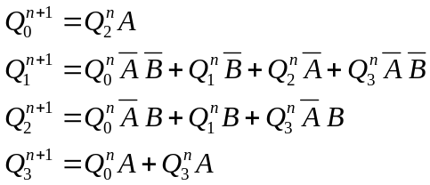
Where:
Q is the state variable, a four-bit binary number
Q_{i} is the ith bit of the state variable (bit 0 is least significant).
Q_{i}^{n} is the present state of the ith bit of Q
Q_{i}^{n + 1} is the next state of the ith bit of Q
If D flip-flops are used then just let each D_{i} = Q_{i}^{n+1}. Consider the equation for Q₁^{n+1}. This bit of the state variable (second from the right) can only be a 1 for state number 0010 named Beta. This means that the single bit, Q₁, can be used to represent state Beta. Similarly, one bit can be used to represent each state. Inspecting the flow chart, observe that the paths into Beta occur only if the present state is Alpha (Q₀^{n} = 1) and A = 0 and B = 0, or when the present state is Beta and B = 0, or when the present state is Gamma and A = 0 or when the present state is Delta and A = 0 and B = 0. Now look at the equation above for Q₁^{n+1} and observe that the equation literally represents these statements. It can be written by inspection of the flow chart. The same method gives the other equations.
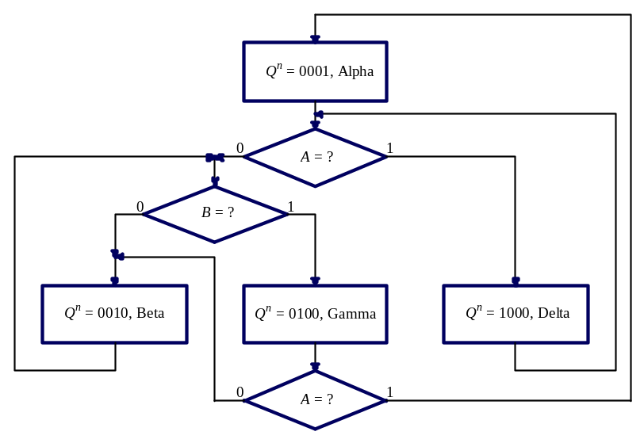
Figure 1. An illustration of next state logic for one-hot state assignment.
If one-hot state assignment is used, it is imperative that the power-on reset circuits assure that a valid state number (exactly one logic 1 stored in the memory) results. If one of the unused states is entered at power up, for example any of 1111 or 0101 or 0000, then usually these circuits will never cycle into one of the valid states. The circuit is usually not self correcting. This is because so few of the states in the state-space are used and because the many don’t cares in the next state equations tend to resolve to inject more 1’s into the state number, not fewer.

DESIGN PROBLEMS

Vending Machine Controller (Challenging)
A certain vending machine dispenses two types of candy, M&M’s or Milk Duds, each for 25 cents in nickels and dimes. There are two buttons on the front of the machine, which the customer may use to select M&M’s or Milk Duds after inserting the money in a slot. The vending machine has three main parts. Firstly, a coin acceptor which handles the money. Secondly, there is the vending apparatus that contains push buttons to select a type of candy, and a limit switch to indicate when candy has been vended. The vending apparatus receives binary signals to actuate the vending of a product. Thirdly the vending machine controller receives the signals from the coin acceptor and vending apparatus, counts the money and vended product, and sends output signals to the vending apparatus and the coin acceptor to cause proper operation. A block diagram of the vending machine is shown in Figure 2. You are to design only the vending machine controller. The coin acceptor and vending apparatus can be simulated by switches and LED’s on the FOX kit.
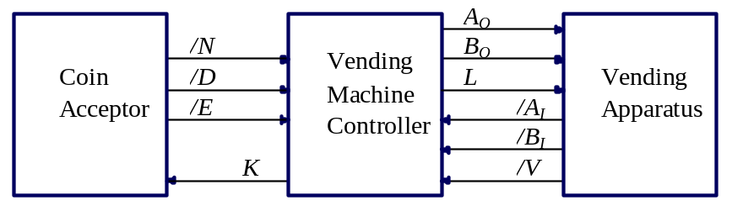
Figure 2. Block diagram of a vending machine.
A real coin acceptor is a clever mechanical apparatus that processes coins from the slot in the front of the machine. For the purpose of this lab, assume the slot is too small to accept quarters or anything larger than a nickel. Each coin rolls by the force of gravity past a strong permanent magnet to which any ferrous slugs will stick. (U.S. coins contain nickel and copper which are nonferrous.) Then the coins are sorted according to size by rolling over slots and sorted according to weight by rolling on counterbalanced tracks that can swing down, delivering the coin to either an upper or lower track. After this process, nickels and dimes have been separated onto two different tracks. Mounted on the track for nickels is a microswitch that is normally open. This switch closes momentarily whenever a nickel rolls over it. There is a similar switch for the dimes. The outputs of these two switches produce logic signals /N and /D. Signal /N pulses to logic 0 when a nickel passes through the coin acceptor, similarly, /D pulses low for a dime. After rolling past a microswitch, the nickels and dimes fall into an accumulator box located above the coin return. It accumulates all the nickels and dimes the customer inserts. Pennies and nonferrous slugs will fall onto a third track and be delivered directly to the coin return.
For a real coin acceptor, each /N or /D pulse lasts about 10 ms depending on how fast the coin is moving. You can simulate the output of a coin acceptor using switches, for example the Port 2 switch bank of the FOX kit. Of course rocking a switch down and up again will take more than 10 ms, but it will not matter since both 10 seconds and 10 ms are practically an eternity from the point of view of logic gates.
A real coin acceptor has a coin return lever that the customer may pull. This tips the accumulator box nearly upside down toward the coin return causing all the contents to be returned to the customer. This action also closes a switch causing a logic output /E (for “emptied”—the accumulator box has been emptied) to go to logic 0 as long as the accumulator box is tipped toward the coin return. The coin return lever also wipes any slugs off the permanent magnet and they fall into the coin return too. If the customer inserts coins while holding the coin return lever, they are diverted past the entire mechanism directly into the coin return and no /N or /D pulses can be generated. When the coin return lever is released, springs return the lever, diverter, and accumulator box to their normal positions. Signal /E will remain low until all three of these mechanisms are back in place.
The coin acceptor also accepts a logic input signal, K, (for “keep”) that operates a solenoid. When K is high the accumulator box is tipped nearly upside down but away from the coin return so that the contents fall into the coin hopper for storage until the vending machine is serviced. Input K must remain high long enough for the coins to actually fall out of the accumulator box. To give the state machine an indication of when the accumulator box is empty the /E output of the coin acceptor will go low when the accumulator box hits a stop at the end of its tipping action. At this time it can be assumed the coins have fallen out of the accumulator box. While K is high any coins the customer inserts are diverted to the coin return without making any pulses on /N or /D.
Imagine what might happen if there is a line of customers eager to get candy. It is possible that just after one customer selects a product, while the vending mechanism is still operating, a second eager customer already starts inserting coins in the slot. This customer is expecting to make a second selection right on the heels of the first customer but has not waited for the first customers sale to be completed. Because of this possibility, it is necessary that signal K goes high as early as possible after enough money has been inserted and that it is held high until the product is completely vended, as indicated by signal /V, described later. This way the coins from the second customer will be diverted into the coin return while the controller is busy vending product and presumably cannot count coins.
If a customer deposits more than 25 cents—three dimes for example—this machine gives no change, keeps all the money, and vends the product.
After enough money has accumulated, the controller should turn on a light by making L go high. On a real vending machine this would illuminate the two selection buttons and a message prompting the customer to press one of the selection buttons. The light should go out immediately when the customer presses one of the buttons. If the customer tries to press both selection buttons at the same time, either product may be vended, but not both. If the selection buttons are not illuminated the controller should ignore any action of the selection buttons. If a selection button has been held down while coins were being inserted, it may be ignored until it is released and pressed again when the selection light is on. Each selection button produces a logic 0 for as long as it is pressed. The button labeled with an illustration of M&M’s produces logic signal /A_{I} and the button labeled with an illustration of Milk Duds produces signal /B_{I}.
To vend a product, the controller must activate logic signal A_{O} (for M&M’s) or signal B_{O} (for Milk Duds). Signal A_{O} or B_{O} must remain high until the product is completely vended which is indicated by a signal, /V, which is activated by a limit switch that in turn is activated when the vending mechanism has completed its motion and the product has fallen into the delivery chute.
When power is first applied, or when power fails, the vending machine should never accidentally vend candy. Otherwise enterprising burglars will simply jiggle the power cord in the wall outlet until candy is vended.
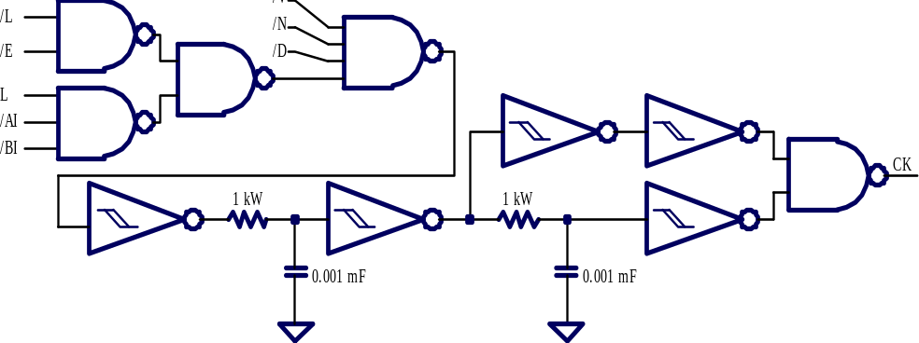
A special clock circuit is shown in Figure 3. It has a built in delay relative to input changes to effectively debounce all the inputs. The inverters are Schmitt triggers, type ’LS14. The CK output produces a single short clock pulse after any input to the controller goes low and is done bouncing. Inputs are ignored when they go high, /E is ignored if the button illumination is on, and /A_{I} and /B_{I} are ignored if the button illumination is off.
Figure 3. A clock generator for debouncing all inputs of the vending machine controller.

Traffic Light Controller (Intermediate Difficulty)
A traffic intersection similar to the one at Third Street and Main Avenue in Sioux Center has sensors on the side street so that the light can stay green on the main avenue as much as possible. The sensor sends a signal, /V equal to logic 0, to the traffic light controller whenever a vehicle is waiting on the side street. However, the traffic light controller does not immediately respond to /V because the vehicle might take a free right turn in just a few seconds obviating the need for a green signal on the side street. In addition, by making side traffic wait it is more likely that several vehicles will queue up for the green signal on the side street, increasing the percentage of time on average that the main avenue has a green signal. A block diagram of the traffic light controller is shown in Figure 4.
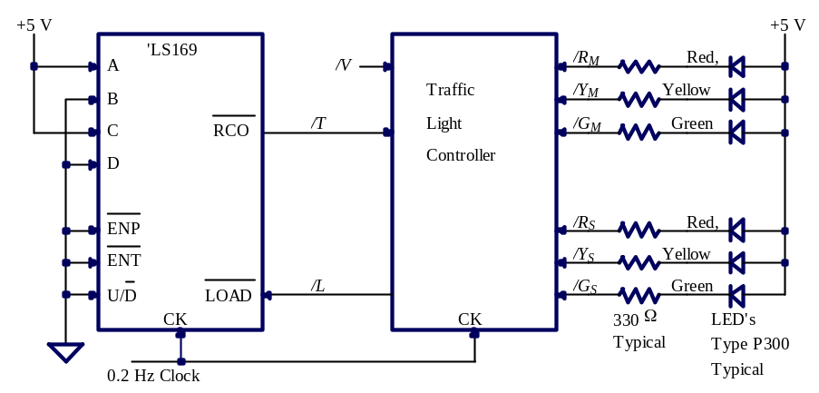
Figure 4. A traffic light controller.
The traffic light controller has seven outputs. Three of them, /G_{M}, /Y_{M}, and /R_{M}, control the green, yellow and red lights on the main avenue. Another three, /G_{S}, /Y_{S}, and /R_{S}, control the green, yellow, and red lights on the side street. One more output, /L is used to reset a counter, described later. All these outputs are negative true, meaning for example that the main avenue has a green light (light is on) when /G_{M} is low. Then /Y_{M}, and /R_{M} would also have to be high so that those lights are out. The counter can run when /L is high. The counter is reset to zero and stays at zero as long as /L is low.
The traffic light controller has two inputs, /V and /T. Input /V becomes logic 0 when a vehicle is waiting over either or both of the two sensors buried in the road on the side street. Input /T becomes logic 0 to indicate a time-elapsed condition, as described later.
If there are no vehicles waiting on the side street then the main avenue should have a green signal, and the side street a red signal of course. If a vehicle stops at the red signal in either direction on the side street the /V signal becomes logic 0. The traffic controller has a slow clock, about 0.2 Hz (a 5 second period) and with every clock cycle the traffic controller may check the /V signal. When /V is first found to be 0 the controller starts a counter to count off 5 clock cycles (about 25 seconds) and after this time elapses, if /V is still 0 the main avenue gets a yellow signal. One cycle later, the main avenue gets a red signal. One cycle still later the side street gets a green signal and the timer is restarted for another 5 clock cycle interval, the maximum length of the green signal on the side street. (Traffic engineers have found it necessary to have a red signal in all directions for a while before a green signal since so many drivers run yellow lights.) After /V goes back high (no more side street traffic) or after /T goes low (the timer elapses) the side street gets a yellow signal, then on the next cycle a red signal, and then on the next cycle the main avenue gets a green signal.
Once the main avenue gets a green signal, it must stay green for at least 5 clock cycles. If there is a vehicle waiting on the side street when this minimum green-signal time for main avenue expires, that traffic can be assumed to have been waiting the whole time so the signal on the main avenue should become yellow leading eventually to the green signal on the side street.
After a vehicle stops for a red light on the side street it might take a free right turn so that /V goes back to 1 before the 5 clock cycles expire. In this case, as soon as the controller finds /V high it should reset the counter and start waiting for side traffic again.
When power is first applied the traffic light should be red in both directions, and then cycle to some sensible state.
Optionally, to make this a more challenging project, add a left turn signal sensitive to vehicles waiting in either left turn lane on the main avenue. This requires one more input to the controller, /L, which is 0 when there is a vehicle waiting to make a left turn from the main avenue onto the side street. The left turn signal should be inserted into the cycle just before the green signal on main avenue and should end on the next clock signal after /L goes high or after five clock cycles, whichever happens first. After the green arrow there should be a yellow arrow, After the yellow arrow goes out the intersection should have red lights in all four directions for one clock cycle to let the intersection clear of drivers who run the yellow arrows, then main avenue can get a green signal. This requires two more outputs, green arrow and yellow arrow, labeled G_{A} and Y_{A}.

Three-Bit Gray-Code Counter (Easiest)
Design a synchronous sequential counter circuit such that the state number sequence is in gray code (000, 001, 011, 010, 110, 111, 101, 100 counting up). There will be no output logic for this circuit since the state variables, Q^{n}₂ Q^{n}₁ Q^{n}₀, are the outputs and they can drive LED’s L2, L1, L0 of Port 2 on the FOX kit. There should be one input to the state machine labeled U which can come from S7. If U = 1 then the counter should count up, one count with each clock cycle. If U = 0 it should count down. The clock pulses can come from the push-button, PB1. There should be another input called LOAD which, by means of combinational logic, controls all the preset and clear inputs of the state flip-flops to override the clock and U inputs and instead load a 3-bit count from S₂, S₁, S₀. This counter may start in any random state on power-up. Presumably any circuit that used this counter could control the power-up state via the LOAD and S₂, S₁, S₀ inputs.

