Engineering Department
EGR 204 Introduction to Hierarchical design and VHDL Spring 2005, Lab 3

OBJECTIVES:
- To simulate a hierarchical described logic circuit
- To enter a logic circuit design into the simulator via a hardware description language (VHDL in particular).
- To enter a hierarchical design using VHDL
- To specify a primitive logic element in VHDL.

EQUIPMENT NEEDED
- Computer with Quartus II installed (Web Edition or similar. This handout was developed with version 4.1)
- (Fox kits are not needed for this lab.)

RECOMMENDED REFERENCE
The handout for Lab 1 contains a tutorial on using Quartus II for logic circuit simulation.
Your text (Mano and Kime, 3rd edition), especially Section 3.1

INTRODUCTION
As logic circuits get more complicated, conventional schematic diagrams become unwieldy. A technique to avoid this problem is to resort to a hierarchical circuit diagram. This technique has a key advantage: blocks of logic that are frequently repeated only need to be completely drawn out once. This process is described in more detail and with an example on pages 89 – 92 in your text. For this lab exercise, you will enter the example design given in the text into the Quartus II logic simulator and then simulate it to verify its functionality.
One disadvantage of using schematics (or block diagrams) for circuit design is that it tends to encourage the designer to work from the bottom up. (Top down vs. bottom up design is discussed on page 92 of your text.) Notice as you do this lab how you must start with the lowest level logic and work up. This can be difficult to do for a large project. An alternative strategy is needed. Hardware description languages serve this purpose.
There are two different hardware description languages in popular use right now. They are VHDL and Verilog. Both are included in our textbook, but we will cover only VHDL in this course. Quartus II also supports both languages and a third, called AHDL (Altera Hardware Description Language).
The first lab exercise for this course was an introduction to the equipment. You used a single NAND gate to discover the basics of wiring up a gate and simulating the same circuit. Your first VHDL design will be equally simple, so that you can initially focus on the process of operating the software. Next week you will be guided through an exercise using VHDL to create the nine-input odd function in a top-down style. Then you will discover more about the syntax and usefulness of a hardware description language.

A HIERARCHICAL SCHEMATIC OF A 9-INPUT ODD FUNCTION
The design for this logic circuit is given in your text on page 90, Figure 3-2. To enter this design into a logic simulator via a schematic, start with the lowest level of the hierarchy, which is illustrated in Figure 3-2 part (d). The figure in your text does not explicitly label the inputs and outputs at this level, but a schematic editor will need these labels. Figure 1 below illustrates a complete schematic for this level.
Begin the process of drawing the schematic by starting a new project in Quartus. A suggested name for this project is “ODD.” After the project opens, create a new schematic (block diagram file) but this time, do not give it the project name. Instead give it a name for this level of the hierarchy. Since this level forms an exclusive or gate, the name “XOR” would be a natural choice, but you should not use that name since it is already reserved in Quartus II for a logic primitive. A conventional way to get around a naming problem like that is to prefix the name you want with something else and an underscore. A suggested name is “L3_XOR”. To establish this as the name of the schematic file, do a “File | Save As.” Be sure “Add file to current project” has a check mark. Use the type 7400 NAND gates from the “maxplus2” library. Your final schematic for this level should look like Figure 1. After you have finished entering this file save it, but do not close it.
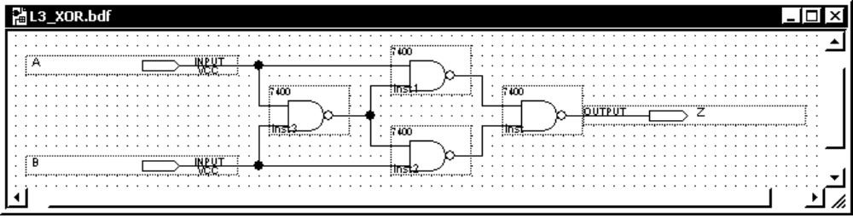
Figure 1. The schematic file for the lowest hierarchical level of the 9-input odd function
The next step is to define this schematic as a block. First be sure the schematic has the focus (title bar is highlighted). Then select “File | Create/Update | Create Symbol Files for Current File.” Quartus II now creates a new library named “project.” In that library it creates a new symbol with the same name as your schematic, for example “L3_XOR.”
To move up a level (textbook Figure 3-2 (c)) in the design, open a new schematic file (“File | New. . .”) and immediately name it for the new layer and associate it with the project (“File | Save As”). A suggested name is “ODD3” since this will be a three-input odd function. In the same fashion you would use to insert a 7400 NAND gate, Insert two instances of the “L3_XOR” block from the “project” library and connect them as shown in Figure 2. Your finished file should look like Figure 2. Save the file. (Compare with Figure 3-2 (c) in your text, page 90. Label “C” below compares with label “A₀” in the text, etc.)
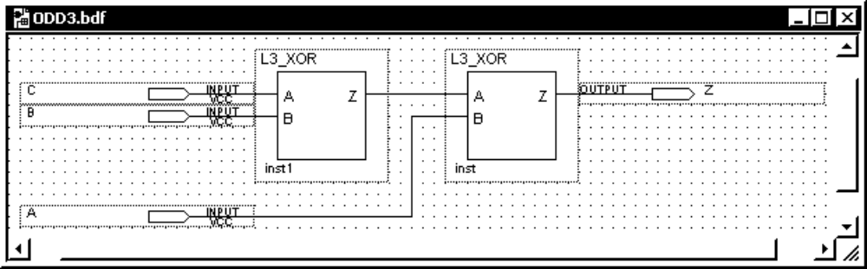
Figure 2. The schematic for second level in the hierarchy.
Continue up the hierarchy by creating a symbol in the project library for the ODD3 function. To create the symbol, while the ODD3 schematic has the focus select “File | Create/Update | Create Symbol Files for Current File. Then create a new schematic file, name the new file for the new level of the hierarchy, and associate it with the project. A suggested name for the new layer is “ODD9”.
Draw the logic for the ODD9 file and save it. Your finished schematic should look like Figure 3.
When that is done, create a symbol for it in the project file. Finally, create the top-level schematic. Name the schematic and associate it with the project. Note that the top-level schematic conventionally should have the same name as the project. That is normally how Quartus II finds the top-level entity. (When you create a new project with the “new project wizard,” you are asked what the name of the top-level entity is. The project name is the default.) The suggested name for this project is “ODD,” which should then be the name of this schematic file. Instantiate (insert) the ODD9 symbol in this schematic and add input and output pins for simulation. This schematic should look like Figure 4. Save the file.
After all these schematics are finished, generate a functional simulation netlist.
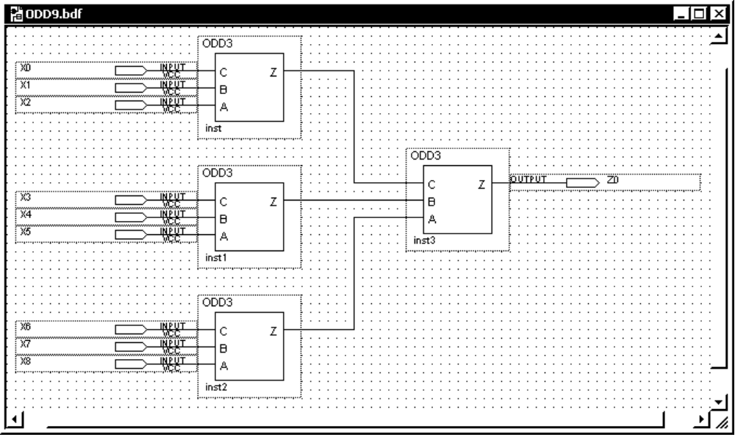
Figure 3. The schematic for the third level of the hierarchy

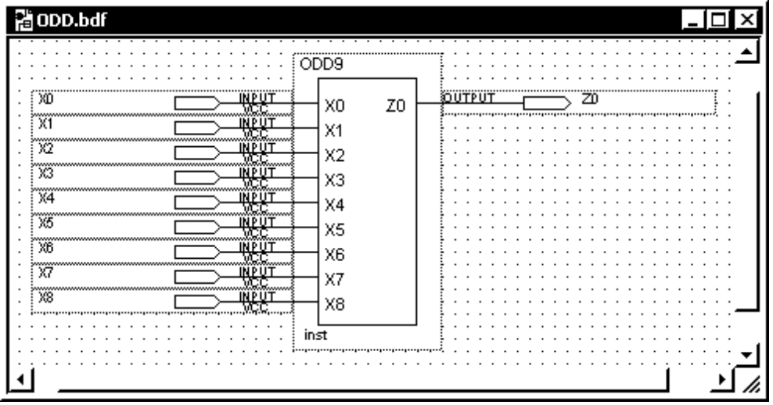
Figure 4. The top-level entity for the nine-input ODD function.
After the functional simulation netlist is generated, you may create your own vector waveform file for input stimulus, or you may copy the file “ODD.vwf” from the course web page (in the “LAB” section). To copy a file from another source into your project, use “My Computer” or “Windows Explorer” or something equivalent to copy the file into the project folder—the same folder that holds all the schematics, the *.bdf files. (In “Internet Explorer,” right-click the link to the file and choose “Save Target As. . .” be sure that Windows does not rename the file or change the file extension. The file name must end with “.vwf”—manually edit the file name before saving it if needed.) Then, in Quartus II choose “File | Open. . .” In the dialog box, in the “Files of type” box, select “Waveform Vector Files.” Then choose the ODD.vwf file, make sure “Add file to current project” is selected, and click “OK.” The vector waveform file provided on the course web page is shown in Figure 5.
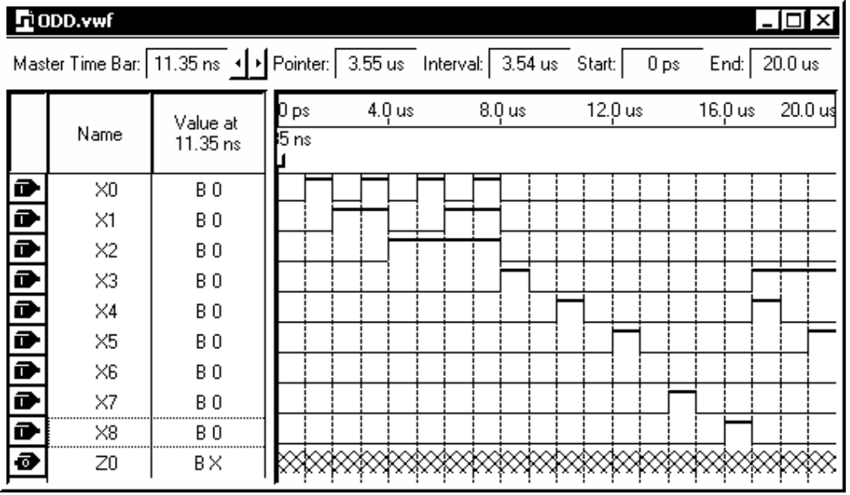
Figure 5. A suggested vector waveform file for simulating the nine-input ODD function.

You should now be able to do a functional simulation. Before simulating be sure to check the simulator’s settings to be sure a functional simulation is selected and that the simulation will have the correct vector waveform file as its source for inputs. Inspect the resulting output (signal “Z0”) and see if it works correctly. Whenever there is an odd number of inputs at logic-1, the output should be logic-1.

SIMULATING A NAND GATE USING VHDL
The process of creating blocks in a schematic editor encourages you to work in a bottom up style. A hardware description language allows you to work in a top-down style more easily. There are many other advantages to hardware description languages when they are applied to larger projects. These advantages will not be apparent this week as you learn just how to make the software work.
As an introduction to a hardware description language, you will type the VHDL description which is the equivalent to the first lab of the semester (when you simulated a single NAND gate). To begin, exit Quartus II to be sure that all files from the previous project are closed. Then restart Quartus II and create a new project. A suggested name for this project is “TUTORIAL2”. Once the project is created, open a VHDL text editing file by choosing “File | New | Device Design Files (tab) | VHDL File” A text editing window will open. Immediately name the file (“File | Save As”). Give it the same name as the project (“TUTORIAL2”) and associate it with the project.
Type the code shown in Figure 6 into the editor. You may omit all the comments. Each comment starts with two dashes and continues to the end of that line. Extra white space (tabs, spaces, linefeeds) is unimportant. VHDL ignores extra white space. VHDL ignores capitalization, but it is conventional to use upper case for VHDL statements and lowercase for signal and entity names. The example below follows this convention except for the signals S0, S1, and L0 since they were borrowed from the labels on the Fox kit. As you type, the editor will add line numbers in gray text on the left side of the window. These line numbers are not saved in the VHDL text file. They only show on the screen for the purpose of helping you find the location of any errors that might be reported. After you have entered the file, save it. You should now be able to generate a functional netlist. Make sure the VHDL file window has the focus, and select “Processing | Generate Functional Simulation Netlist.” If there are any errors, compare what you have typed to Figure 6.
To simulate the NAND gate, you will need a vector waveform file. The file you used in Lab 1 will work fine since this is actually the same circuit. Copy your own version of the file from the “TUTORIAL1” project folder into the TUTORIAL2 project folder. (If you did not save your file, you can download a copy of TUTORIAL1.vwf from the course web page.) Then within Quartus II use “File | Save As” to associate the file with the project. Then check the simulator settings (Functional simulation and correct source file) and you should be able to simulate the NAND gate. Check your results to see that they do represent a NAND gate.

LIBRARY IEEE;
USE IEEE.STD_LOGIC_1164.all;

LIBRARY ALTERA;
USE ALTERA.MAXPLUS2.all;

ENTITY tutorial2 IS
PORT(
S0, S1 :IN STD_LOGIC;
L0 :OUT STD_LOGIC );
END tutorial2;

ARCHITECTURE a OF tutorial2 IS
--The lines from "COMPONENT" to "END COMPONENT" pick the type 7400
--logic gate from the ALTERA library and make it available in
--this simulation.
COMPONENT a_7400
PORT(
a_2, a_3 : IN STD_LOGIC;
a_1 : OUT STD_LOGIC);
END COMPONENT;
--The altera library file shows you how to write the above 5 lines.
BEGIN
--The next line instantiates the 7400 gate (inserts one copy of it).
u1:a_7400
PORT MAP(S0, S1, L0);
--The above line connects S0 to a_2, S1 to a_3, and L0 to a_1. These
--signals are listed in the same order they appear in the component
--declaration.
END a;
Figure 6. VHDL code to simulate a type 7400 NAND gate.

