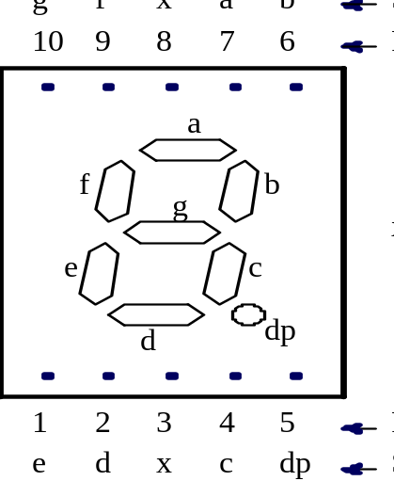
Figure 1. Pinout for a 7-segment LED display.
To operate the display:
If it is a common cathode display, connect either of the common terminals (“x”) to ground. Connect each of the segment terminals to a resistor that supplies current from the driver circuit shown below. The signal in the driver circuit shown below will be logic-0 when the segment is illuminated and logic-1 when the segment is dark.
If it is a common anode display, connect either of the common terminals (“x”) to +5 V. Connect each of the segment terminals to a resistor that supplies current from the driver circuit shown below. The signal in the driver circuit shown below will be logic-1 when the segment is illuminated and logic-0 when the segment is dark.

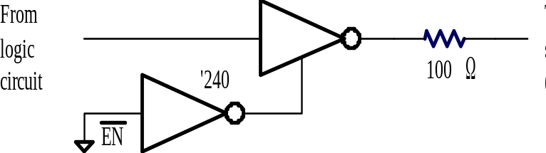

Figure 2. Driver circuit for one segment of a 7-segment display.

The driver circuit for the 7-segment display uses a ’240 octal inverting buffer. The tri-state inverter in the signal path is used to increase the power of the signal so that it can drive the LED segment. The resistor is needed to limit current flow to a safe and uniform level. The lower inverter in the enable path is actually not needed for this project. Just connect the 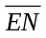signal to ground so that all the inverters are enabled to drive logic-1 and logic-0 signals. The ’240 chip has two groups of four tri-state inverters that share enable signals. Ground both enable inputs on the ’240 chip to enable all eight of the tri-state inverters.

Suggestion: Do not include the circuitry shown in Figure 2 in your simulation files (schismatic or VHDL). Call the outputs of your circuit the signals that connect to the inputs of the ’240 buffer. If you choose to download your circuit to the programmable logic chip on the UP-2 kit then there is no need for this buffer circuit. The 7-segment display is built right onto the board and connected to certain pin numbers on the programmable logic chip. If you decide to wire the circuit by hand on a breadboard, the simulation is still valid and shows exactly what you designed (you did not design the buffer circuit for the 7-segment display).

