Engineering Department
EGR 304 Creating a “Development Environment” Spring 2006, Lab 2

OBJECTIVES:
- To set up hardware and software to assist with the task of designing an embedded system using the 6811..
- To demonstrate the development environment by programming the 6811 to act like a small-scale integrated circuit containing NAND gates.

EQUIPMENT NEEDED
- Breadboard with power supply
- Wire-wrap adapter for the 6811 chip, CGN company, part number CGN1001-232
- MC68HC11E2CFN2 microcontroller installed in the wire-wrap adapter
- IBM PC with floppy disk drive, DOS boot disk
- AS11 cross assembler (Freeware, available from the Simtel archive and many other sources)
- 6811 resident portion of a monitor program for the 6811, three files named 6811PROM.*
(source = *.ASM, assembler comments = *.TXT, machine code = *.S19
- PC resident portion of a monitor program for the 6811, two files named 6811.*
(source = *.C, executable code = *.EXE)
- RS-232 cable (9 pin male to 9 pin female, a 3-wire cable is adequate, 9-pins-through also works)
- Male 9-pin D-SUB connector for RS-232
- Wire-wrap equipment, jumper wires, dip switches, LED’s, etc from lab stock as needed.

REFERENCES
- Assembler user’s manual in file ASREF.RTF
- 6811 Monitor documentation in file MANUAL.DOC
- M68HC11 E series Technical Data manual, available on the web, there is a link on the course web page.
- Your text by Valvano

INTRODUCTION
Designing the software and hardware for a system that is controlled by a microcontroller can be a tedious process. In today’s world, this process needs to be assisted by a computer. Actually, there may be several computers involved. Engineers usually use an IBM PC (DOS, Windows, Linux, etc.) to perform assembly, compilation, simulation, and to maintain documentation of the system (CAD schematic files, etc.). Also we use an “evaluation board” which includes a microcontroller identical or similar to the type that will be used in the final design. The “evaluation board” is used to test the operation of the design in hardware (not a simulation) before committing to a final design. The phrase “development environment” has come to mean a functioning set of all these elements. One of our goals for today is to set up such an environment for the Motorola MC68HC11E2CFN2 microcontroller.

SIMULATOR INSTALLATION AND OPERATION
Most engineers prefer to start testing a design on a simulator. The simulator supports debugging in greater detail than real hardware typically does. However simulating I/O functions and the actual speed of the final design is difficult. For this reason, following simulation the next step is a hardware prototype. In this course we will use the TExaS simulator. Install it now if that has not already been done.

ASSEMBLER INSTALLATION AND OPERATION
In order to assemble programs efficiently, we need a software program to do the assembly work for us. This is called an assembler. More specifically, if we run the assembler on one type of computer, and then download the code to another type of computer (PC to 6811 in this case) then it is called a cross assembler. Motorola freely distributes a cross assembler for the microcontroller we will use. It is available at Dordt on the Defender 3 server, in \\Defender3\DATA\classes\egr\MotorolaFreeware. Create a working folder on your personal G: drive (G:\304\LAB is a suggested folder name) and copy the files listed in Table 1 into it.
File Name | Description
ASREF.RTF | User’s manual
AS11.EXE | The cross assembler for 6811 microcontrollers
Table 1, Files needed for the cross assembler
Next, use notepad (or VI or any text editor of your choice) to create the source program shown in Figure 1. Save the file, naming it INVERTER.ASM, and place it in the same folder as AS11.EXE. After you have created this source file, run the assembler. To run the assembler, open a DOS command window. Change drives and directories (if necessary) to the folder that contains these files. The commands to do this are illustrated in Figure 2. (Some variations in prompts and commands are normal from system to system.) Leave this DOS command window open for future use. To re-assemble the program after making some edits in the source file you only need to issue the “as11” command line again. It can usually be recalled easily by pressing the F3 function key when Windows is focused on the command window. Use a Windows Explorer (not Internet Explorer) window to view the working folder. Double-click on the assembler’s text output file, INVERTER.TXT. Notepad should show no a listing of the assembled code ending with a line like, “0 errors”.

* INVERTER.ASM
*******************************
* A program to demonstrate assembling, downloading,
* and executing a program on a 68HC11 microcontroller
*******************************
* Target device: MC68HC11E2 in single chip mode.
* With "6811 monitor" loaded in EEPROM
* PORT C used for I/O
*
* Memory Map:
* $0000 - $003F Registers
* $0040 - $00FF 192 bytes ram (This program)
* 64 bytes ram wasted by mapping
* registers over it--monitor does that
* $F800 - $FFFF EEPROM
*
********************************
*LBL OPCODE OPERAND COMMENTS
PORTC EQU $0003 8-bit bidirectional port C
DDRC EQU $0007 data direction register for port C
COPRST EQU $003A

MAIN ORG $0040
LDAA #$F0 Bits 7-4 will be output, 3-0 input
STAA DDRC
LOOP LDAA PORTC
COMA
ASLA Shift register A left one place
ASLA
ASLA
ASLA
STAA PORTC
LDAA #55H Salute the COP
STAA COPRST
COMA
STAA COPRST
BRA LOOP
Figure 1, A program to demonstrate assembling, downloading, and
executing a program on a 68HC11 microcontroller.

c:> g:
g:> cd 304\lab
g:\304\lab> as11 inverter.asm –l >inverter.txt
g:\304lab>
Figure 2, DOS commands to navigate to the assembler program and run it.

BASIC MICROCONTROLLER HARDWARE
You will need some hardware to run the above code on. Put a 68HC11 chip in a wire wrap adapter and connect it to a power supply and the computer using an RS-232 cable and the wire list shown in Table 2.
From | To
DB-9 connector pin 7, RTS (request to send) | DB-9 connector pin 8, CTS (clear to send)
DB-9 connector pin 4, DTR (data terminal ready) | DB-9 connector pin 6, DSR (data set ready)
DB-9 connector pin 5, GND | Power supply GND terminal
DB-9 connector pin 2, TD (transmit data) | CGN 1001-232 board TXD terminal*
DB-9 connector pin 3, RD (receive data) | CGN 1001-232 board RXD terminal*
Power supply ground terminal | CGN-1001-232 board pin 1, Vss*
Power supply 5 V terminal | CGN-1001-232 board pin 26, Vdd*
*Make this connection on the parts side of the CGN-1001-232 board.
Table 2. Wire list for powering and connecting the 6811 to a computer.
Before turning the power on, connect a VOM to the ground and +5 V terminals of the power supply and set the VOM on an appropriate range and function (+DC volts). Turn the power on briefly and note the voltage. It should be 5 ±0.5 V. If the voltage is in specification, the power supply connections are probably OK. Turn the power on and watch for smoke for the first few minutes of operation. (Don’t walk away from it.)
The CGN-1001-232 board has two jumpers for selecting the mode of the 6811 chip as shown in Table 3. Set the jumpers for bootstrap mode to prepare for loading the 6811 resident portion of the monitor program. (If you want a jumper “off,” just move it so that only one pin enters the jumper. This way the jumpers do not get lost.)
Jumpers
A | B | Mode
On | On | Bootstrap
On | Off | Single Chip
Off | On | Special Test
Off | Off | Expanded
Table 3, How to set the mode

INSTALLING THE MONITOR
The monitor program, which allows you to download code into the 6811 and run it, has two parts. One part resides in a PC, and the other part resides in the EEPROM of the 6811. The two parts communicate with each other via an RS-232 link. To “install” the PC resident part of the monitor in your PC, just copy the files in Table 4 into your working folder. (Optional: also copy 6811RAM.* for future use.)
File Name | Description
6811.EXE | PC resident part of the monitor
6811.C | Source code for the above (ASCII text file)
MANUAL.DOC | User’s Manual for the above
6811BOOT.S19 | Object code for boot loader (also embedded in 6811.C)
6811BOOT.ASM | Source code for boot loader
6811BOOT.TXT | Assembler text output for boot loader
6811PROM.S19 | 6811 resident part of the monitor (EEPROM version)
6811PROM.ASM | 6811 resident part of the monitor (source code)
6811PROM.S19 | 6811 resident part of the monitor (assembler text output)
Table 4. Files associated with the monitor program
After copying the necessary files to your working folder, make sure the power to your 6811 is off, the mode jumpers are set for bootstrap mode (both jumpers on) and then use a DOS command window to run the 6811 monitor on your PC. (the command is simply “6811”) The program will use the RS-232 port to check for the resident part of the monitor in the 6811 chip, but that will fail after a moment since among other things, there is no power on the 6811 chip. Press “4” (be sure not to press “Enter” after pressing the “4”) to select the bootstrap mode. When instructed to “Reset” turn the 6811’s power on, then “press any key.” The monitor will be loaded into the EEPROM and you will be returned to the mode selection screen. At this point turn the power to the 6811 chip off again. The monitor should now be loaded into the EEPROM which is non-volatile storage (it keeps its memory even without power). Reset the mode jumpers for single chip mode. (Just move jumper B so that only one pin goes into the jumper.) The Monitor should now be installed in both the PC and the 6811. (You should never need to load the monitor into this chip again.) Next you will test the monitor to see if it is working.
On the PC resident part of the monitor, press “2” to select single chip mode (be sure not to press “Enter” after pressing the “2”) and when prompted to “Reset” turn the 6811’s power on, and then “press any key when ready.” A new screen should display the contents of the 6811’s memory, registers, and other things. Toggle the “help” on and off with the “H” command to get a more complete list of available commands.
See if you can use the monitor to modify the contents of the PC and SP registers. Also try modifying memory at address $0040. If you can do these things, your monitor system is probably working fine.

LOADING AND RUNNING A USER PROGRAM
Earlier you had assembled program INVERTER.ASM. You can now use the monitor program to load this program into the 6811 through the RS-232 link. Be sure to load the INVERTER.S19 object code (also known as machine code), not the source code. Do that, and then examine memory starting at address $0040. By comparing those memory locations to the assembler’s text file output, you should be able to observe the INVERTER program in the memory of the 6811.
In order to run the program, you need to tell the 6811 where the program starts and where the stack will be. Use the monitor to set the PC to $0040 and the SP to $00FF. Then use the “Go” command to run the program. At this point we have no way to stop the program other than by shutting the power to the 6811 off. You should be able to run the program at this time.
To test the operation of you program, build the circuit shown in Figure 3 on the breadboard area and connect it to Port C of the 6811. (Be sure the power is off while you are building this circuit. The 6811 is a CMOS part and therefore is not as robust to shorts and general abuse as the TTL parts we used in EGR 204.) Load the INVERTER.S19 program and run it. The 6811 should now act like a quad inverter. (Not a very earth-shattering accomplishment, but enough for today!)
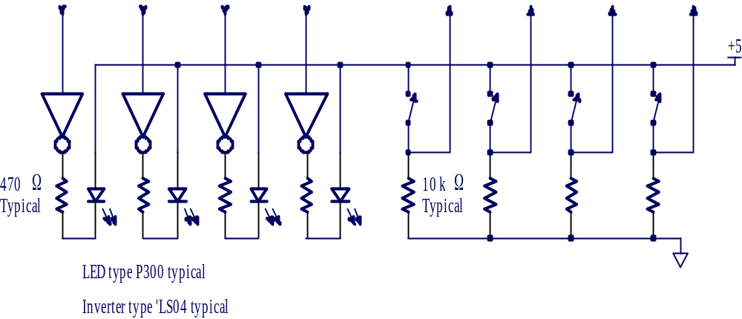
Figure 3, A circuit for the INVERTER user program.

