Since 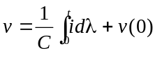and v(0) = 0,

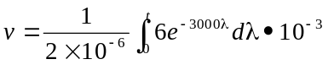

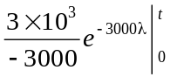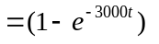 V

Since 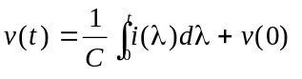and v(0) = 0,

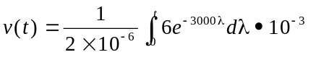

V

