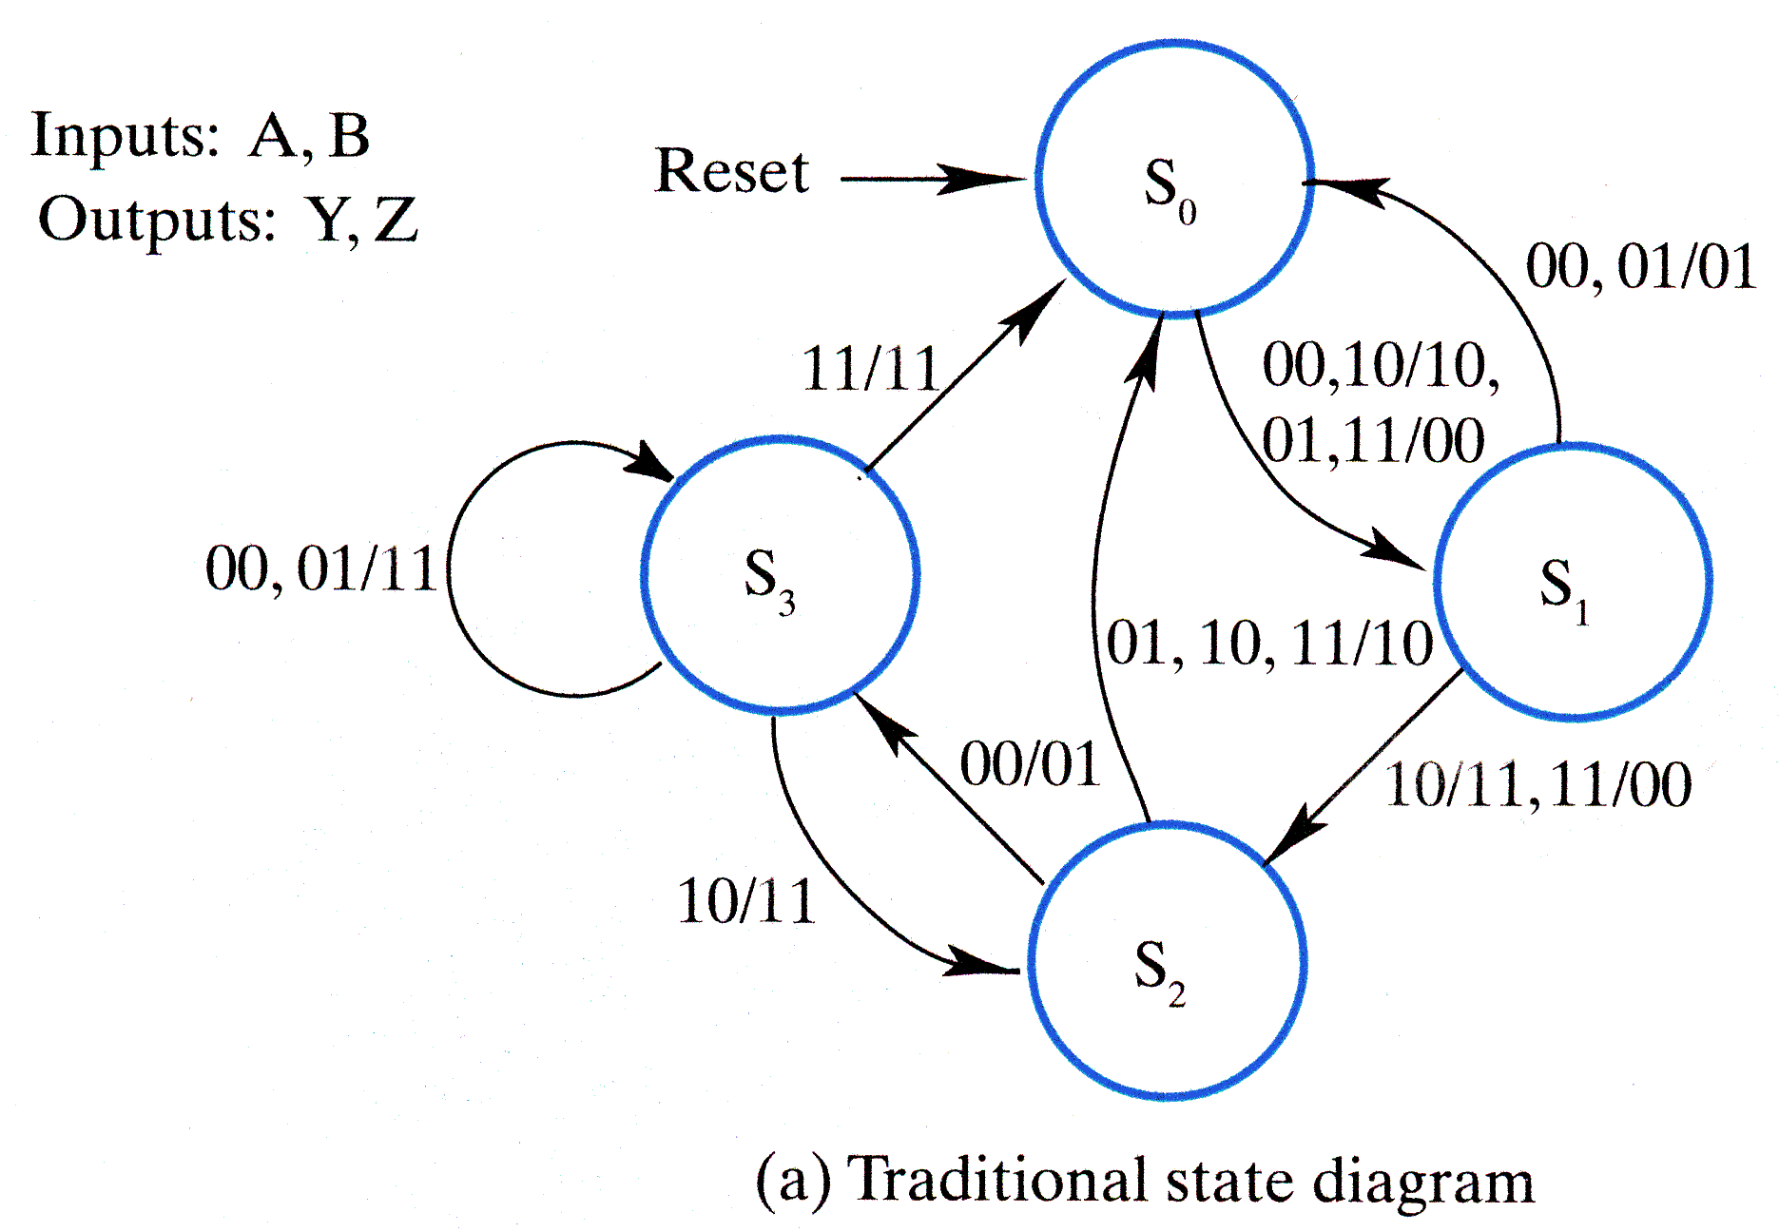

Suggestion: Print this page, then. . .
cut all the way across the page just below the figure and again just above the figure.
Then cut off excess paper about 2 inches to the right of the figure.
Open your text to page 251. Tuck the left edge of the corrected figure into the margin to lay the corrected figure over the incorrect figure. The correction will stay in place due to friction in the binding.

