Render the equations by viewing at 150% zoom, screen capture, GIMP to adjust “curve”, Irfanview to save with transparent background.

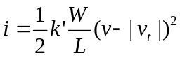

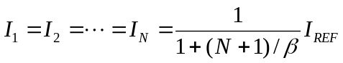

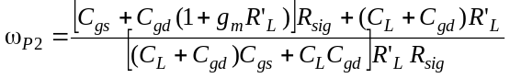 (6.67)

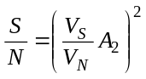 (8.15)

