1 Plot voltage vs. time of the Tx line in RS-232  for sending this text: "Z#" (without the quotation marks,   
with a capital "Z"). Assume ±12 V signal voltages, 53 kbaud, eight data bits, and one stop bit. Be sure to   
label your axes properly. An ASCII table can be found in many places, e.g. <http://www.asciitable.com>   
Note that the illustration in the Wikipedia reading does not have properly labeled axes. Specifically, the   
independent axis lacks scale and units.

10/10

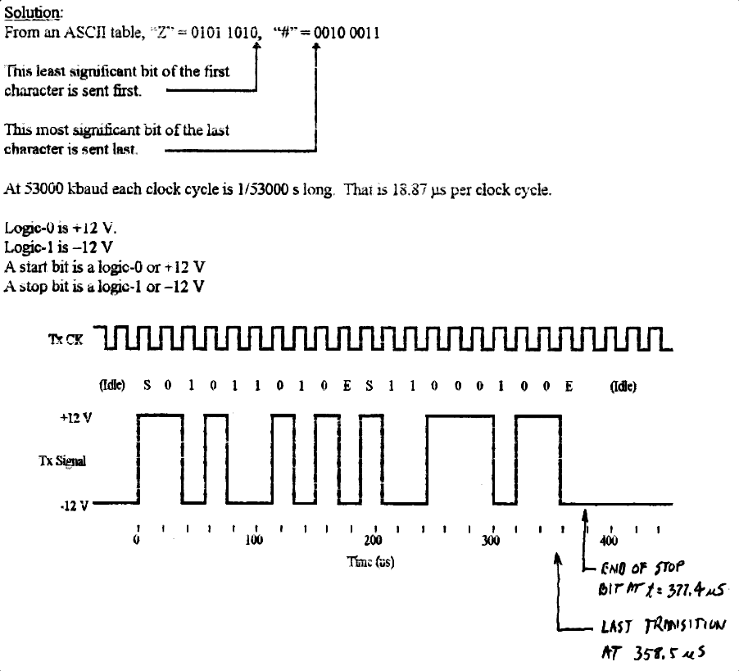

10/10