dDB’s notes on the sermon delivered by Jim Lucas   
October 2, 2022, referenced as “Affirmation Sunday.”

Sermon Title:

**What’s Live-Giving?  
(Jesus’ Hermeneutic)**

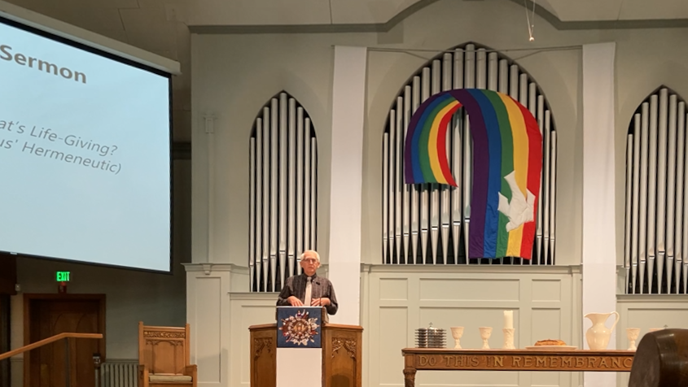

**Prayer for Illumination**: [A plea for the Holy Spirit to open our hearts to receive the Word.]

**Scripture**: Luke 6:6-11, Jesus heals a man’s hand on the Sabbath in the presence of disapproving Pharisees.

**Introductory remarks**: Thanks for the invitation to preach on this “historic occasion.” Sets the table by stating that in the text Jesus articulates a Biblical hermeneutic. This particular hermeneutic is “pivotal” for him.

**Personal Life-Story**: States that he grew up in a normal CRC household, and that he was a “good kid”—good grades, serious demeanor. [Possible Implication: A was a bit of a social outsider?] Felt called to be a pastor but became disturbed when he felt homosexual urges as a college student.

He feels “tormented and traumatized.” He prayed for God to heal him. Felt at first that God did not answer. Became depressed.

**A Personal Breakthrough**: A lecture titled “Homosexuality: Homophobia and Healing” at Calvin was the first time he met people he found thoughtful and compassionate toward gay people. The salient points of the lecture for him: 1.) Homosexuality was removed from the APA’s list of mental disorders. 2.) Scholars now have concluded that the Bible has been misinterpreted throughout history up to about now. His hope grew. He started feeling OK to, “be who I am.”

Two key points of the new scholarship: 1.) Biblical passages about male-female relationships are *descriptive*, not *prescriptive* (his emphasis). The Bible offers notable exceptions of people who do not live in male-female relationship: Jesus, Paul, the Ethiopian eunuch, etc. 2.) The few texts that speak negatively about same-sex relationships are not about homosexuality as we know it today. They are about abusive relationships that sometimes happen to be same-sex. These texts do not relate to “loving faithful [gay] marriages.”

**His Personal** **Reification** of the New Scholarship: Initially he had doubts about the new scholarship. Wondered if he was just trying to justify sinful desires. But the new scholarship felt so *life-giving*. (his emphasis) John 10:10 [Thieves kill and destroy, Christ came to give abundant life.] gave assurance that seeking this life-giving scholarship was a good thing to do. He that Jesus was answering his prayers via this new way of interpreting the Bible.

**A Biblical Example** of the New Scholarship in action: In Luke 6 the Pharisees use a technique of “*building a fence around the law*” (his emphasis). The Bible does not forbid healing on the Sabbath. It forbids working on the Sabbath, and just in case healing requires work, the Pharisees forbid healing on the Sabbath. [Possible implication: Is requiring marriage to be M-F a fence around a less restrictive Biblical law?] Jesus recognizes the sincerity and devotion of the Pharisees. But Jesus does ask point-blank, “What is lawful?” and then he proceeds to heal on the Sabbath. The life-giving nature of his action puts the Pharisees in an impossible predicament. They can’t chastise Jesus after he has done such obvious good.

**Contemporary Application**: Our society’s condemnation of LGBTQ+ people has been disruptive. It is “obvious” that an affirming approach is “life-giving and literally life-saving.” ***Jesus’ hermeneutic in Luke 6:6-11 is to ask, “What is life-giving.”*** (My emphasis: I take this as the thesis of this sermon.) Jesus came to set free those whom society is oppressing.

**Connection of the Hermeneutic to the Entire Bible**: The Bible is a story of how God wants people to flourish. The Hebrew word for this is “shalom.” What happens (in the Bible) when there is no shalom? God reaches out to humanity to re-establish shalom and all that is life-giving.

**Connection of the Hermeneutic to present culture**: What would be life-giving in the present LGBTQ+ community? Affirmation brings peace, brings families back into communion, ends suicidal ideation. What about the Church’s response? By God’s grace churches are becoming affirming. In the past the church has been tragically wrong.

**Personal Reflection on the Hermeneutic’s Influence in His Life**: Depression disappeared. He has a vibrant life with wonderful relationships. He has seen the same in the lives of others he has ministered. We now have examples of durable happy gay relationships that demonstrate shalom. The conclusion is unmistakable. Affirmation is life giving.

**Thanks to Eastern Ave. CRC**: For “listening deeply,” acknowledging past harms, and turning in a new direction. “I thank you for stating your full affirmation of LGBTQ+ people. . .” this is following the restorative work of Jesus in Luke 6. May God Bless.

(End of sermon.)