CorpTnE-Corporate Travel and Expense Management System

Version 1.0

TABLE OF CONTENTS

1. Introduction
1.1 Purpose ………………………………………………………………………………………………………………..…..
1.2 Scope Purpose
1.2.1 Basic Features…………………………………………………………………………………………....….
1.2.2 Additional Features ………………………………………………………………………………………
1.3 Definitions, Acronyms and Abbreviation………………………………………………………………….…
1.5 Technologies to be Used…………………………………………………………………………………………………….
1.6 Overview………………………………………………………………………………………………………………………
2. Overall Description
2.1 System Architecture…………………………………………………………………………………………………………
2.2 Software Interface …………………………………………………………………………………………………………….
2.3 Hardware Interface …………………………………………………………………………………………………………..
2.4 Product Functions…………………………………………………………………………………………………………….
2.5 User Characteristics ………………………………………………………………………………………………………….
2.6 Constraints ……………………………………………………………………………………………………………………….
2.7 Database Design ………………………………………………………………………………………………………………..
2.7.1 ER Diagram ………………………………………………………………………………………………………
2.7.2 Schema Diagram …………………………………………………………………………………………………

3. Specific Requirements
3.1 Character Specification
3.1.1 Admin…………………………………………………………………………………………………………
3.1.2 Employee…………………………………………………………………………………….………………..
3.1.3 Manager…………………………………………………………………………………….…………………
3.1.4 Finance Approver.
3.1.5 Travel Desk ……………………………………………………………………………………….………….
3.1.6 Travel Agent ………………………………………………………………………………………………………..
3.2 Use Case Reports
3.1.1 User Specific Requirements ………………………………………………………………………………..
3.2 Supplementary Requirements …………………………………………………………………………………………...

4. Future Enhancement
4.1 Future Enhancement……………………………………………………………………………………….

1. INTRODUCTION

CorpTnE - THE Travel Expense Management System is software designed to submit, process, reimburse, and track employee expenses. The software Designed with advanced options for travel which include getting the Best Available Quotation, approval of the quotation, booking the tickets and claiming other expenses with one request with enforcement of strong policy compliance.

Administrators can track expense reports, and enforce company policies for travel and expense, can set-up approval hierarchy and will be able to generate the reports of travel and expense on different criteria like monthly, yearly etc.

CorpTnE tool has three important aspects – the process an employee follows in order to book tickets , add the expense for the claim, the process where request go to Travel desk with different scenario with updated status and the approving manager and finance approver undertake to process the claim within the system.

CorpTnE can be expected to deliver time and cost saving by reducing travel and other expenses through policy rules and reminders and dramatically reducing the costs of processing expense claims.

1.1 PURPOSE
The basic purpose of the Travel and Expense management system software is to reduce the process cost and the time for employees of organization for claim their expense s associated with various aspect like Travel, Hotel stay and other general expense.

To Integrate Travel into your Expense, Drive cost efficiency, Ensure internal and regulatory compliance, Increase visibility into spending, minimize Fraud, Reinforce company policy to manage behavior, Stay Flexible and Scalable with automated bill submission and process integrated Solutions

1.2 SCOPE
Corporate business travel has been a long-term necessity in the greater scheme of organization growth; business travel is linked to effective customer development, supplier relationships on the global stage.

CorpTnE is effective Travel and Expense management tool to accelerate the process speed with its integrated modular design with travel Desk and different hierarchy level in the organization,

There are five types of users for this system
1. Admin
2. Employee
3. Manager
4. Finance approver
5. Travel Desk

Below are the Basic features which are carried out by the system

1.2.1 Basic Features:
Create different system users: Profiles for different users like Employee, Manager, Administrator, Backup Administrator, Finance department (Accountant) of this system will be created and managed

Authenticating different users on the system: Authentication of each and every user on the system using login id and password technique to keep the system safe from breach. These will be initially provided by the organization itself.

Delegate authority: The employee has the right to assign authority to his/her colleague in case he/she may not be present to submit the voucher on time and avail the amount claimed.

Multi-level workflow approval hierarchy: Based on the Employees department and designation, the vouchers flow to his supervisors for their approvals. The number of approvals required will vary according to total amount of the voucher and approval limits set for supervisors.

Elimination of fraud: The users will not be able to deceive the system software by claiming for vouchers once held in abeyance.

Maintain proper hierarchical organization with Real Time Updates: The administrator of the organization will have full fledged control of maintaining the hierarchical structure of the organization right from the grass root level. Also real time updating will be provided as per the promotions/demotions and changes in the working environment of the organization.

Specifying business purpose in the description section: The employee can specify the business purpose in the description section of the voucher to help the organization to accept it as a report header and classify their records.

Categorized Monetary limits: Each genre of predefined voucher will have a specified limit up to which the employee can claim a maximum amount. For claimable amount exceeding maximum amount the voucher claimed would be forwarded by manager to higher executive in the organizational hierarchy.

Case Management: Every voucher starts a new process instance (case). Managers are able to view vouchers waiting for their approval in their Inbox by logging in to the application. Employee is also able to track progress of his vouchers through the unique voucher id.

Rejection Flow: At any point in the workflow, managers have the option of rejecting any voucher stating appropriate reasons. Rejected vouchers come back to the Employee, who is then allowed to change details on the vouchers or provide additional information required for the approval.

Accounts View: Accounts department users are able to view approved vouchers of all employees and mark vouchers as paid. This step completes the lifecycle of the voucher and the associated process instance.

Email alerts: Automated email alerts will reach the users at specific stages of the process. E.g.:
When a voucher is sent, the manager will get an email notification about the review of the voucher sent by the employee. Similarly, when a voucher is approved an e-mail will be sent to the user to alert him about the same.

Keep the Employee’s satisfied: One of the most important aspects of any software system is to keep the users happy. Through the employee self-service portal, employees will be able to file for reimbursements. They will also be able to access compensation, whenever they’re updated.
Enhanced transparency lets employees understand what’s going on and keeps everyone abut. They can focus on what they do best instead of chasing and filing for claims.

Uploading Files: Uploading various files (pdf, doc, excel, txt) which may include scanned reports, receipts is allowed in the vouchers. This helps in speedy verification of expenses made by employee.

Report Generation: Following reports are included in the system:

- MIS Reports – MIS reports stating status of the vouchers
- Exception Reports – Reports providing the in depth details of the exception.
- Master data management – Creation of masters for Employee Hierarchy, setting approval limits etc.
- Employee Hierarchy View - View of Employee Hierarchy.
- Rejected vouchers report – Report listing vouchers rejected by Managers.
- Reports customizing the stored data in a platform independent format and displaying it using style sheets.
- Administrator is able to print data in reports in excel sheets and PDF formats.
- Administrator is able to make pictorial depiction of data in excel sheets for better understanding.

Managing different user profiles: Users can manage their respective profile. They can update or change or remove basic details from their profile but the major initial details will be managed by the Administrator

Voucher Entry: Forms for entering expense vouchers for any reimbursable expenses borne by the employee. A voucher should have one header and multiple lines providing detailed information of expenses incurred along with amounts.

Ease of Use: Interface is designed so as to allow ease of use, even for inexperienced user. Help menu and user guides ensure that no formal training is required

1.3 DEFINITIONS, ACRONYMS AND ABBREVATIONS

- Employee: The basic fundamental user of the system for whom the system has been designed. The entire process of creating a voucher right up to submitting a voucher to claim the expenses is an integral part of the employee’s job. The employee can also track the progress of his voucher.
- Approver-Manager(Hierarchically above employee) : Any user having the hierarchical placement above an employee will be considered as a manager and has the right to claim a voucher as well as review vouchers sent by employees for approval.
- Finance: The user who is logged in as the Finance has the privilege of approving/rejecting those vouchers forwarded by the approval-manager under certain circumstances as stated in the policy made by the organization. Although he cannot claim a voucher through the system interface.
- Administrator: The job of defining the hierarchical structure of the organization and also stating the expense limits on all genre of vouchers rests with the administrator. The administrator also has the rights for managing the departments, updating policy and other expense related.
- Travel Desk: Travel Desk is a user of system who is able to book tickets for travel/accommodation , he refers the request from the employee to process the booking.
- HTML/HTML 5: Hyper Text Mark-up Language to create static web pages.
- PHP: is a scripting Language that helps make WebPages more interactive by allowing them to do more things.
- CSS 3: Cascading Style Sheets (CSS) is a style sheet language used for describing the look and formatting of a document written in a markup language.
- Java Script: JavaScript is the programming language of HTML and the Web.
- J-Query: it is a fast, small, and feature-rich JavaScript library. It makes things HTML document traversal and manipulation, event handling, animation, and Ajax much simpler with an easy-to-use API that works across a multitude of browsers. With a combination of versatility and extensibility.
- JSon: It is an open standard format that uses human-readable text to transmit data objects. It is used primarily to transmit data between a server and web application, as an alternative to XML.
- XML: Extensive Mark-up Language used for data transfer.
- AJAX (Asynchronous Java and XML): It is a technique used in java script to create dynamic
Web pages.
- MySql: MySql is the database management system that provides flexible and efficient database platform to erect strong on demand business applications.
HTTP: Hypertext transfer protocol is a transaction oriented client/server protocol between web browser and a web server.

1.5 TECHNOLOGIES TO BE USED

HTML –Hyper Text Markup Language
PHP - Hyper Text Pre-Processor
CSS - Cascading Style Sheets
Json: Java Script Object Notation
JSP: Java Server Page
JavaScript- Scripting Language
XML – Extensive Markup Language
AJAX- Asynchronous java and XML
MySql- Database
UML – Unified modeling Language

1.6 OVERVIEW

Overall Description: This section will describe major components of the system, interconnections and external interfaces.
Specific Requirements: This section will define the function of actors, the role they play in the system and the constraints faced by the system.

2. OVERALL DESCRIPTION

2.1 System Architecture
The CorpTnE tool provide the platform for employee to raise the Expense Request , the request is may be of three kind , pre-travel budget, post-travel claim, other expense , the work flow for each process is pre-defined by the administrator .
The workflow is the approval hierarchy, the hierarchy level are designed based on the designation of the employee and is also able to delegate the approval authority whenever required, based on the workflow chart, the Request will be redirect to the concern level like manager approval and finance approval.

The claim settlement process done by the finance after all the required approvals, if there is any description required on the request then all the modules all designed with communication bar, through which they can quote there comment on the specific request which give the quick and transparent communication among all.

Travel desk option is provide for Pre-travel request and the Group Travel Request where employee can access the real-time fares regarding journey/stay and sent quotation to the approval and by ref. that quotation Travel desk will book the tickets with considering the tolerance limit of each.

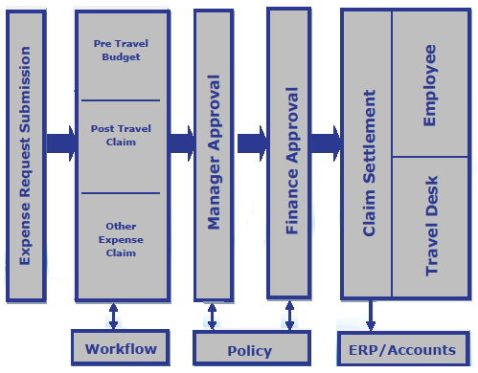

Figure 1. System Architecture

2.2 SOFTWARE INTERFACE
Front End Client:
Web browser (Any)
Operating System (Any)

Web server
Linux and Apache tom-cat server

Development End
Html, CSS3,
PHP
Adobe Dreamweaver
Windows/Linux Operating System

Database System
MySql, XML

2.3 HARDWARE INTERFACE

CLIENT SIDE
IE 8 and above, Mozilla Firefox, Google Chrom, Opera, Epics etc. | Processor | RAM | Disk Space
 | Pentium IV and above | 512 MB and above | 20GB and above
SERVER SIDE
Web Sphere  Application Server | Pentium IV and above | 2GB and above | 100GB and above
MySql | Pentium IV and above | 512MB and above | 2GB (Excluding  Data size)

2.4 PRODUCT FUNCTIONS
The administrator has the superlative authority to define the hierarchical structure of the organization.
The Three main actors (Employee, Manager and Finance approver) have to go through the common process of login for authorization. Once logged in, they have various options from viewing/updating profiles, raising new voucher, editing the existing voucher, and sending it for the approval, upload files and track progress of voucher.
The Manager, finance approver or an employee belonging to a hierarchical level above the employee can review a voucher, manually check the details and if feel any description can ask for it vie communication bar and have authority to reject it with or without stating reason for disapproval.

Throughout the entire process, the Executive can track the progress of any voucher and approve/disapprove it at any stage. The finance department (accountant) will finally get the voucher and the claimable amount is send to the employee with an e-mail notification stating the same message.
Financial reports will be generated by the administrator when required by the organization to study the financial status of the organization.

2.5 USER CHARACTERISTICS

- Every user should be comfortable of working with computer and net browsing.
- He must have basic knowledge of English.

DATABASE DESIGN

ER DIAGRAM

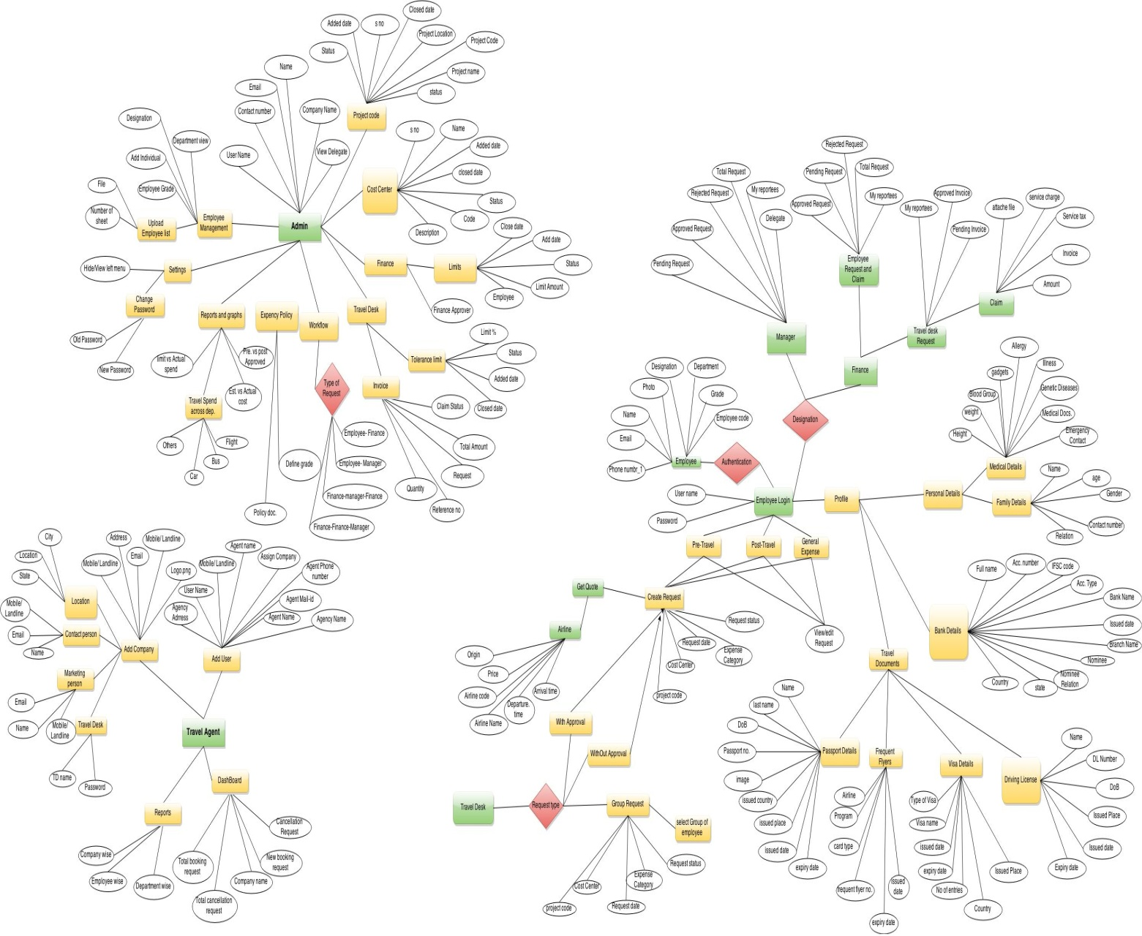

Figure 2. Entity Relation Model
2. SCHEMA DIAGRAM

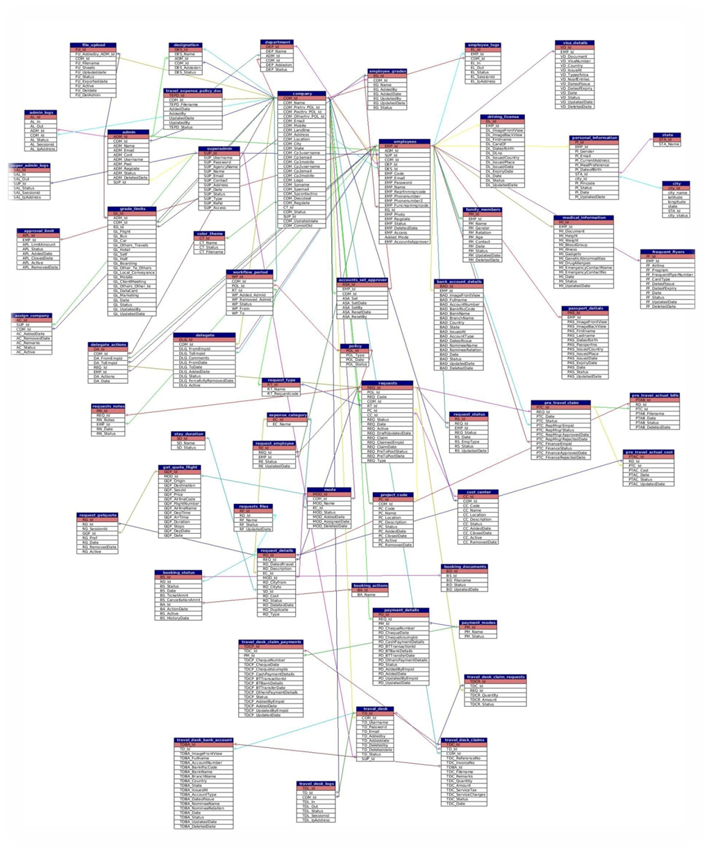

Figure Schema Diagram

ASSUMPTIONS AND DEPENDENCIES
The end user should have a basic knowledge of English and computer usage.
Administrator is created in the system already.

Roles and tasks are predefined.
User id and initial password are provided by the organization.

3. SPECIFIC REQUIREMENTS

3.1 USE CASE REPORTS:
Actors
The System caters to the following users
- Admin
- Employee
- Manager
- Finance-Approver
- Travel Desk

Admin:
Admin is one of the major parts of the system. Admin is the only authorized person who can control the complete activity from one end, he can set the grade level, authorization power

Key Feature Available for Admin:

- Add/remove employee
- Block employee
- Define Travel budget for each Department / Units**
- Define Work flow
- Set finance approver
- Employee Grade
- Account Creation
- Reports and Analytics
- Define Travel & Expense Policy
- Define Budget limits **

Add/Remove Employee
Admin can add list of employee of organization to the CorpTnE system, and if required can remove from system.

Block Employee:
Admin can block any user of the system, if he block then employee will not be able to use his CorpTnE account.

Work Flow:
Work flow is a systematic arrangement for request redirection,
There are four different work flow used here and they are
- Employee-Approver-finance
- Employee-Finance-Approver
- Employee-Approver
- Employee-Finance
Admin will set work flow for each category of Request i.e Pre-Travel Request, Post-travel Request, General request ,
And according to work flow the Request will redirect for approval
Set Finance approver
Admin can set any employee as finance approver, along with that he can set the approval limit so that the approval will be authorized to approve the up to his/her limit .

Employee Grade
Admin is authorized person to set the grade for all employees in the system, whenever it required he can change any employee grade in the system.

Travel Desk Account
Admin can Create and delete the Travel desk account.

Reports and Visibility
Admin can generate Detailed report, can drill down by relevant business wise or
Can Generate annual/monthly Report on different criteria and sort them by department wise, Request category, and compression between each other.
Ex. Estimated Cost Vs Actual Cost, Pre-approved travel Vs Post-approved travel

Employee:
Employee is the Basic module of the system with integration of unique features and they are common for all other module, to use this employee need to have authorized and verified user name and password, which he will get once the administrator of the system insert his/her details in Main system database, System will Send generate and send a mail with unique username and password for each employee.

Key Feature Available for employee:
- Pre-Travel Request.
- Post-Travel
- General Expense Request.
- Reports.

Pre-Travel Request
Request raised by employee for pre-travel/booking Approval from approving manager is a Pre-travel request. Here Employee is able to generate Request with Live Quotation for his/her travel and accommodation Expense in prior of the journey, the request goes to concerned approving manager for approval. Where he can approve /reject the request if feels any other description or files to be needed then he will communicate vie Note Bar available at bottom of the window.
Once the Request approved/Reject from the approver, employee will get notification mail with status. If its approved employee can go for self-booking option where he /she will be able to book tickets with own and need to attach tickets wherever it required, else can send request to travel desk to book the tickets, where they will refer the quotation attached by employee and book the tickets with consideration of Grade facility limitation and Fare Tolerance Limit on quotation for respective the employee.
After journey employee need to update the bills to claim the expense to the same request id, which will again follow the workflow hierarchy and finally employee will get his claims.

Post-Travel Request
Request raised by employee for claiming the expense amount after the journey is called post-travel request. Here employee will Raise Request after the travel , he can add all expense like travel , accommodation and any other expense list to the same voucher. It necessary to attach the bills along with the request. Once the request has been raised, it will redirect it to the concern level for approval according to workflow and once approved, finance manager will settle the claim, and if it’s reject for any reason then he/she can update the same voucher, and send it back for claim.
General Expense Request:
The Employee is able to raise request to claim any general expense like marketing expense, local convey, mobile bills, data card bills etc, here employee need to attach bills along with request. System will redirect the request to concern person for approval, once it get approve then finance team will pay the claim amount.

Reports:
The system will generate the sorted , claimed expense report for the employee, where he can filter the report by year-wise , month wise, each category of expense will be generate separate report .

Manager/Approver:
Manager contain all the basic feature of the employee module , here manager is a level above the employee in grade , who is having Request Approval authority of his Reportees who are level bellow in grade , he will verify the request raised by his reportees and wherever its applicable he will update the request as approved/reject. If employee updates his request after manager approval then again the request will come to his end for re-approval of the updated request.

Key Feature Available
- Approval
- Delegate

Approval:
Request Raised by the employee like pre-travel, general expense request will come to manager for approval, here manager will verify the request, bills attached to it and the Quotation marked by the employee and approve it, if any extra description need, bills are not correct then he can reject the request, the status for the will be updated to all employee.

Delegate:
Here manager can delegate his approving authority to any other manager for particular time; during delegation period delegate person can view the entire request and can be able to approve/reject it. During delegation period, whenever it required manager can login with his normal credential and can cancel the delegation, and resume back his approval authority.

Finance Approver:
Finance Approver is one of the central principles of authorization in the system for any financial Approval/Decision. Finance approver means for each Request/Voucher, There Must be at least once individuals necessary for the review. Depending on the work flow the request he will get the Request and review it and will approve the voucher.
There must be at least two finance approver in the organization, each finance approver will be having approval limits, which has already decided by the admin, he is not authorized approve /reject the request beyond the approval limit

Key Feature Available Finance Dashboard
- Employee’s travel & Expense Request
- Travel Desk claims
- Travel Desk claims – dashboard
- Review / Approve Expense Request
- Review Bills & Claims Make Payments & Reconciliations

Employee’s travel & Expense Request:
This Dash board consist of the all Request generated by employee, and Finance approver sort request by pending, approved, rejected request separately. Here finance approver need to approve the voucher, he will manually check the bills and match with the quotation, if request matches all criteria then he will approve it.

Travel Desk claims:
Travel Desk dash board consist of the all invoice generated by the Travel desk for travel Desk claim. Here invoice consist of one or more Request/Voucher, generated by employee or Travel Desk. Vouchers need to approve first then it will be settled by the finance approver.

Travel Desk
The Travel Desk is unique feature attached to the system, which required maintaining considerable information of the employees, their passports, and visa related information, traveling information etc. When a new employee joins into the company his information is stored in the database by admin. Whenever there is request from employee for travel or accommodation, he will book the tickets with quoted amount (with consideration of tolerance limit).
Travel desk can book ticket without request generated by the employee, whenever it required TD can directly book tickets for employee (on request vie email or call).

Key Feature Available
- Request with approval.
- Request without approval.
- Group request.

Request with approval:
Here Travel desk will raise request for travel or accommodation on behalf of employee and that request will follow the approval hierarchy , once it get approve Travel desk will book the tickets and employee will get notification of confirmation of his/her booking . Here if there is any extra expense needs to add by the employee then he can add it to the same request and claim the amount, no need to generate separate request.

Request without approval:
Here Travel desk will book the tickets on behalf of employee , which is not required any approval ,but if there is any extra expense added by employee to the same request then it will redirect for the approval , once it get approve with all level, finance team will settle the claim.

Group request:
Here on request Travel desk will raise request and book ticket for group of employees. The voucher will directly go to finance approval and will settled from there.

Travel Agent:

Travel agent is a private retailer who provides travel and tourism related services to the Company employees on behalf of suppliers such as airlines, car rentals, hotels, railways, and package tours. Travel Agents can add new company name in its list along with can create company specific travel desk.

In CorpTnE, Super admin is the only person who can create the Travel agent and Travel agent will take care of booking and cancelling the travel/hotel tickets on request.

Key Feature Available

- Company Management.
- User Management.
- Reports***

Company Management:
Travel Agent is the person who can create the new company profile along with Travel Desk account. Once he create the new company profile that will be updated CorpTnE System and company will get profile creation notification mail from CorpTnE.

CorpTnE support team creates Admin for the newly created company from Travel Agent and along with that CorpTnE system has right to modify/delete the company created by Travel agent.

User Management:
Travel Agent can create any number of Travel desks and travel desk itself is user here. Once the new user creates by Travel agent, user will welcome along with login credentials to the CorpTnE as travel desk. Here travel desk can have more than one company.

3.1 .1 USER SPECIFIC REQUIREMENTS
NAME | Pre-Travel Request
Description | Raise request for Travel
Actors | Employee
Pre Condition | 1. Actor must be logged in to the System.  2. Actor must have sufficient privilege to add Entry.
Basic Path | 1. User navigates through the front End Login page.  2. User will log in successfully.  3.click on Pre-Travel request→ Create Request  4. System displays a form to capture following details.
Basic Path |  | Form  Field | Type | Unique | Requirements | Conditions
Basic Path |  | Date | Date  Picker | No | Yes | --
Basic Path |  | Expense Description | Text Area | No | Yes | --
Basic Path |  | Expense Category | Dropdown list | No | Yes | --
Basic Path |  | Expense sub-Category. | Dropdown list | No | Yes | 1.for accommodation Category select stay duration from dropdown list
Basic Path |  | City/Location | Text Area | No | Yes | --
Basic Path |  | Estimated Cost | Text Area | No | Yes | Auto filled if select Get-Quote
Basic Path |  | Get Quote | Get Quote- Button | No | No | Select for travel and accommodation
Basic Path | 6. User will enter all the information properly  7. User click on Submit button  8. System saves data and creates new Entry in respective  Employee Account with Unique Request/Voucher Id  9. System refreshes the changes and reflects the changes.
Alternate Path | Travel Desk can generate pre-travel Request on employee Request.
Exceptions | If employee doesn’t provide any details properly then it would not proceed further until user provides correct information.
Business Validation/Rules
Post Condition | Actor will get Unique Request Id along with notification message  have successfully added . You have successfully added a Pre Travel Expense Request  Your Req Code: PRE1041510747  Please wait for approval..
NAME | Post-Travel Request
Description | Raise Voucher for claim
Actors | Employee
Pre Condition | 1. Actor must be logged in to the System.  2. Actor must have sufficient privilege to add Entry.
Basic Path | 1. User navigates through the front End Login page.  2. User will log in successfully.  3.click on Post-Travel request→ Create Request  4. System displays a form to capture following details.
Basic Path |  | Form  Field | Type | Unique | Requirements | Conditions
Basic Path |  | Date | Date  Picker | No | Yes | --
Basic Path |  | Expense Description | Text Area | No | Yes | --
Basic Path |  | Expense Category | Dropdown list | No | Yes | --
Basic Path |  | Expense sub-Category. | Dropdown list | No | Yes | 1.for accommodation Category select stay duration from dropdown list
Basic Path |  | City/Location | Text Area | No | Yes | --
Basic Path |  | Total Cost | Text Area | No | Yes | One numeric’s allowed
Basic Path |  | Bills/tickets | Choose file | No | No | --
Basic Path | 6. User will enter all the information properly  7. User click on Submit button  8. System saves data and creates new Entry in respective  Employee Account with Unique Request/Voucher Id  9. System refreshes the changes and reflects the changes.
Alternate Path | N/A
Exceptions | If employee doesn’t provide any details properly then it would not proceed further until user provides correct information.
Business Validation/Rules
Post Condition | Actor will get Unique Request Id along with notification message  have successfully added . You have successfully added a Pre Travel Expense Request  Your Req Code: PRE1041510747  Please wait for approval..

NAME | General Expense Request
Description | General expense Request for claim
Actors | Employee
Pre Condition | 1. Actor must be logged in to the System.  2. Actor must have sufficient privilege to add Entry.
Basic Path | 1. User navigates through the front End Login page.  2. User will log in successfully.  3.click on General Expense request→ Create Request  4. System displays a form to capture following details.
Basic Path |  | Form  Field | Type | Unique | Requirements | Conditions
Basic Path |  | Date | Date  Picker | No | Yes | --
Basic Path |  | Expense Description | Text Area | No | Yes | --
Basic Path |  | Expense Category | Dropdown list | No | Yes | --
Basic Path |  | Total Cost | Text Area | No | Yes | One numeric’s allowed
Basic Path |  | Upload Bills | Choose file | No | No | --
Basic Path | 6. User will enter all the information properly  7. User click on Submit button  8. System saves data and creates new Entry in respective  Employee Account with Unique Request/Voucher Id  9. System refreshes the changes and reflects the changes.
Alternate Path | N/A
Exceptions | If employee doesn’t provide any details properly then it would not proceed further until user provides correct information.
Business Validation/Rules
Post Condition | Actor will get Unique Request Id along with notification message  have successfully added . You have successfully added a Pre Travel Expense Request  Your Req Code: PRE1041510747  Please wait for approval..

NAME | Request without approval
Description | Raise request for Travel
Actors | Travel Desk
Pre Condition | 1. Actor must be logged in to the System.  2. Actor must have sufficient privilege to add Entry.
Basic Path | 1. User navigates through the front End Login page.  2. User will log in successfully.  3.click on Request without approval→Create Request  4. select employee from employee dropdown list  4. System displays a form to capture following details.
Basic Path |  | Form  Field | Type | Unique |  | Requirements |  | Conditions
Basic Path |  | Date | Date  Picker | No |  | Yes |  | --
Basic Path |  | Expense Description | Text Area | No |  | Yes |  | --
Basic Path |  | Expense Category | Dropdown list | No |  | Yes |  | --
Basic Path |  | Expense sub-Category. | Dropdown list | No |  | Yes |  | 1.for accommodation Category select stay duration from dropdown list
Basic Path |  | Place | Text Area | No |  | Yes |  | For travel select both FROM and TO place.  For accommodation select stay duration
Basic Path |  | Total Cost | Text Area | No |  | Yes |  | Only numeric’s allowed
Basic Path |  | Bills/tickets | Choose file | No |  | Yes |  | --
Basic Path | 6. User will enter all the information properly  7. User click on Submit button  8. System saves data and creates new Entry in respective  Employee Account with Unique Request/Voucher Id  9. System refreshes the changes and reflects the changes.
Alternate Path | N/A
Exceptions | Employee should communicate to travel Desk directly vie mail or call to book ticket.
Business Validation/Rules
Post Condition | Tickets booked by Travel desk
NAME | Request With approval
Description | Raise request for Travel
Actors | Travel Desk
Pre Condition | 1. Actor must be logged in to the System.  2. Actor must have sufficient privilege to add Entry.
Basic Path | 1. User navigates through the front End Login page.  2. User will log in successfully.  3.click on Request with approval→Create Request  4. select employee from employee dropdown list  4. System displays a form to capture following details.
Basic Path |  | Form  Field | Type | Unique |  |  | Requirements |  |  | Conditions
Basic Path |  | Date | Date  Picker | No |  |  | Yes |  |  | --
Basic Path |  | Expense Description | Text Area | No |  |  | Yes |  |  | --
Basic Path |  | Expense Category | Dropdown list | No |  |  | Yes |  |  | --
Basic Path |  | Expense sub-Category. | Dropdown list | No |  |  | Yes |  |  | 1.for accommodation Category select stay duration from dropdown list
Basic Path |  | Place | Text Area | No |  |  | Yes |  |  | For travel select both FROM and TO place.  For accommodation select stay duration
Basic Path |  | Estimated Cost | Text Area | No |  |  | Yes |  |  | Only numeric’s allowed
Basic Path |  | Get Quote | Get Quote- Button | No |  |  | No |  |  | Select for travel and accommodation
Basic Path | 6. User will enter all the information properly  7. User click on Submit button  8. System saves data and creates new Entry in respective  Employee Account with Unique Request/Voucher Id  9. System refreshes the changes and reflects the changes.
Alternate Path | N/A
Exceptions | Employee should communicate to travel Desk directly via mail or call to book ticket.
Business Validation/Rules
Post Condition | Ticket will be booked by travel Desk with unique request id, and will redirect the request according to Travel Desk WORK-FLOW
NAME | Group Request
Description | Raise group request for Travel
Actors | Travel Desk
Pre Condition | 1. Actor must be logged in to the System.  2. Actor must have sufficient privilege to add Entry.
Basic Path | 1. User navigates through the front End Login page.  2. User will log in successfully.  3.click on Group Request→Create Request  4. select employee’s(min. 2) from employee dropdown list  4. System displays a form to capture following details.
Basic Path |  | Form  Field | Type | Unique | Requirements |  |  |  | Conditions
Basic Path |  | Date | Date  Picker | No | Yes |  |  |  | --
Basic Path |  | Expense Description | Text Area | No | Yes |  |  |  | --
Basic Path |  | Expense Category | Dropdown list | No | Yes |  |  |  | --
Basic Path |  | Expense sub- Category | Dropdown list | No | Yes |  |  |  | 1.for accommodation Category select stay duration from dropdown list
Basic Path |  | Place | Text Area | No | Yes |  |  |  | For travel select both From and To place.  For accommodation select stay duration
Basic Path |  | Unit Cost | Text Area | No | Yes |  |  |  | Only numeric’s allowed
Basic Path |  | Estimated Cost | Auto-fill | No | Yes |  |  |  | Auto-fill area
Basic Path |  | Bills/tickets | Choose file | No | Yes |  |  |  | --
Basic Path | 6. User will enter all the information properly  7. User click on Submit button  8. System saves data and creates new Entry in respective  Employee Account with Unique Request/Voucher Id  9. System refreshes the changes and reflects the changes.
Alternate Path | N/A
Business Validation/Rules
Post Condition | Ticket will be booked by travel Desk with unique request id, and will redirect the request according to Travel Desk WORK-FLOW

NAME | Rejection Flow
Description | It is used to send rejected voucher to the employee.
Actors | Manager(of particular hierarchy)
Pre Condition | 1. Manager must log in to the System.  2. Manager will Access the voucher.
Basic Path | 1. First Manager of a particular hierarchy in going to log in to the system.  2. Then Manager will open his/her main window where the pending approvals are present.  3. Here Manager will be getting the notifications from lower level hierarchy Members.  4. If Manager feels that data provided by lower level employees is inappropriate then he will reject that particular Voucher stating appropriate reason.
Alternate Path | N/A
Exceptions | -
Business Validation/Rules
Post Condition | Voucher has been rejected and notification has been given to that Particular Employee.

NAME | Set Delegate
Description | Creating Manager Delegate with Time Period
Actors | Manager/Approver
Pre Condition | 1. Actor must be logged in to the System.  2. Actor must have sufficient privilege to add Entry.
Basic Path | 1. User navigates through the front End Login page.  2. User will log in successfully.  3.click on Delegate→Set delegate  4. select delegate person from Reporting Managers dropdown list  5. Select Date range, both From and To date.  6. write comments for the delegation to delegate person
Alternate Path | N/A
Exceptions | ----
Business Validation/Rules | ----
Post Condition | All his Managerial approving authority will go to Delegate for mentioned duration, whenever Required can withdraw it.

NAME | Manager Review/Approve a voucher
Description | To review Voucher for approval
Actors | Manager(under particular hierarchy)
Pre Condition | Hierarchical level must be above an employee and all field conditions must be satisfied under all Conditions.
Basic Path | 1. First Manager of a particular hierarchy head is logs into the System.  2. Select Request for My Approval→ Pending Request  3. Select the Request from the list  3. The Manager will check details manually.  4. Based on the Condition, Manager will approve  /reject voucher because of some reason  5.Notification send to lower hierarchy user regarding  and status(Application accepted/rejected)
Alternate Path | N/A
Exceptions | -
Business Validation/Rules | ---
Post Condition | - Request approved  Request will Redirect to the the next level approval (ex. Finance) or to Travel Desk to book the Tickets

NAME |  |  | Generating the Report
Description |  |  | The Manager is going to generate a report for better understanding.
Actors |  |  | Administrator, Manager
Pre Condition |  |  | 1. Administrator logs in to the system successfully.  2. Administrator after assessing all the data generates reports for specific set of results
Basic Path |  |  | 1. Administrator logs in to the system successfully.  2. System displays the generate reports as one of  The option.  3. Administrator clicks on it for getting any kind of specific data as required.  4. This Report gives the brief description to  Administrator about a Particular voucher.  5. These reports are printed if required.
Alternate Path |  |  | N/A
Exceptions
Business Validation/Rules
Post Condition |  |  | Generate report has taken place successfully.
NAME | Upload Employee list
Description | Upload the group of employee details at a time
Actors | Admin
Pre Condition | 1. Actor must be logged in to the System.  2. Actor must have sufficient privilege to add Entry.
Basic Path | 1. User navigates through the front End Login page.  2. User will log in successfully.  3.click on Employee Management→Upload Employee List  4. Download the excel format and enter all the details accordingly.  5. The table form to capture following details.
Basic Path |  | Form  Field |  | Type | Unique | Requirements | Conditions
Basic Path |  | Employee code |  | --- | Yes | Yes | --
Basic Path |  | Name |  | --- | No | Yes | ---
Basic Path |  | Email ID |  | --- | Yes | Yes | Should be active mail Id
Basic Path |  | Department |  | Text Area | No | Yes | Mention employee designated dept.
Basic Path |  | Reporting Manager |  | Employee id | No | Yes | Level should be high in company hierarchy
Basic Path |  | Mobile number |  | Numeric | No | Yes | --
Basic Path |  | Landline |  | Numeric | No | Yes | If not then enter same mobile number
Basic Path |  | Designation |  | Text area | No | Yes | ---
Basic Path |  | Functional RM |  | Emp. Code | No | Yes | ---
Basic Path |  | Grade |  | --- | No | Yes | ---
Basic Path | 6. All fields in the chart are mandatory , enter all the information properly  7. Entering data in Multiple sheets are allowed.  8. Select the file and select no. of sheets to be uploaded from the file.  9. Select Submit, System refreshes employee list by adding new employee list to database.
Exceptions | --
Business Validation/Rules
Post Condition | All employees will be added to CorpTnE Database and will get their respective Login Credentials to the mentioned Email-id.
3.2 SUPPLEMENTARY REQUIREMENT

- Secure access of confidential data (user’s details). SSL can be used: SSL is the backbone of our secure Internet and it protects your sensitive information as it travels across the world. It keeps the Internet from being ruled by anarchists and criminals and provides many direct benefits to all the users.
- 24x7 Availability: If the base is now the entire world, staying open 24 hours a day becomes critical. Because system can be an automated Process, so it can stay open for 24 hours a day. So UPS support must be on server site for at least 8 hours in case of power failure.
- Better Component Design to get better Performance at PEAK time: This involves better understanding by the developer of the system. A properly designed system helps in elaborating and understanding refined aspects of system. System development becomes efficient. A well designed system also helps in early detection of problems in critical areas, if any. An error free system saves development time since it helps in understanding without any discussion. Better quality of reporting formats. Modifications can be made easily in the system. Little maintenance is required in the operations phase.
- Flexible service based Architecture: SOA allows creating new applications on top of existing enterprise solutions, increasing the value of the current systems and automating new processes. This results in faster implementations and more cost-effective upgrades.

4. Future Enhancement

Corp TnE Product – Future Enhancement

- Mobile App (iOS, Android, Windows )

- ERP Integration

- Expense Requests Via Email & SMS

- Receipt Management / Document Repository

- Bank Account & Credit Card Integration

- Utility Bill Integration

- Preferred Airlines & Hotels

- Self Booking Tool Integration

- Multiple OTA / Supplier integration with CorpTnE.

- Itinerary Management

