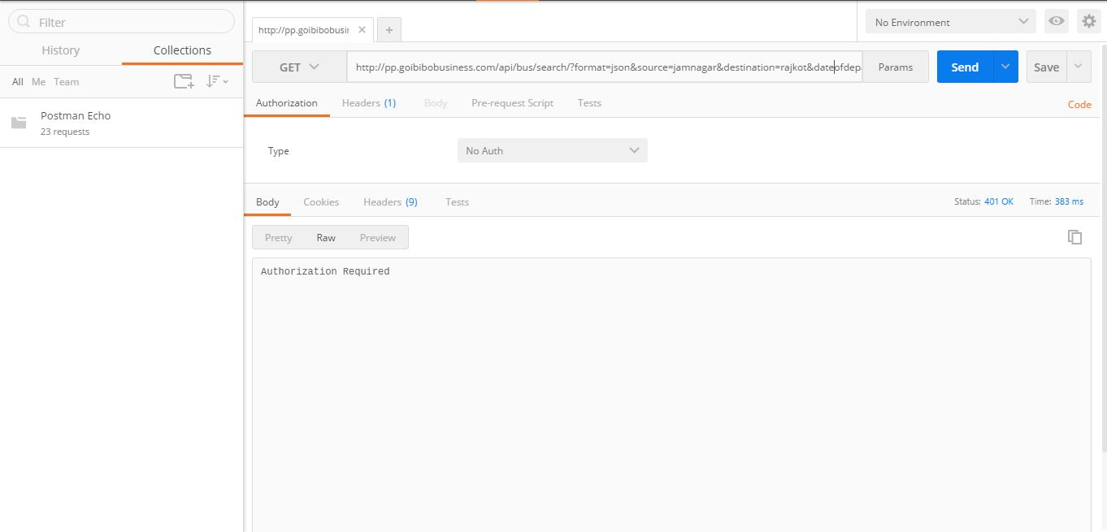

**GET REQUEST (Not Working) - Using**[*pp.goibibo.com*](http://pp.goibibo.com/)

**Error: Authorisation Failure**

Request URL: <http://pp.goibibobusiness.com/api/bus/search/?format=json&source=jamnagar&destination=rajkot&dateofdeparture=20170310>

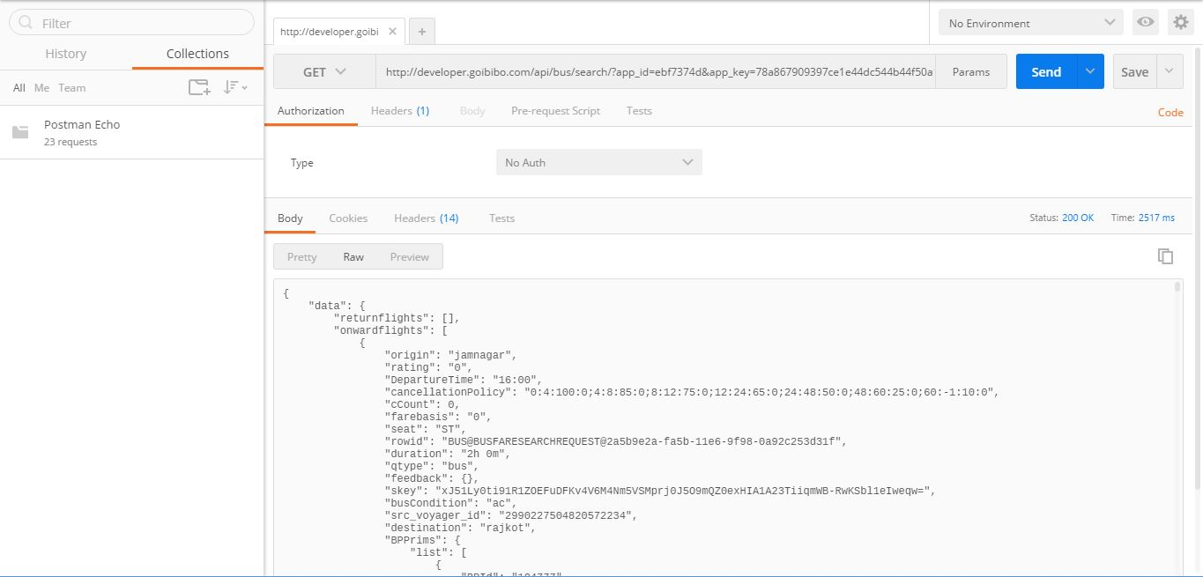

**GET REQUEST (Working) - Using**[*developer.goibibo.com*](http://developer.goibibo.com/)

Request URL:

<http://developer.goibibo.com/api/bus/search/?app_id=ebf7374d&app_key=78a867909397ce1e44dc544b44f50a18&format=json&source=jamnagar&destination=rajkot&dateofdeparture=20170310>