Table of Contents

# Education, children’s social care and offending, descriptive statistics: a focus on TlDJE

## Executive Summary

This analysis uses the Ministry of Justice and Department for Education data-share to look at the education and children’s social care background of children who had been cautioned or sentenced for an offence and had attended school in TlDJE. We focus on two main groups: children who had been cautioned or sentenced for any type of offence, and those who had been cautioned or sentenced for a serious violence offence. For the cohorts used in this analysis, there are approximately 160 children who had attended school in TlDJE and been cautioned or sentenced for any offence, equivalent to 42% of the all-pupil cohort that had attended school in TlDJE, and approximately 100 children who had attended school in TlDJE and been cautioned or sentenced for a serious violence offence (equivalent to 27% of the all-pupil cohort).

While this publication focuses on those that attended school in TlDJE, some of the accompanying tables include information on those that lived in TlDJE but did not necessarily attend school there. There are approximately 160 children that lived in TlDJE (regardless of where they attended school) who had been cautioned or sentenced for any offence, equivalent to 42% of the all-pupil cohort that lived in TlDJE. There are approximately 100 children that lived in TlDJE who had been cautioned or sentenced for a serious violence offence (equivalent to 27% of the all-pupil cohort). However, the primary focus of this analysis is on those who attended school in TlDJE, unless otherwise stated.

This publication follows a previous [national level publication](https://assets.publishing.service.gov.uk/government/uploads/system/uploads/attachment_data/file/1059556/Education_children_s_social_care_and_offending_descriptive_stats_FINAL.pdf) that looked at the education and social care background of children that had been cautioned or sentenced for an offence across England and Wales. We have conducted this analysis in order to inform the work of the ten SAFE (Support, Attend, Fulfil, Exceed) Taskforces (for more information see [Support for vulnerable young people in serious violence hotspots](https://www.gov.uk/government/news/support-for-vulnerable-young-people-in-serious-violence-hotspots)). The SAFE Taskforces will commission targeted interventions to reduce serious violence, improve school attendance, increase social and emotional wellbeing, and improve behaviour in school. A further publication will follow, that uses more complex analytical methods to understand the relationships between education, children’s social care and offending, on a national level.

Equivalent analysis has been produced for each of the 10 SAFE areas, which will then be followed by a dashboard containing all local authorities in England, due to be published in Autumn 2022. All of the data and findings in this publication refer to TlDJE. To see the findings for England or the other nine SAFE areas, please see [Education, children’s social care and offending](https://www.gov.uk/government/publications/education-childrens-social-care-and-offending).

## Introduction

This paper investigates the education and children’s social care background of children who had been cautioned or sentenced for an offence and attended school in TlDJE, based on key variables from the Ministry of Justice and Department for Education data share which was undertaken in 2020. The share covers offending data up to the end of 2017 and education and social care data up to the end of academic year 2017/18.

This descriptive statistics analysis has been produced to provide greater insight into the education and children’s social care background of children who had been cautioned or sentenced for an offence, including attainment outcomes and characteristics. However, this analysis does not imply there is a causal link between the educational outcomes, characteristics and offending.

Section 1 includes a high-level analysis of demographic factors, including:

• Previous offending  
• Gender  
• Age  
• Ethnicity  
• Free School Meals eligibility

Section 2 includes analysis that relates to children’s experiences during school, including:

• Attainment  
• Persistent Absence  
• Exclusions and Suspensions  
• Alternative Provision  
• Special Educational Needs  
• Children with a Social Worker

For more details on the data share that this analysis is based on, refer to the separately published [Technical Note](https://assets.publishing.service.gov.uk/government/uploads/system/uploads/attachment_data/file/1059557/Education_children_s_social_care_and_offending_descriptive_stats_Technical_Note_FINAL.pdf), and Annex C at the end of this paper. The data and variables used in the analysis for this paper are presented in the accompanying tables (with the source table referenced in this paper, where relevant).

## Defining the study population

### Defining the all-pupil cohort

The cohorts of children within this analysis include all pupils who finished key stage 2 (KS2) in 2007/08, 2008/09 or 2009/10, were aged 10 at the start of these academic years, and attended school in TlDJE. Therefore, this cohort has a key stage 4 (KS4) academic year of 2012/13, 2013/14 or 2014/15 amounting to approximately 400 children. For these children, all their records from Year 1 to Year 13 (or equivalent) are included. Pupils who do not have a KS4 record are not included (See figure 1 below). Pupils who attended an independent primary or secondary school have been excluded from the data as their characteristics are not recorded, except for those registered in independent Alternative Provision (AP) settings[1]. The cohorts were selected in this way to maximise data coverage and balance data availability across each of the datasets provided in the share.

Children that appear on a school census at the end of KS2 and the end of KS4 have been included in this analysis, with allowances for those that have moved ahead or been kept behind by one or more school years. Independent AP schools have been included, however those with KS4 results at mainstream independent schools have been removed.

Results are provided for the all-pupil cohort in TlDJE (including all children who had been cautioned or sentenced for an offence) for comparison purposes[2].

This publication will present statistics relating to the Local Authority (LA) of a child’s school during the school year they entered when they were aged 15. We selected age 15 as this is the most common age at which children who had been cautioned or sentenced for a serious violence offence commit their first serious violence offence[3]. Where this isn’t possible, the closest previous year has been used. We have also conducted analysis using the records of the LA of the child’s home address when they were aged 15, which can be found in the accompanying tables.

Year group breakdown for the all-pupil cohort

Academic Year

KS4 Academic Year 2014 15

KS4 Academic Year 2013 14

KS4 Academic Year 2012 13

2016/17

Year 13

2015/16

Year 12

Year 13

2014/15

Year 11

Year 12

Year 13

2013/14

Year 10

Year 11

Year 12

2012/13

Year 9

Year 10

Year 11

2011/12

Year 8

Year 9

Year 10

2010/11

Year 7

Year 8

Year 9

2009/10

Year 6

Year 7

Year 8

2008/09

Year 5

Year 6

Year 7

2007/08

Year 4

Year 5

Year 6

2006/07

Year 3

Year 4

Year 5

2005/06

Year 2

Year 3

Year 4

2004/05

Year 1

Year 2

Year 3

2003/04

Year 1

Year 2

2002/03

Year 1

The findings presented throughout this publication are the combined results of all three cohorts, with the exception of findings discussing:

1. KS4 attainment: This is due to the implementation of two major reforms in 2013/14[4] which affect the calculation of KS4 performance measures data. Since the cohorts in the analysis are matched to years in the KS4 attainment data that fall either side of this reform, KS4 results for these cohorts cannot be combined to look at overall figures. Therefore, when analysing KS4 attainment, the analysis refers to the results of those with KS4 academic year 2014/15 as this provides the most recent indicator of academic achievement.
2. Children known to children’s social care: Full children in need (CIN) data is available from 2011/12, term 3[5]. Children are included in this CIN analysis if they had been recorded as a child in need on the 31st March in any period between the ages of 12 - 16. Those matched to earlier years in the KS4 attainment data will have less coverage than those matched to later years. For example: those with KS4 academic year 2012/13 have coverage from age 14 and above. To maximise coverage of the CIN data and avoid skewed results, analysis of children in need and children who are looked after is based on children matched to KS4 academic year 2014/15 only.

### Defining the offending groups

‘Children who had been cautioned or sentenced for an offence’ relates to all children and young people in the linked data who attended school in TlDJE, were in the academic years described above, and who been cautioned or sentenced for any offence recorded on the Police National Computer over the defined coverage period[6].

All cohorts in this analysis are limited to ages 10-17. This means that for each cohort, the last year of offending data would be during Year 13 (or equivalent). This is to ensure that each child had the same amount of time to offend - if the data was not limited by age, then children born in earlier years would have more years of data available to record offences, thereby skewing the results.

The analysis has identified approximately 160 children who had been cautioned or sentenced for an offence and attended school in TlDJE, which is equivalent to 42% of the all-pupil cohort that attended school in TlDJE. In comparison, this analysis looks at approximately 160 children who had been cautioned or sentenced for an offence lived in TlDJE, which is equivalent to 42% of the all-pupil cohort that live in TlDJE.

As well as ‘children who had been cautioned or sentenced for an offence’, ‘children who had been cautioned or sentenced for a serious violence offence’ have also been included in this analysis. The definition of serious violence offences is based broadly on the following categories of offence groups and offence types: indictable only ‘violence against the person’ offences, indictable only ‘robbery offences’, and triable either way or indictable only ‘possession of weapons offences’[7].

The analysis has identified approximately 100 children who had been cautioned or sentenced for a serious violence offence and attended school in TlDJE, which is equivalent to 27% of the all-pupil cohort that attended school in TlDJE. In comparison, this analysis looks at approximately 100 children who had been cautioned or sentenced for a serious violence offence and lived in TlDJE, which is equivalent to 27% of the all-pupil cohort that lived in TlDJE.

Approximately 64% of the ‘children who had been cautioned or sentenced for an offence’ group are in the ‘children who had been cautioned or sentenced for a serious violence offence’ group.

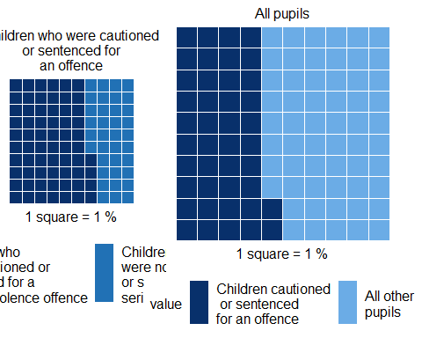

The proportion of children who had been cautioned or sentenced for an offence that had also been cautioned or sentenced for a serious violence offence, and the proportion of children who had been cautioned or sentence for an offence, for pupils matched to KS4 academic years 2012/13, 2013/14,2014/15 [Source: DfE-MoJ data share, table: …]

## Key points on the analysis: interpreting results

Care should be taken when interpreting this analysis as the findings do not imply a causal link between the educational or children’s social care characteristics and being cautioned or sentenced for an offence. Future work using these data will aim to build upon this analysis to better understand the relationships between the outcomes and characteristics in this publication.

The education variables included in this paper have generally been analysed independently of each other. It is important to note that there may be links between these key variables which have not been factored into the analysis, and other factors which could not be taken into account.

Children who had been cautioned or sentenced for a serious violence offence represent a small, atypical group of young people; their results should not be assumed to be representative of all children who had been cautioned or sentenced for an offence or young people more generally.

The data used for this publication allows us to see what proportion of a certain offending group had a characteristic, as well as being able to see what proportion of children with a characteristic are also in the offending groups. For example, approximately 49.3304767% of children who had been cautioned or sentenced for a serious violence offence and had attended school in TlDJE were known to had ever been eligible for free school meals (FSM), but it is not possible to conclude from these findings that there is a causal relationship between FSM eligibility and being cautioned or sentenced for a serious violence offence (or vice versa).

Indeed, those children who had been cautioned or sentenced for a serious violence offence identified as being eligible for FSM made up 12.5306122% of all pupils known to be eligible for FSM. If there were a causal link, a much higher number might be expected. Whilst it can be said that most children who had ever been cautioned or sentenced for a serious violence offence had also been eligible for FSM at some stage, it is not true that most children eligible for FSM had also been cautioned or sentenced for a serious violence offence. This is a pattern which emerges throughout this analysis; it is therefore important to consider this when reading the publication.

In addition to those given above, there are other reasons why this analysis cannot draw causal links. For example, there are many additional factors which could influence someone’s offending behaviour for which the data is not available for this analysis. The factors looked at in this paper come from education, children’s social care, and offending datasets, meaning there are many unobserved factors which have not been accounted for here, for example health characteristics.

Tests for statistical significance have been performed on certain outcomes in this analysis[8]. Where an outcome is deemed to be ‘statistically significant’, this means that we are relatively confident that the results given for TlDJE are genuinely different to the national figure, and not due to random variation. More specifically, we have concluded that there is a less than 5% chance that the results are due to chance alone. These tests have been performed for children who had been cautioned or sentenced for a serious violence offence only (not the all-pupil cohort or children who had been cautioned or sentenced for any offence).

## Statistical Disclosure Control

In order to prevent the disclosure of sensitive data, any numbers in this publication that relate to less than 6 pupils have been replaced by the word ‘suppressed’. Where there are further risks of identification (for example where a suppressed number can be calculated using other numbers), numbers have been further suppressed. Due to the size variation across the ten SAFE Taskforce Local Authority areas, this happens more in some of the ten publications than others.

## Defining ‘ever’

It is important to note that this analysis will not be directly comparable with other published government statistics. Unless otherwise specified, when referencing whether a child has ‘ever’ had a certain characteristic, the analysis considers all periods up to the end of KS4. This methodology may differ from that of other published statistics where, for example, only the previous six years are considered. For this reason, figures discussed here may appear higher than those available in other publications.

## Difference between home and school Local Authorities

In some cases, a child’s home and school LA can differ. 20% of children who had been cautioned or sentenced for an offence that had a home LA of TlDJE had a different school LA (approximately 30 children). 20% that had a school LA of TlDJE had a different home LA (approximately 30 children). In comparison, 20% of children who had been cautioned or sentenced for a serious violence offence and had a home LA of TlDJE had a different school LA (approximately 20 children). 20% that had a school LA of TlDJE had a different home LA (approximately 20 children). For the all-pupil cohort, 20% of children that had a home LA of TlDJE had a different school LA (approximately 80 children). 20% that had a school LA of TlDJE had a different home LA (approximately 80 children). These results are depicted in figure 2 below.

Please note that this publication does not include any information on where any of the offences took place - only the home or school LA of the child that had been cautioned or sentenced for the offence.

The remainder of this document refers only to children with a school LA of TlDJE.

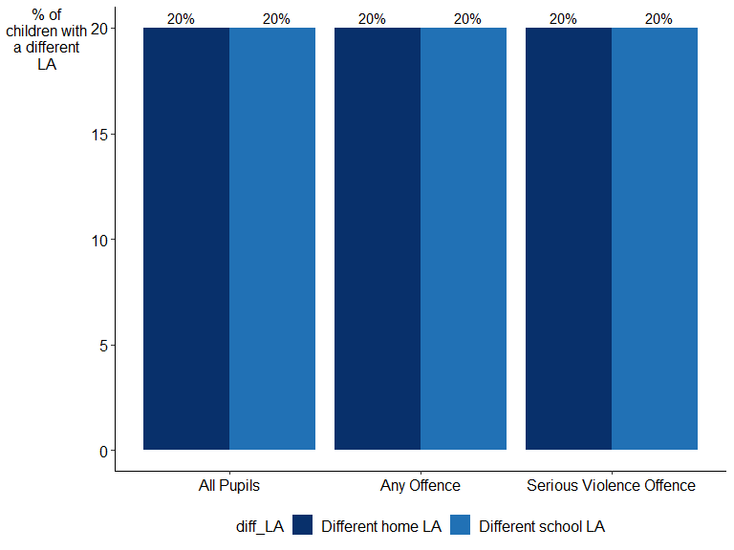

Proportion of children with different home and school LAs. [Source: DfE-MoJ data share, table: …]

# Section One: Demographics

## Previous offending

In order to better understand offending trajectories for children who had been cautioned or sentenced for a serious violence offence, this analysis looks at the volume of offending which preceded a first serious violence offence.

71% of children who had been cautioned or sentenced for a serious violence offence and had attended school in TlDJE had not been cautioned or sentenced for a previous offence. This result was at the 5% level.

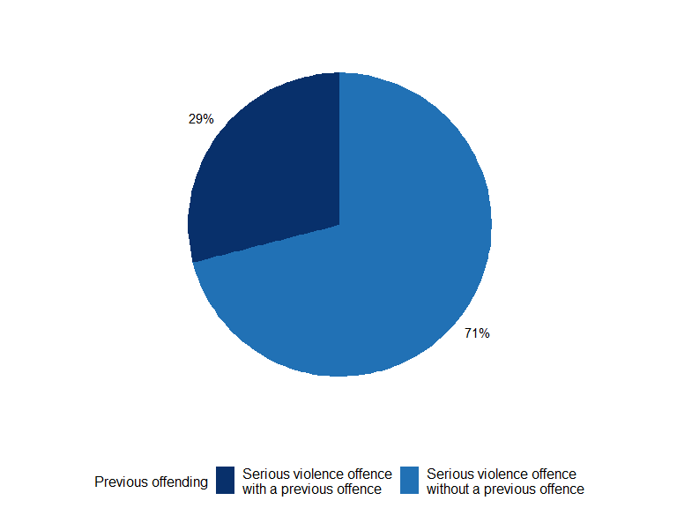

The proportion of children who had been cautioned or sentenced for a serious violence offence with or without a prior offence, for pupils matched to KS4 academic years 2012/13, 2013/14 and 2014/15. [Source: DfE-MoJ data share, table: …]

## Gender

Male pupils were over-represented amongst children who had been cautioned or sentenced for an offence and children who had been cautioned or sentenced for a serious violence offence - 75% of those that had been cautioned or sentenced for any offence were male, and 80% of those that were cautioned or sentenced for a serious violence offence were male. In comparison, 51% of the all-pupil cohort that attended school in TlDJE was male. For children who had been cautioned or sentenced for a serious violence offence, this result was at the 5% level.

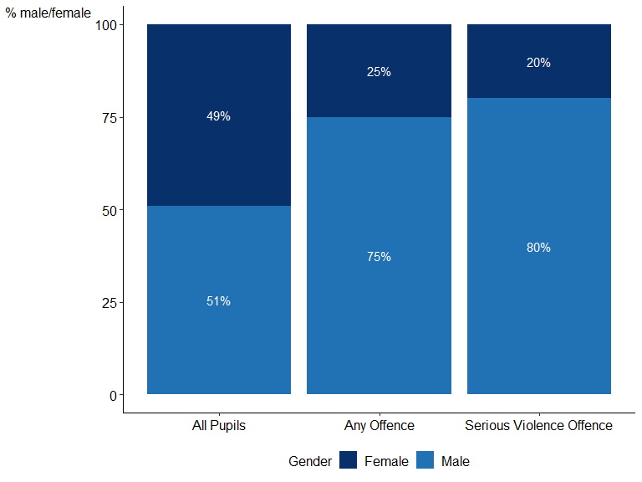

The gender breakdown of offending and pupil group, for all pupils matched to KS4 academic years 2012/13, 2013/14, 2014/15. [Source: DfE-MoJ data share, table: …]

## Age

The most common age at first offence for all those that were cautioned or sentenced for an offence and attended school in TlDJE was 14. The most common age at first serious violence offence for all those that were cautioned or sentenced for a serious violence offence and attended school in TlDJE was 15. The chart below shows the distribution of the age at first offence in TlDJE[9].

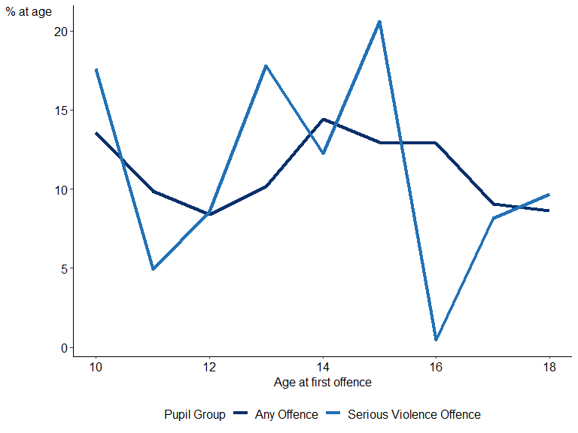

The proportion of children relative to their age at first offence by offending group, for pupils matched to KS4 academic years 2012/13, 2013/14 and 2014/15. [Source: DfE-MoJ data share, table: …]

## Ethnicity

Ethnicity[10] has two different categorisations in the school census - ethnic group major and ethnic group minor. Ethnic group major contains wider categories (Asian, Black, Chinese, White, Mixed, Unclassified, Any Other Ethnic Group) whereas ethnic group minor is more detailed[11].

The most common major ethnic group amongst all pupils with a school LA of TlDJE was Mixed (15.7555548%). The most common major ethnic group amongst children with a school LA of TlDJE who had been cautioned or sentenced for an offence was Unclassified (15.2703014%) - for children who had been cautioned or sentenced for a serious violence offence with a school LA of TlDJE, it was Chinese (17.0316855%).

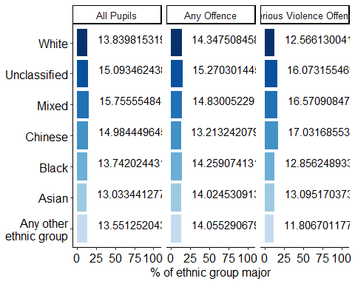

The proportion of all pupils split by ethnic group major, offending and pupil group, for pupils matched to KS4 academic years 2012/13, 2013/14 and 2014/15. [Source: DfE-MoJ data share, table: …]

## Free School Meals

Children who had been cautioned or sentenced for an offence that attended school in TlDJE were more likely to be eligible for free school meals (FSM)[12] than the all-pupil cohort, with children who had been cautioned or sentenced for a serious violence offence having the highest proportion of those eligible for FSM.

74.8389615% of all children who had been cautioned or sentenced for an offence and had attended school in TlDJE had ever been eligible for FSM (approximately 3830 children), compared to 49.3304767% of children who had been cautioned or sentenced for a serious violence offence and had attended school in TlDJE (approximately 920 children). This compares to 73.943662% of all pupils who attended school in TlDJE and had ever been eligible for FSM (approximately 7350 children). For children who had been cautioned or sentenced for a serious violence offence, this result was at the 5% level.

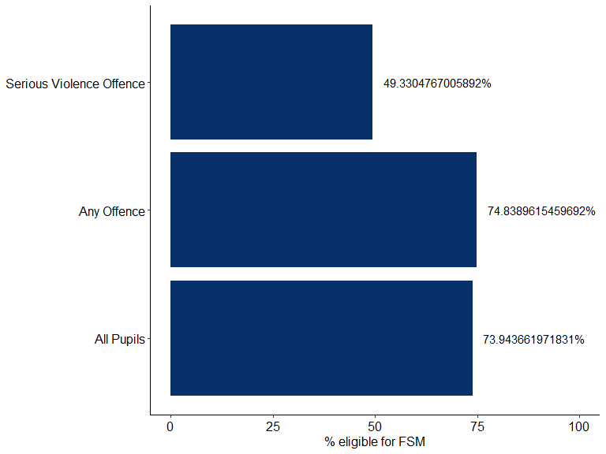

Proportion of all pupils eligible for free school meals (FSM) by offending and pupil group, for pupils matched to KS4 academic years 2012/13, 2013/14 and 2014/15. [Source: DfE-MoJ data share, table: …]

However, whilst the majority of children who had been cautioned or sentenced for an offence and had attended school in TlDJE had ever been eligible for FSM, it is not the case that the majority of children eligible for FSM were also cautioned or sentenced for an offence: only 52.1632653% of those that had ever been eligible for FSM and had attended school in TlDJE had also ever been cautioned or sentenced for an offence, and only 12.5306122% had ever been cautioned or sentenced for a serious violence offence.

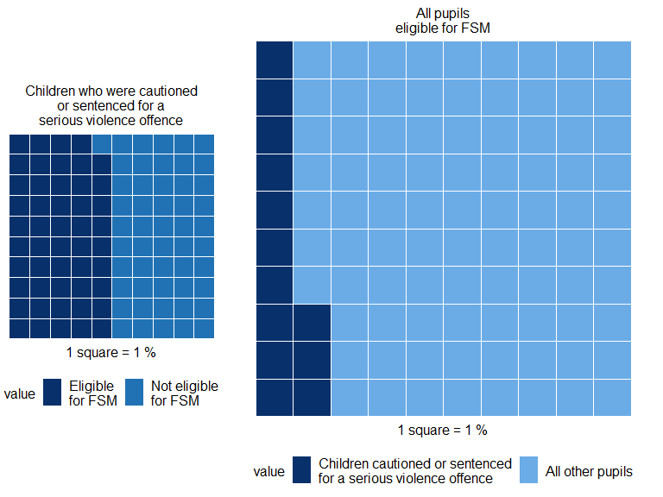

The proportion of children who had been cautioned or sentenced for a serious violence offence and had ever been eligible for free school meals (FSM), and all pupils who had ever been eligible for FSM, for pupils matched to KS4 academic years 2012/13, 2013/14 and 2014/15 [Source: DfE-MoJ data share, table: …]

# Section Two: School Experience

## Attainment

A lower proportion of children who had been cautioned or sentenced for any offence and had attended school in TlDJE achieved the expected standard in English and Maths at key stage 2 (KS2)[13], or achieved various key stage 4 (KS4) benchmarks, compared to the all-pupil cohort that had attended school in TlDJE.

KS2 attainment in TlDJE differed across English and Maths, with children who had been cautioned or sentenced for any offence tending to perform worse in English compared to Maths. 79.1697014% of children who had been cautioned or sentenced for an offence and 62.8681627% of children who been cautioned or sentenced for a serious violence offence achieved a level 4 or above in English. In comparison, 82.0101966% of children who had been cautioned or sentenced for an offence and 55.5399719% of children who had been cautioned or sentenced for a serious violence offence achieved a level 4 or above in Maths. This compares to 87.0956399% of the all-pupil cohort that achieved a level 4 or above in English and 83.8373183% of the all-pupil cohort that achieved a level 4 or above in Maths.

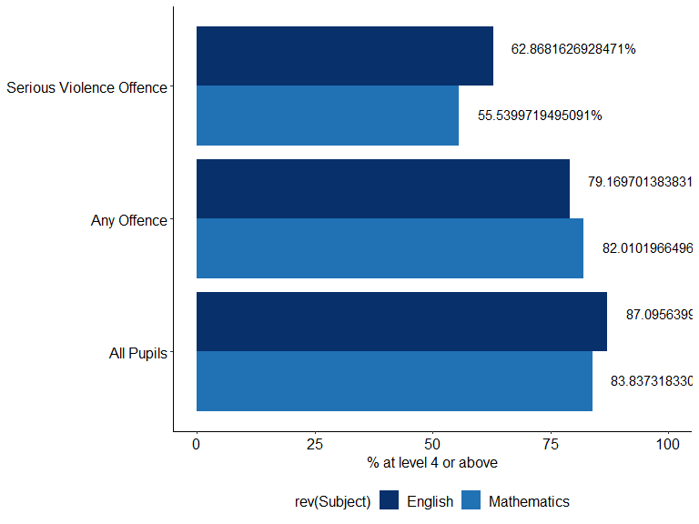

Proportion of all pupils who achieved level 4 or above in English and Mathematics at key stage 2 (KS2) by offending and pupil group, for pupils matched to KS4 academic years 2012/13, 2013/14 and 2014/15. [Source: DfE-MoJ data share, table: …]

In 2014/15[14], 82.9313544% of children who had been cautioned or sentenced for an offence and had attended school in TlDJE and 83.5002835% of children who had been cautioned or sentenced for a serious violence offence and had attended school in TlDJE achieved any pass at GCSE (or equivalent), compared with 84.0252614% of the all-pupil cohort that had attended school in TlDJE.

The results for those that achieved 5 or more GCSE (or equivalent) passes at grades A star - G follow a similar pattern: in 2014/15, 84.0180228% of children who had been cautioned or sentenced for an offence and had attended school in TlDJE and 81.2322812% of children who had been cautioned or sentenced for a serious violence offence and had attended school in TlDJE achieved 5 A star - G at GCSE (or equivalent), compared with 90.7650896% of the all-pupil cohort that had attended school in TlDJE.

Similarly, for those that achieved 5 or more GCSE (or equivalent) passes at grades A star - C: in 2014/15, 82.5470448% of children who had been cautioned or sentenced for an offence and had attended school in TlDJE and 91.6839917% of children who had been cautioned or sentenced for a serious violence offence and had attended school in TlDJE achieved 5 A star - G at GCSE (or equivalent), compared with 83.9838493% of the all-pupil cohort that had attended school in TlDJE.

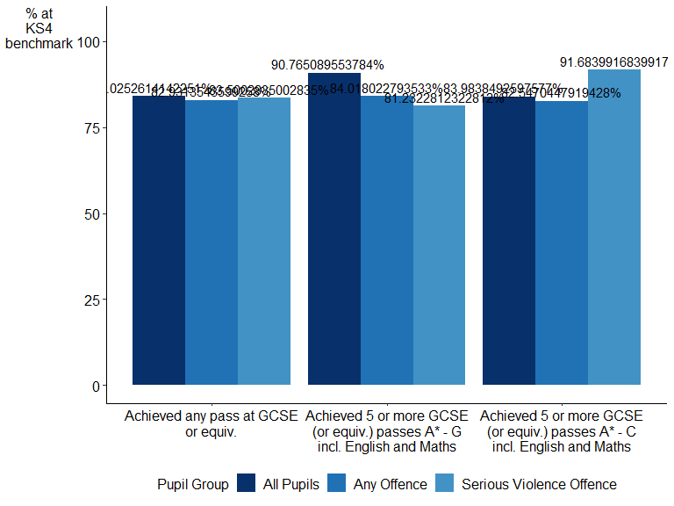

Proportion of all pupils who achieved various key stage 4 (KS4) benchmarks by offending and pupil group, for pupils matched to KS4 academic year 2014/15 only. [Source: DfE-MoJ data share, table: …]

## Persistent Absence

A child is said to be persistently absent (PA) if they miss 10% or more of the sessions they could possibly have attended in an academic year or term. Most sessions represent a half-day. For context, this would amount to between 6 and 7 days of a 13-week term or around 19 days for a school year[15]. This includes both authorised and unauthorised absences[16].

For the following analysis, a pupil was marked as having ever been persistently absent if they had missed over 10% of their possible sessions over the course of a school year, not a term.

It is worth noting that persistent absence can include various reasons for absence, including absence due to being suspended or permanently excluded[17].

Children who had been cautioned or sentenced for an offence and had attended school in TlDJE were more likely to be persistently absent for any reason than the all-pupil cohort.

57.4272887% of children who had been cautioned or sentenced for an offence and had attended school in TlDJE had ever been persistently absent (approximately 2940 children), compared to 43.706481% of children who had been cautioned or sentenced for a serious violence offence (approximately 820 children). This compares to 62.7967807% of the all-pupil cohort that had attended school in TlDJE (approximately 6240. For children who had been cautioned or sentenced for a serious violence offence, this result was at the 5% level.

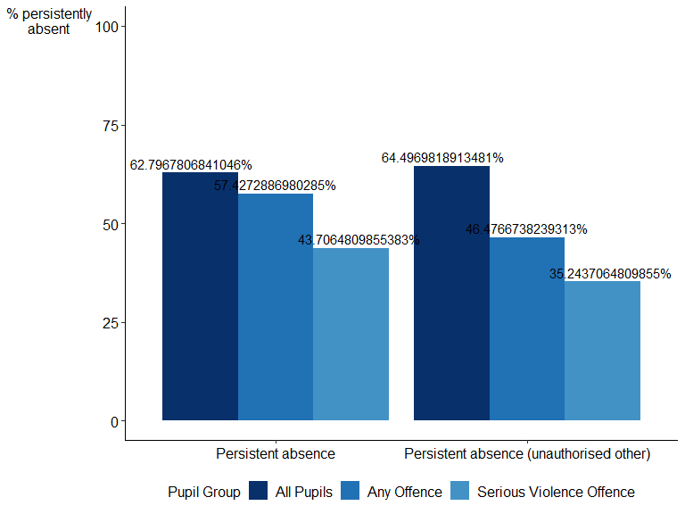

Proportion of all pupils who had ever been persistently absent or persistently absent (unauthorised other) by offending and pupil group, for pupils matched to KS4 academic years 2012/13, 2013/14 and 2014/15. [Source: DfE-MoJ data share, table: …]

Looking at the proportion of the persistently absent pupils who had ever been cautioned or sentenced for an offence and had attended school in TlDJE: 47.1323294% of pupils who had ever been persistently absent pupils had been cautioned or sentenced for an offence, compared to 13.0727331% who had been cautioned or sentenced for a serious violence offence. Therefore, whilst it can be said that the majority of children who had been cautioned or sentenced for an offence had ever been persistently absent, it is not the case that the majority of persistently absent pupils had also ever been cautioned or sentenced for an offence.

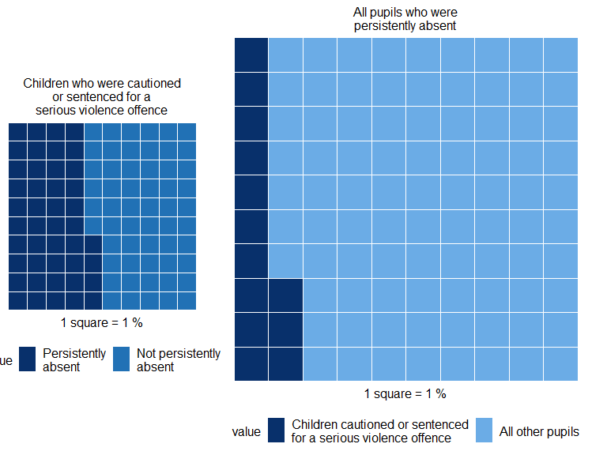

The proportion of children who had been cautioned or sentenced for a serious violence offence and had been persistently absent, and all pupils who had ever been persistently absent, for pupils matched to KS4 academic years 2012/13, 2013/14 and 2014/15 [Source: DfE-MoJ data share, table: …]

Schools use a set of national codes to record the reasons for any absences. As the rates of persistent absence are so high amongst the all-pupil cohort, we have used these codes below to analyse the reasons why children are marked as persistently absent[18].

The absence reason ‘persistent absence unauthorised other’ (PAUO) is used as a proxy for persistent truancy. Looking at this reason code in isolation, 46.4766738% of children who had been cautioned or sentenced for an offence and had attended school in TlDJE had ever been PAUO, compared to 35.2437065% of children who had been cautioned or sentenced for a serious violence offence. This compares to 64.4969819% of the all-pupil cohort that had attended school in TlDJE. For children who had been cautioned or sentenced for a serious violence offence, this result was at the 5% level.

Another possible reason for absence is due to a suspension[19], where the pupil has been temporarily removed from the school[20], and in some cases permanent exclusion. If this reason code is removed from the calculation of persistent absence (so as to avoid overlap with the exclusions and suspensions statistics included elsewhere in this publication), the proportions decrease slightly but follow the same pattern as above: 58.4227991% of children who had been cautioned or sentenced for an offence and had attended school in TlDJE had ever been persistently absent, compared to 47.5093733% of children who had been cautioned or sentenced for a serious violence offence and had attended school in TlDJE. This compares to 69.637827% of the all-pupil cohort in TlDJE.

Looking at the reason code for those that were persistently absent due to suspensions or permanent exclusions (PAE) in isolation, 42.5336717% of children who had been cautioned or sentenced for an offence and had attended school in TlDJE had ever been PAE, compared to 31.1730048% of children who had been cautioned or sentenced for a serious violence offence and had attended school in TlDJE. This compares to 61.5593561% of the all-pupil cohort that had attended school in TlDJE.

### Timing of Persistent Absence and Persistent Absence Unauthorised Other

This analysis looks at children who had been cautioned or sentenced for a serious violence offence who had ever been flagged as persistently absent, and whether the first record of persistent absence occurred before, after or during the same school term as the first serious violence offence[21].

Almost all (16.6197183%) of children who had been cautioned or sentenced for a serious violence offence and had attended school in TlDJE who had ever been recorded as persistently absent for any reason were first flagged as being so prior to their first serious violence offence. This compares to about 38.3663366% for children that had ever been recorded as persistently absent (unauthorised other) in TlDJE [22].

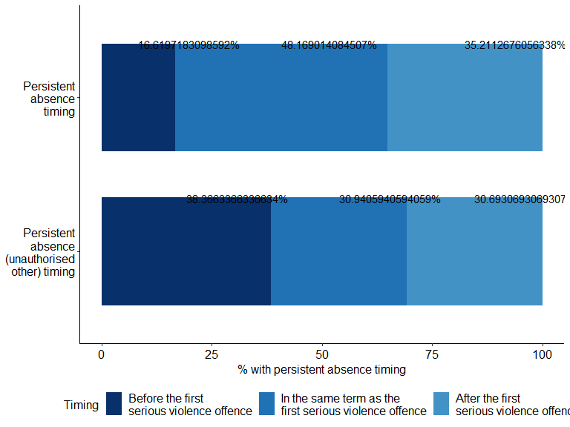

Timing of first record of persistent absence or persistent absence (unauthorised other) relative to the timing of children’s first serious violence offence, for all pupils matched to KS4 academic years 2012/13, 2013/14 and 2014/15. [Source: DfE-MoJ data share, table: …]

## Suspensions and permanent exclusions

A suspension is where a pupil has been temporarily removed from the school[23], whilst a permanent exclusion is when a pupil is no longer allowed to attend a school[24].

Children who had been cautioned or sentenced for an offence and had attended school in TlDJE were more likely to be both suspended and permanently excluded than the all-pupil cohort.

53.4062073% of all children who had been cautioned or sentenced for an offence and had attended school in TlDJE had ever received a suspension (approximately 2740 children), compared to 4.1242635% of children who had been cautioned or sentenced for a serious violence offence (approximately 80 children). This compares to 68.3702213% of the all-pupil cohort that had attended school in TlDJE (approximately 6800 children). For children who had been cautioned or sentenced for a serious violence offence, this result was at the 5% level.

Overall, 73.2578567% of children who had been cautioned or sentenced for an offence and had attended school in TlDJE had been permanently excluded (approximately 3750 children), compared with 43.9207284% of children who had been cautioned or sentenced for a serious violence offence and had attended school in TlDJE (approximately 820 children). This compares to 61.4688129% of the all-pupil cohort that had attended school in TlDJE (approximately 6110 children). For children who had been cautioned or sentenced for a serious violence offence, this result was at the 5% level.

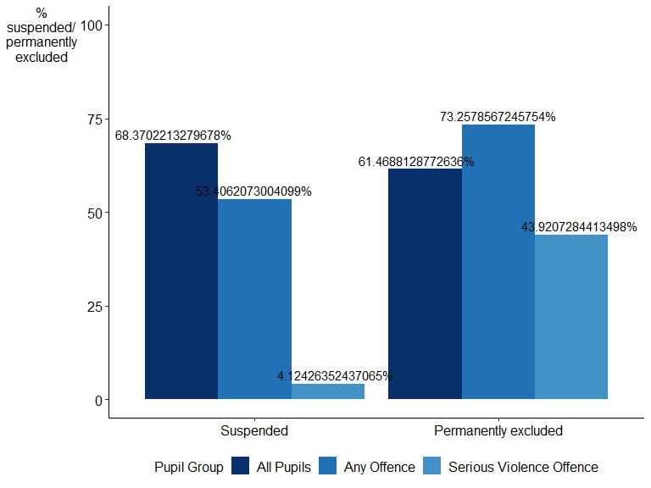

The proportion of all pupils who had a record of being suspended or permanently excluded by offending and pupil group, for all pupils matched to KS4 academic years 2012/13, 2013/14 and 2014/15. [Source: DfE-MoJ data share, table: …]

In comparison to the proportions seen above, 40.2589759% of suspended pupils that had attended school in TlDJE had ever been cautioned or sentenced for an offence, compared to 1.1330194% who had been cautioned or sentenced for a serious violence offence. This shows us that, whilst the majority of children cautioned or sentenced for offences had also been suspended, it is not the case that most suspended pupils are cautioned or sentenced for offences.

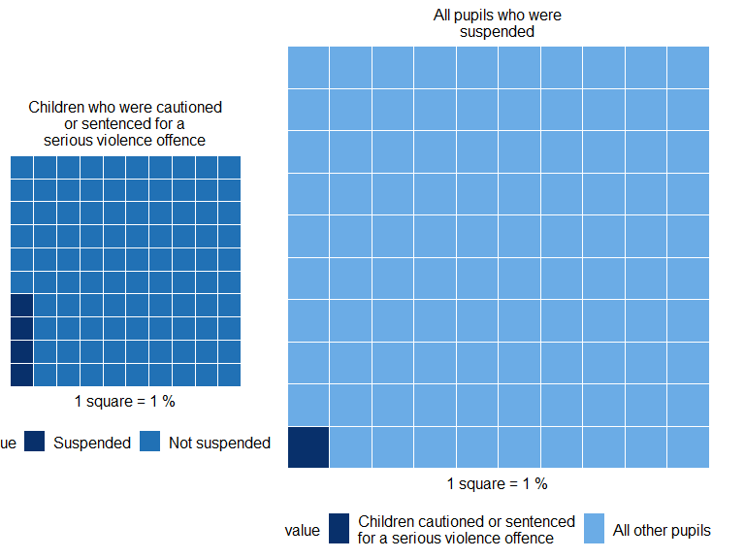

The proportion of children who had been cautioned or sentenced for a serious violence offence and had ever been suspended, and all pupils who had ever been suspended, for pupils matched to KS4 academic years 2012/13, 2013/14 and 2014/15 [Source: DfE-MoJ data share, table: …]

When looking at all children that had ever been permanently excluded and had attended school in TlDJE, 61.4238953% had ever been cautioned or sentenced for an offence, compared to 13.4206219% who had been cautioned or sentenced for a serious violence offence.

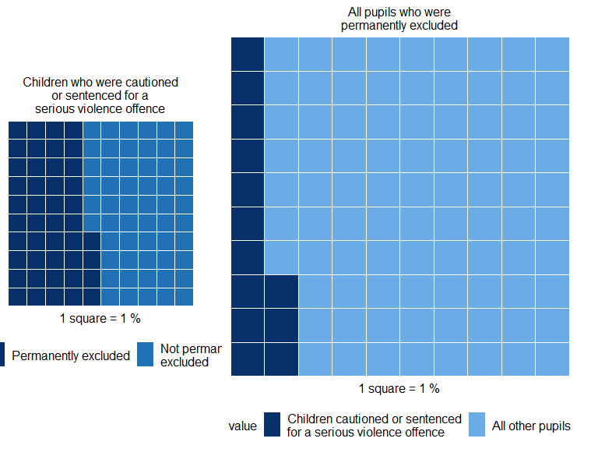

The proportion of children who had been cautioned or sentenced for a serious violence offence and had ever been permanently excluded, and all pupils who had ever been permanently excluded, for pupils matched to KS4 academic years 2012/13, 2013/14 and 2014/15 [Source: DfE-MoJ data share, table: …]

### Timing of exclusions and suspensions

The following analysis first investigates the sequencing of suspensions and permanent exclusions with serious violence offences. It looks at both the child’s first suspension or permanent exclusion and, in the case of multiple events, their closest suspension or permanent exclusion relative to their first serious violence offence.

*Did first suspensions / permanent exclusions commonly precede or follow first serious violence offences?*

Most children who had been cautioned or sentenced for a serious violence offence and had attended school in TlDJE who had received a suspension, received their first suspension before their first serious violence offence.

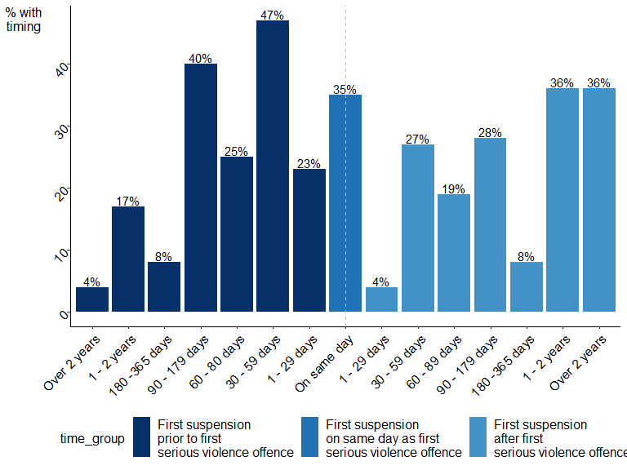

Timing of children’s first suspension relative to their first serious violence offence, for all pupils matched to KS4 academic years 2012/13, 2013/14, 2014/15. [Source: DfE-MoJ data share, table: …]

Many children who had been cautioned or sentenced for a serious violence offence and had attended school in TlDJE who had received a permanent exclusion, also received their first permanent exclusion before their first serious violence offence.

*Chart has been suppressed due to small numbers.*

*Did the closest suspensions*[25] */ permanent exclusions commonly precede or follow serious violence offences?*

Similar to the first suspension or permanent exclusion seen above, many children who had been cautioned or sentenced for a serious violence offence and had attended school in TlDJE received their closest suspension or permanent exclusion before their first serious violence offence. There was also often a long period of time in between the closest suspension or permanent exclusion and the first serious violence offence[26].

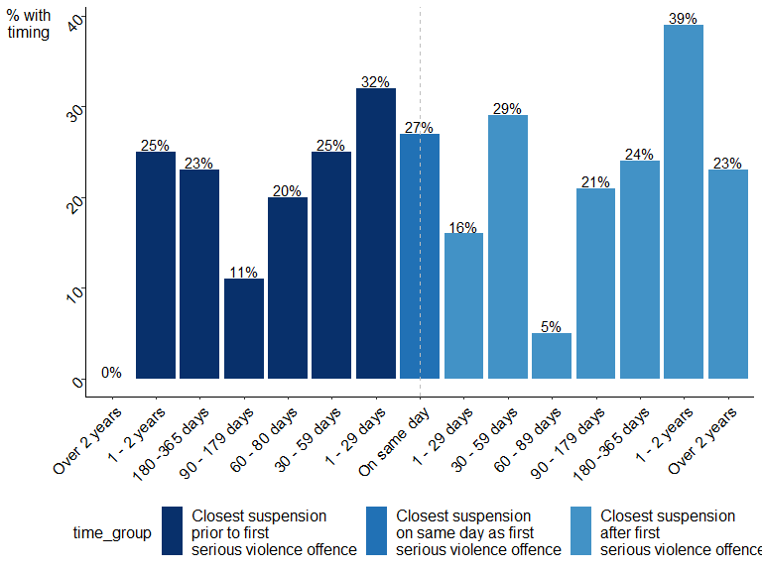

Timing of children’s closest suspension relative to their first serious violence offence, for all pupils matched to KS4 academic years 2012/13, 2013/14, 2014/15. [Source: DfE-MoJ data share, table: …]

*Chart has been suppressed due to small numbers.*

## Alternative Provision

Alternative Provision (AP) is full or part-time education arranged by:

1. local authorities, either directly or working with schools, for pupils who, because of permanent exclusion, illness or other reasons, would not otherwise receive suitable education.
2. schools for pupils to improve their behaviour off-site, or during a suspension

The education often takes place at a pupil referral unit (PRU), AP academy or free school, known collectively as the ‘state place-funded AP’ sector.

However, alternative provision placements can also be arranged in independent schools, Further Education colleges or unregistered education settings, known as the ‘independent AP’ sector. Some of the pupils identified in the data as attending independent and unregistered AP settings were registered in independent special schools named on their Education, Health and Care plans, some of which do not meet the Department for Education’s (DfE) statutory definition of AP.

Children who had been cautioned or sentenced for an offence and had attended school in TlDJE were more likely to have attended AP than the all-pupil cohort that had attended school in TlDJE[27].

43.1583057% of all children who had been cautioned or sentenced for an offence and had attended school in TlDJE had ever been registered at an AP setting (approximately 2210 children), compared to 52.4906267% of children who had been cautioned or sentenced for a serious violence offence and had attended school in TlDJE (approximately 980 children). This compares to only 67.082495% of the all-pupil cohort in TlDJE (approximately 6670 children). For children who had been cautioned or sentenced for a serious violence offence, this result was at the 5% level.

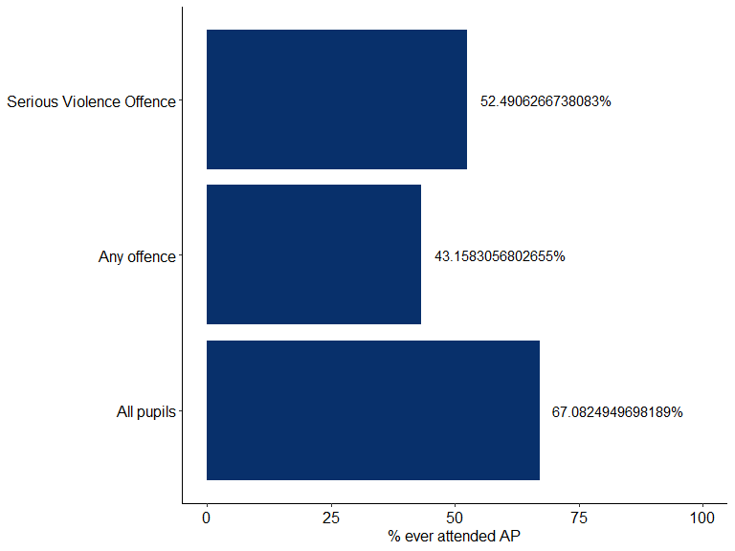

The proportion of all pupils who had ever attended alternative provision by offending and pupil group, for pupils matched to KS4 academic years 2012/13, 2013/14 and 2014/15. [Source: DfE-MoJ data share, table: …]

Looking only at pupils that had ever been registered at an AP setting and had attended school in TlDJE, 33.1583683% had ever been cautioned or sentenced for an offence. In addition, 14.6970606% of those that had ever been registered at an AP setting and had attended school in TlDJE had ever been cautioned or sentenced for a serious violence offence.

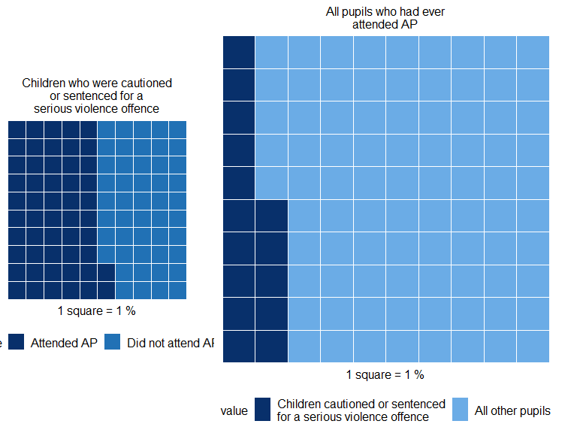

The proportion of children who had been cautioned or sentenced for a serious violence offence and had ever attended alternative provision, and all pupils who had ever attended alternative provision, for pupils matched to KS4 academic years 2012/13, 2013/14 and 2014/15 [Source: DfE-MoJ data share, table: …]

### Timing of AP in relation to offence

*Did the first term a child attended alternative provision (AP) commonly precede the first serious violence offence?*

For children who had been cautioned or sentenced for a serious violence offence, attended school in TlDJE, and had ever been registered at an AP setting, 52.5469169% first attended AP before their first serious violence offence and 17.1581769% first attended AP after their first serious violence offence, whilst 30.2949062% first attended AP in the same term as their first serious violence offence.

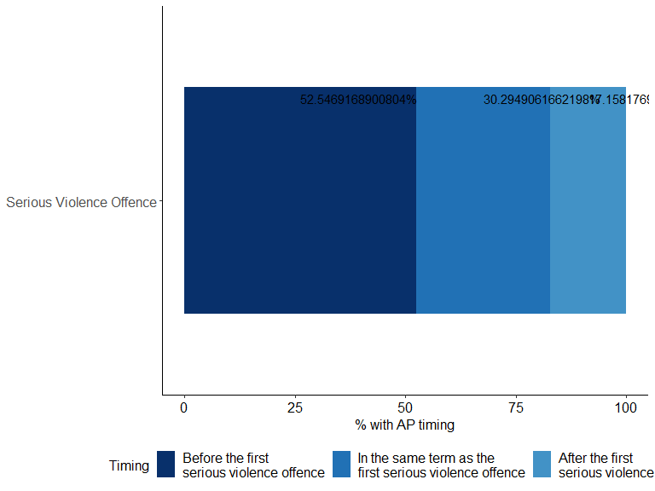

The first term children attended alternative provision (AP) relative to the timing of their first offence, for all pupils matched to KS4 academic years 2012/13, 2013/14 and 2014/15. [Source: DfE-MoJ data share, table: …]

## Special Educational Needs

This analysis looks at the proportion of children who had been cautioned or sentenced for an offence and had attended school in TlDJE who were ever recorded as having Special Educational Needs (SEN)[28].

A child or young person is classified as having SEN if they have a learning difficulty or disability which calls for special educational provision to be made for them[29].

Most children with SEN will have their needs met by their education setting with no additional funding from the local authority (‘SEN support’)[30], whilst others may undergo a formal assessment resulting in an Education, Health and Care plan (EHC plan)[31] if they are assessed as having a complex need that requires additional provision. It is important to note that this analysis only covers children who have identified SEN, and some children will have unidentified needs and therefore relevant support will not have been put in place.

Children who had been cautioned or sentenced for an offence or a serious violence offence and had attended school in TlDJE were more likely to be recorded as having SEN (either with SEN support and with an EHC plan) than the all-pupil cohort that had attended school in TlDJE.

Of children who had been cautioned or sentenced for an offence and had attended school in TlDJE, 75.1069813% had ever had SEN (approximately 6140 children), compared to 24.9552544% of children who had been cautioned or sentenced for a serious violence offence and had attended school in TlDJE (approximately 980 children). The corresponding proportion is lower for the all-pupil cohort in TlDJE, at 61.4968907%, which is approximately 8310 children. For children who had been cautioned or sentenced for a serious violence offence, this result was at the 5% level.

Of children who had been cautioned or sentenced for any offence and had attended school in TlDJE, 26.3601907% had ever had an EHC plan (approximately 2160 children), compared to 10.7389414% of children who had been cautioned or sentenced for a serious violence offence and had attended school in TlDJE (approximately 420 children). The corresponding proportion of the all-pupil cohort that had attended school in TlDJE with an EHC plan is lower at 32.8027835%, which is approximately 4430 children. For children who had been cautioned or sentenced for a serious violence offence and had attended school in TlDJE, this result was at the 5% level.

Of children who had been cautioned or sentenced for any offence and had attended school in TlDJE, 48.7467906% had ever had SEN support (approximately 3990 children), compared to 14.216313% of children who had been cautioned or sentenced for a serious violence offence and had attended school in TlDJE (approximately 560 children). The corresponding proportion of the all-pupil cohort that had attended school in TlDJE with SEN support is lower at 28.6941072%, which is approximately 3880 children.

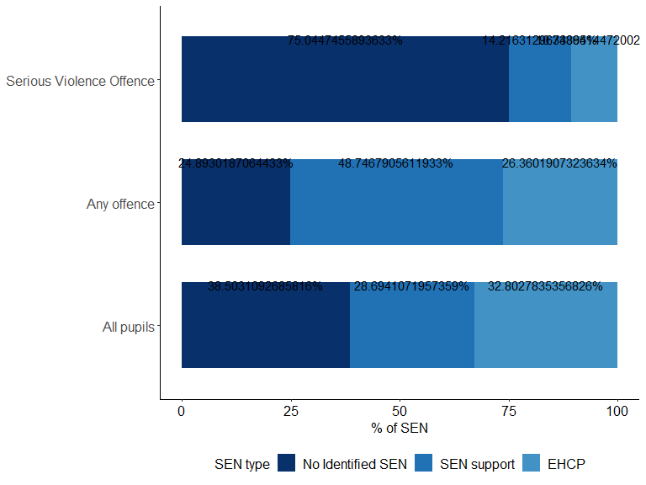

Special Educational Needs (SEN) of all pupils by offending and pupil group, for pupils matched to KS4 academic years 2012/13, 2013/14 and 2014/15. [Source: DfE-MoJ data share, table: …]

14.216313% of children who had been cautioned or sentenced for a serious violence offence and had attended school in TlDJE had ever had SEN support (without an EHC plan)[32], however only 14.3446852% of children who had ever had SEN support and had attended school in TlDJE were children who were cautioned or sentenced for a serious violence offence.

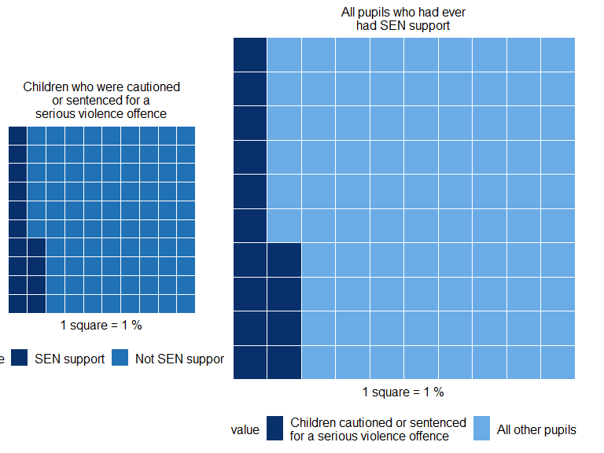

The proportion of children who had been cautioned or sentenced for a serious violence offence and had ever had SEN support, and all pupils who had ever had SEN support, for pupils matched to KS4 academic years 2012/13, 2013/14 and 2014/15 [Source: DfE-MoJ data share, table: …]

When looking at children who had ever had an EHC plan, 9.478673% of those that had attended school in TlDJE were children who were cautioned or sentenced for a serious violence offence.

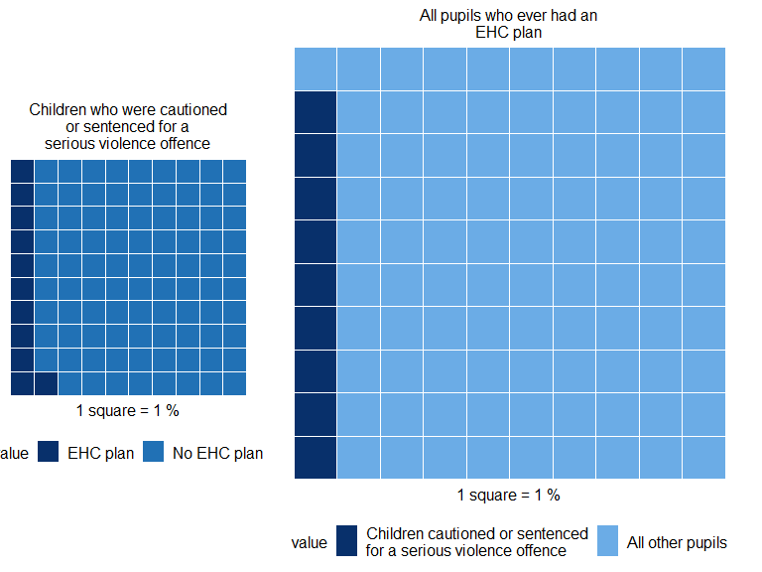

The proportion of children who had been cautioned or sentenced for a serious violence offence and had ever had an EHC plan, and all pupils who had ever had an EHC plan, for pupils matched to KS4 academic years 2012/13, 2013/14 and 2014/15 [Source: DfE-MoJ data share, table: …]

### Types of SEN

For this analysis, both primary and secondary SEN type have been considered when exploring types of SEN.

The most prevalent type of recorded SEN amongst children who had been cautioned or sentenced for an offence and went to school in TlDJE was Social, Emotional and Mental Health needs (SEMH)[33].

89.9620981% of children who had been cautioned or sentenced for an offence and had attended school in TlDJE were recorded with SEMH, compared to 1.9688059% of children who had been cautioned or sentenced for a serious violence offence and had attended school in TlDJE. The corresponding proportion for the all-pupil cohort in TlDJE was 60.3494226%.

Another SEN type of interest is Speech and Language Communication needs (SLCN). 84.09341% of children who had been cautioned or sentenced for an offence and had attended school in TlDJE were recorded with SLCN, compared to 29.9667604% of children who had been cautioned or sentenced for a serious violence offence and had attended school in TlDJE. The corresponding proportion for the all-pupil cohort in TlDJE was 70.276873%.

### Timing of SEN

*Did a child being identified as SEN commonly precede the first serious violence offence?*

For children who had been cautioned or sentenced for a serious violence offence, had attended school in TlDJE, and also had an EHC plan, 90.9090909% first had an EHC plan before their first serious violence offence[34].

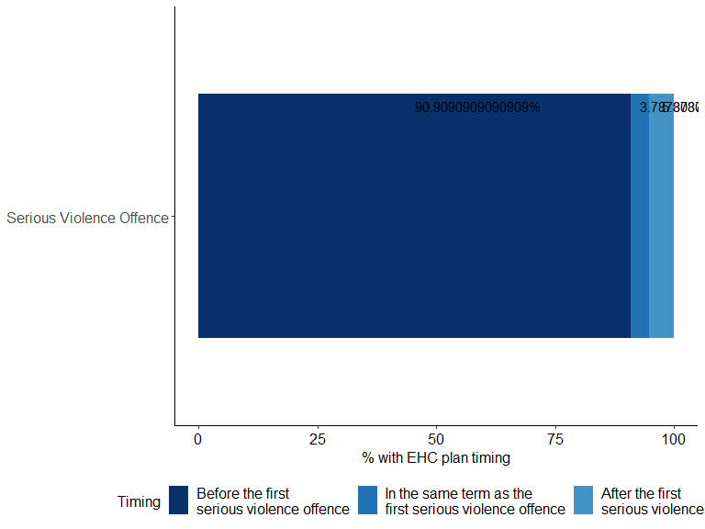

The first term children had an EHC plan, relative to the timing of their first serious violence offence, for pupils matched to KS4 academic years 2012/13, 2013/14 and 2014/15. [Source: DfE-MoJ data share, table: …]

For children who had been cautioned or sentenced for a serious violence offence, attended school in TlDJE, and had ever been recorded with SEN (either with or without an EHCP), 26.5957447% were first recorded with SEN before their first serious violence offence.

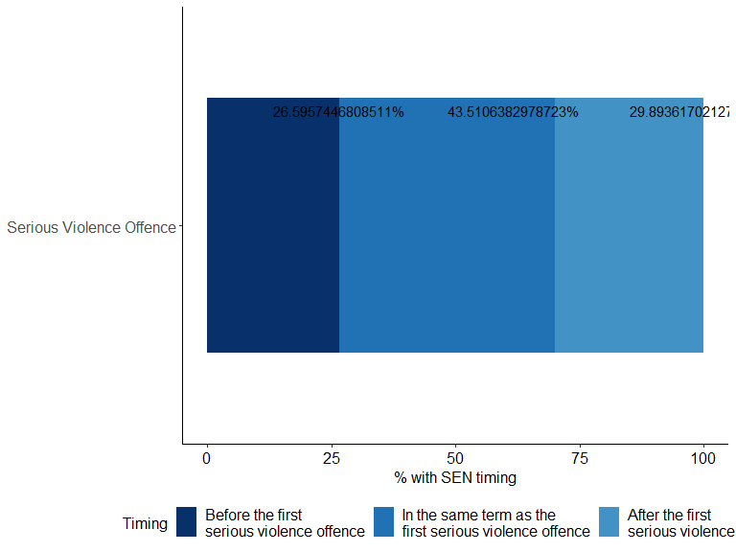

The first term children had been recorded with SEN, relative to the timing of their first serious violence offence, for pupils matched to KS4 academic years 2012/13, 2013/14 and 2014/15. [Source: DfE-MoJ data share, table: …]

### Timing of Social Emotional and Mental Health (SEMH)

As SEMH is consistently the most common recorded SEN type amongst children who had been cautioned or sentenced for an offence and had attended school in TlDJE, further analysis has been carried out on the timing of SEMH.

For children who had been cautioned or sentenced for a serious violence offence, had attended school in TlDJE and had ever been recorded with SEMH (either with or without an EHCP), 23.1404959% were first recorded with SEMH before their first serious violence offence.

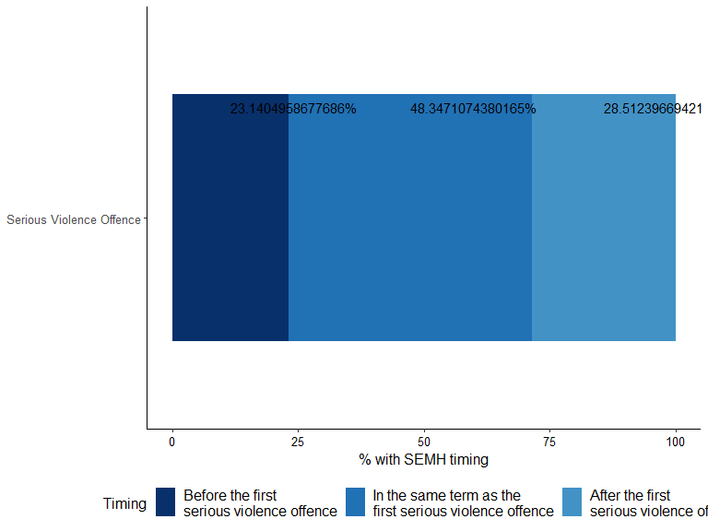

The first term children had SEMH, relative to the timing of their first serious violence offence, for pupils matched to KS4 academic years 2012/13, 2013/14 and 2014/15. [Source: DfE-MoJ data share, table: …]

## Children with a Social Worker

The next set of findings look at the proportion of children who had been cautioned or sentenced for an offence that were recorded as being children in need (CIN) or children who are looked after (CLA) on 31st March in any given year, as defined by the Children Act 1989, between 2011/12 – 2017/18 for CIN, and 2005/06 - 2017/18 for CLA[35] [36]. CIN here refers to children who are designated under a number of different social care classifications: children on a child in need plan; children on a child protection plan[37]; and children who are looked after[38]. As such, CLA figures are included in the figures for CIN. Since the CIN and CLA data cover different time periods, and CIN includes CLA for some of the same period, comparisons of CIN to CLA should be made with caution. To maximise coverage of the CIN data and avoid skewed results, the analysis in this section is based on children matched to KS4 academic year 2014/15 only.

When reading the findings related to children looked after (CLA), it is important to note that the introduction of the Legal Aid, Sentencing and Punishment of Offenders Act 2012 (LASPOA) meant that, from 3rd December 2012, children up to the age of 18 who are remanded to youth detention accommodation as a result of being charged with or convicted of an offence will be ‘looked after’ by the designated local authority[39]. Therefore, caution should be taken when considering the findings related to CLA and offending, as the child may have become CLA due to the offending.

Overall, children who had been cautioned or sentenced for an offence and had attended school in TlDJE were more likely to have been both CIN and CLA than the all-pupil cohort in TlDJE.

19.1919192% of children who had been cautioned or sentenced for an offence and had attended school in TlDJE were children in need on the 31st March in any given year when aged between 12 and 16[40] (approximately 100 children), compared with 22.0512821% of children who had been cautioned or sentenced for a serious violence offence and had attended school in TlDJE (approximately 40 children) and 5.5509112% of the all-pupil cohort that had attended school in TlDJE (approximately 660 children). For children who had been cautioned or sentenced for a serious violence offence, this result was at the 5% level.

7.6767677% of children who had been cautioned or sentenced for an offence and had attended school in TlDJE were CLA on the 31st March in any given year when aged between 6 and 16[41] (approximately 40 children), compared with 10.7692308% of children who had been cautioned or sentenced for a serious violence offence and had attended school in TlDJE (approximately 20 children). This compares to 1.3208494% of the all-pupil cohort that had attended school in TlDJE (approximately 160 children). For children who had been cautioned or sentenced for a serious violence offence in TlDJE, this result was at the 5% level.

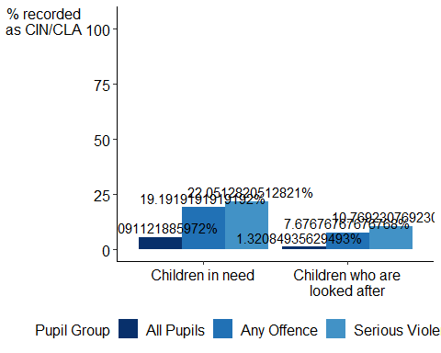

The proportion of children who had been recorded as being CIN/CLA on 31st March in any given year, by offending and pupil group, for pupils matched to KS4 academic years 2012/13, 2013/14 and 2014/15. [Source: DfE-MoJ data share, table: …]

Looking at the CIN and CLA cohorts that had attended school in TlDJE, 6.4759036% of those who were CIN and 13.2911392% of those who were CLA, on 31st March in any given year had ever also been cautioned or sentenced for a serious violence offence. Meaning that, although high proportions of the children who had been cautioned or sentenced for a serious violence offence had been CIN or CLA, it is not the case that most CIN or CLA are also cautioned or sentenced for a serious violence offence.

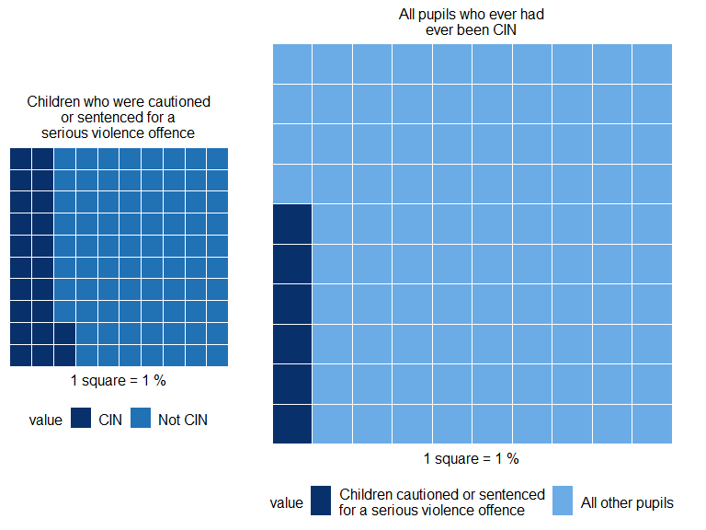

The proportion of children who had been cautioned or sentenced for a serious violence offence and had ever been CIN on 31st March in any given year, and all pupils who had ever been CIN on 31st March in any given year, for pupils matched to KS4 academic years 2012/13, 2013/14 and 2014/15 [Source: DfE-MoJ data share, table: …]

### Timing of CiN/CLA in relation to offence

*Did the first record of a child being known to children’s social care commonly precede the first serious violence offence?*

The focus of this analysis is to understand the sequencing of a child’s journey between different social care groups relative to the interaction(s) with the criminal justice system they may have had. It looks at children who had been cautioned or sentenced for a serious violence offence and whether their first record of being a child in need, a child on a child protection plan, and/or a child being looked after occurred before, after or during the same school term as their first serious violence offence (for those recorded as CIN, including CLA, as defined by the Children Act 1989, at any point in a given school term between 2011/12 – 2017/18 for CIN, and 2004/05 - 2017/18 for CLA).

The analysis presented here utilises a different dataset[42] to that used in the previous section of this publication, enabling more granular examination of those recorded in the children’s social care system at any point during the year, not just on 31st March, and to look at changes in their social care group throughout the year.

Children who had been cautioned or sentenced for a serious violence offence have been classified here as being CIN, CPP or CLA in an academic term, if at any point in that term they have been recorded as CIN, CPP or CLA[43].

55.5555556% of children who had been cautioned or sentenced for a serious violence offence, had attended school in TlDJE and were also recorded as a child in need, were recorded as such before their first serious violence offence. For CPP and CLA, the percentages were 23.0263158% and 40.7079646% respectively.

## Contact

Pupil place planning team

Publication: [Explore Education Statistics: Local authority school places scorecards](https://explore-education-statistics.service.gov.uk/find-statistics/local-authority-school-places-scorecards)

Department for Education enquiries: <hop.statistics@education.gov.uk>

Ministry of Justice enquiries <statistics.enquiries@justice.gov.uk>

download www.gov.uk/government/publications

This document was produced using the [DfE Analytical Services](https://github.com/dfe-analytical-services) Rmarkdown template, which is available on GitHub as part of our [R-Shiny data dashboard template](https://github.com/dfe-analytical-services/shiny-template).

1. For a full definition of Alternative Provision, please see the dedicated section below.
2. Offender numbers and pupil population figures quoted in this analysis may differ when analysing different education variables, since the information on these variables may not be recorded for all offenders and pupils.
3. See table 1.3.1 of the previously published [national statistics](https://view.officeapps.live.com/op/view.aspx?src=https%3A%2F%2Fassets.publishing.service.gov.uk%2Fgovernment%2Fuploads%2Fsystem%2Fuploads%2Fattachment_data%2Ffile%2F1059481%2FEducation_children_s_social_care_and_offending_tables.xlsx&wdOrigin=BROWSELINK)
4. The two major reforms referenced: 1) Professor Alison Wolf’s Review of Vocational Education recommendations which: restrict the qualifications counted; prevent any qualification from counting as larger than one GCSE; and cap the number of non-GCSEs included in performance measures at two per pupil, and 2) an early entry policy to only count a pupil’s first attempt at a qualification, in subjects counted in the English Baccalaureate.
5. The CIN census was introduced in 2008/09, and initially covered a reduced 6-month period. A full year collection was introduced in 2009 – 2010, however a number of local authorities were unable to provide a complete, clean children in need return for that year. Reviews were carried out on the CIN census and resulted in some data items being removed from the 2010 – 2011 collection onward.
6. The data share covers offences in the period 2000 – 2017. However, to reduce the skew of the data, the offence may have been committed at any point over the defined coverage period related to the offending group’s academic year. Offences included in the analysis were committed in the period up to and including 31 August 2015, 31 August 2016, 31 August 2017 for the offending groups with KS2 academic year 2007/08, 2008/09, 2009/10 respectively. Offence age was also limited to 10 and over.
7. A full list of offences included in the definition can be found in Annex B and the separate Technical Note.
8. Significance testing has been performed using the prop.test function in R, which is used for testing the null hypothesis that the proportions (probabilities of success) in several groups are the same, or that they equal certain values.
9. All offences were included in the analysis of age at first offence for children who had been cautioned or sentenced for an offence irrespective of whether they were also serious violence offences. Serious violence offences only were included in the analysis for children who had been cautioned or sentenced for a serious violence offence
10. Where a pupil’s ethnicity changes over time, the most recent ethnicity has been taken. Ethnicity information has been taken from the DfE school census, and from 2011, could only be completed by the child or their parents.
11. Ethnic group minor categories include Bangladeshi, Indian, Any Other Pakistani Background, Pakistani, Black African, Black Caribbean, Any Other Black Background, Chinese, Any Other Mixed Background, White and Asian, White and Black African, White and Black Caribbean, Information Not Yet Obtained, Any Other Ethnic Group, Refused, White British, White Irish, Traveller of Irish Heritage, Any Other White Background, Gypsy/Roma. For a more detailed breakdown of ethnic group minor, see accompanying publication tables.
12. The metric for free school meals (FSM) used in this analysis is FSM eligibility. Children are FSM eligible if a claim has been made by them, or on their behalf, and eligibility has been confirmed.
13. The figures discussed here are the combined results of all three cohorts, of whom reached the end of KS2 in 2007/08, 2008/09 and 2009/10. Based on the metrics used in this analysis, only a very small number of results for the 2009/10 cohort were withheld, in light of the boycott of the delivery of end of KS2 National Curriculum tests. It was determined that a sufficient volume of results were available for this cohort, and that the results of all three cohorts could be combined. Please see here for more information regarding the 2009/10 KS2 National Curriculum tests results: [National curriculum assessments: KS2 and KS3, 2010](https://www.gov.uk/government/statistics/national-curriculum-assessments-at-key-stage-2-and-3-in-england-academic-year-2009-to-2010-provisional)
14. The implementation of two major reforms in 2013/14 that affect the calculation of KS4 performance measures data mean that findings for KS4 attainment cannot be combined over the three year groups, and the analysis will refer to the results of those with KS4 academic year 2014/15 only.
15. [The School Day and Year](https://commonslibrary.parliament.uk/research-briefings/sn07148/)
16. For more information on the definition of pupil absences see [Pupil absence statistics: methodology](https://explore-education-statistics.service.gov.uk/methodology/pupil-absence-in-schools-in-england). This was changed from 15% to 10% in September 2015.
17. The definition of persistent absence includes all possible reasons for absence, including children whose absence was unauthorised, but the school was still provided with a reason for that absence (for example, an unagreed family holiday). The analysis has included this additional metric of absence (PAUO), as a way of differentiating those whose absence was not authorised and were unable to provide a valid reason for that absence, from those not attending school for any reason.
18. A breakdown of rates of persistent absence by reason code are included in the accompanying publication tables.
19. Suspension means a ‘fixed period’ non-attendance on disciplinary grounds. It can’t be open-ended but must have a defined end date that is fixed at the time when the suspension is first imposed.
20. Where a child is not present in school due to receiving a suspension or permanent exclusion they will be marked as absent for the first six consecutive days of that suspension or permanent exclusion provided no alternative provision has been arranged within those six days, which will negatively influence the child’s attendance rate. Where alternative provision has been arranged, they will be marked as attending that setting. It is therefore possible for children that had received successive suspensions within a term or year to see their overall absence equate to 10% of sessions possible or more.
21. Termly absence data has been used in this analysis. Throughout the rest of the publication, annual absence data has been used.
22. For children who were cautioned or sentenced for a serious violence offence, and had been persistently absent, the analysis compares whether the first school term they were flagged as persistently absent in, or PAUO, preceded the school term in which the serious violence offence took place.
23. Prior to 2019/20, suspensions were referred to as fixed term exclusions.
24. Note, suspensions data can include lunchtime suspensions, but suspensions during lunchtime have not been included in this analysis. Please see full definition here: [Pupil exclusion statistics: methodology](https://explore-education-statistics.service.gov.uk/methodology/pupil-exclusion-statistics-methodology)
25. Where children who had been cautioned or sentenced for an offence had received multiple suspensions/permanent exclusions, the analysis defined closest as the shortest amount of time between the start of the suspensions/permanent exclusions and the first serious violence offence date’
26. See accompanying tables for a full breakdown of the length of time between first/closest suspensions and permanent exclusions and the first serious violence offence.
27. Please see here for more information on AP statutory guidance: [Alternative Provision Statutory Guidance](https://www.gov.uk/government/publications/alternative-provision)
28. The Children and Families Act 2014 and the SEND Code of Practice (2015) covers children and young people with Special Educational Needs and Disabilities (SEND). A child or young person has SEN if they have a learning difficulty or disability which calls for special educational provision to be made for them. Children and young people have a disability if they have a physical or mental impairment which has a long-term and substantial adverse effect on their ability to carry out normal day-to-day activities. Children and young people with a disability do not necessarily have SEN, or vice-versa, but there is a significant overlap between disabled children and young people and those with SEN. Data collected and published by Department for Education only records children and young people identified with SEN.
29. [SEND code of practice: 0 to 25 years](https://www.gov.uk/government/publications/send-code-of-practice-0-to-25)
30. Prior to 2014, this category was School Action or School Action Plus. The term ‘SEN Support’ describes the actions taken to support children in mainstream settings who have been identified as having Special Educational Needs (SEN), but who do not have an Education, Health and Care plan (EHC plan). These children receive support and provision from resources already available within the school. Should a child require additional resources that the existing schools SEN support system does not include, then they can apply for a more detailed EHC plan, which outlines the educational, health and social needs of the individual and the specific provisions in place to support them.
31. From 2014 Education, Health and Care plans were introduced. Under previous legislation pupils could be eligible for Statements of SEN. The period for local authorities to transfer children and young people with Statements of SEN to EHC plans started in September 2014 and ended on 31 March 2018. For the purposes of this analysis, ‘EHC plan’ will be used to describe both Statements of SEN and EHC plans unless stated otherwise in the particular context.
32. The analysis throughout this publication refers to children with SEN support as children that had ever been identified as SEN, but never with an EHC plan.
33. There were changes to the classification of type of need in 2015 when the previous code of ‘Behaviour, emotional and social difficulties (BESD)’ was removed, and a new code ‘Social, emotional and mental health (SEMH)’ was introduced. However, those with a primary need of BESD in 2014 were not all expected to move to SEMH in 2015. The analysis combined results for the two SEN types, whilst understanding that SEMH was not intended to be a direct replacement for BESD. Results for types of SEN prior to 2014/15 will include BESD rather than SEMH.
34. This analysis aims to differentiate between children who had been cautioned or sentenced for an offence, or a serious violence offence, that have received different levels of support. As such, the analysis distinguishes between those that have had SEN support, but have never had an EHC plan, and those that have had an EHC plan, and when they were first recorded as receiving that support. It is important to note that this does not necessarily equate to when the child was first identified as SEN.
35. It is important to note on using this measure, the analysis takes no account of how long the children were in need, or in care, and does not count those who were in need, or looked after, during the period specified but were not in need, or looked after specifically on 31st March. As such, the figures stated will be an under-estimate of the true proportion of children in need and children who are looked after.
36. This diverges from the definition of Ever CIN used in the CIN Review, which looks at whether the child was recorded as so in the previous 6 years. Please see here for further details: [Children in need of help and protection: data and analysis](https://www.gov.uk/government/publications/children-in-need-of-help-and-protection-data-and-analysis)
37. Child Protection Plan (CPP) - support for a child where there is reasonable suspicion that child is suffering, or likely to suffer, significant harm.
38. Children who are looked after (CLA) – a child who is looked after by a local authority if they fall into one of the following: is provided with accommodation, for a continuous period of more than 24 hours (Children Act 1989, Section 20 and 21); is subject to a care order (Children Act 1989, Part IV), or is subject to a placement order. The analysis has not analysed children on a child in need plan (CINP) separately, but rather have looked at all children in need, and the two categories of highest intervention.
39. Please see here for more information: [Children looked after return 2020 to 2021](https://www.gov.uk/government/publications/children-in-need-of-help-and-protection-data-and-analysis)
40. Full CIN data is available from 2011/12, term 3. Children are included in this CIN analysis if they had been recorded as a child in need on the 31st March in any period between the ages of 12 - 16. Those matched to earlier years in the KS4 attainment data will as a result have less coverage than those matched to later years. For example: those with KS4 academic year 2012/13 have coverage from age 14 and above.
41. Children are included in this CLA analysis if they had been recorded as a child being looked after on the 31st March in any period between the ages of 6 - 16. Those matched to earlier years in the KS4 attainment data will as a result have less coverage than those matched to later years. For example: those with KS4 academic year 2012/13 have coverage from age 8 and above.
42. Termly CIN and CLA datasets were provided internally to enable us to complete this analysis.
43. A child can move between various stages of the social care system within and between terms, including into and out of need. Each child was assigned a termly activity label based on the following hierarchy: CLA – if a child has been looked after for at least one day in that term; CPP – if a child is not labelled as CLA and has been on a child protection plan for at least one day in that term; CIN – a child that falls into any of the two previous categories, or if they are CINP - if a child is not labelled as CLA or CPP and has been in need for at least one day in the term (child in need plan). The legal definition of children in need includes all disabled children. Unlike other children who must be assessed as in need, disabled children are classed as Children in Need by virtue of having a disability. Please see here for more information: [Children in need of help and protection: data and analysis](https://www.gov.uk/government/publications/children-in-need-of-help-and-protection-data-and-analysis)