Resident Hall Manager Northern Michigan College, Traverse City, Michigan

Dear Sir or Madam,

My long term goals:

- To receive all the training I need not to be ridiculed by an Assembly of God Minister. Even though it is not my fault people think I can do more than I can, it is my fault if I do not try.
- To marry a good, good looking woman, with a healthy child, 10,000 acres of Navel oranges, pecan and honeybees in Southern California, who is in love with me, begs me to give her a child and has a decent chance of becoming President of the United States. She should be 25% Christine Hayes, Robert F. and Patricia Ross Weis Professor of Religious Studies in Classical Judaica at Yale University, 25% Elizabeth Holmes, 25% Sarah Palin, and 25% unique.

When mom was dying she wanted to see her husband, my father. When I got him to the nursing home parking lot he called the police and wouldn’t let them leave until I gave up trying to get him to see her and agreed to take him home. As much as that turns my stomach it is a testament to my father’s good character that he never laid a hand on me.
But Jimmy Carter was right; it is a sin even to lust in the heart. My father died in 2009 and to this day I still occasionally wake up in the middle of the night scared he is going to lay his hand on me.
Mom was supposed to live two months, she lived four. I ate every meal with her except her last. She died the day I missed eating breakfast with her.

This is the last picture I have of her, an 87 year old woman, eight months before her death, walking out over rocky, uneven land to take a picture of her son and his garden.

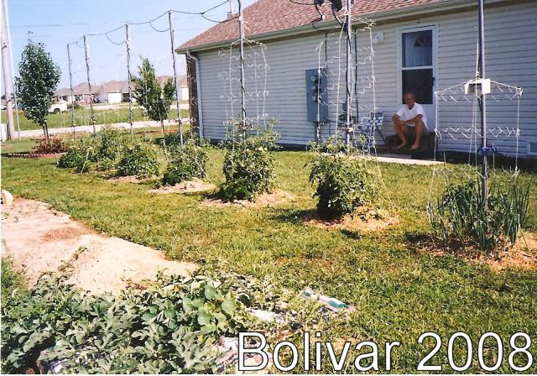

I do not match all of your requirements and preferences.

But I have six things most of your candidates will not have:

- 64 years of experience.
- 29 years of Windows system analysis.
- 14 years of Full Stack Development.
- At 64 a desire to start my life.
- Knowledge of how far computer training can take a person.
- And a desire to take a Master of Public Administration, a Bachelors of Science in Business Administration with an emphasis in Information Technology and end my days managing the computer resources of a small American town getting paid for all the work I have so far done for free.

Traverse City is a beautiful town.

My brother, Dr. Neal Fellows, and his wife Deborah Wyatt Fellows, the publisher of Traverse Magazine work in Traverse City and I’d like to move to Traverse City to be near them.

I am a self taught system analyst. I have done it for 29 years. There isn't anything I do not know about running Windows on a PC. There isn't anything I do not know about how to learn about what I do not know.

I am a self-taught full stack developer. I have done it for 14 years. I taught myself PHP and use it extensively in my website http://dfellows.rf.gd

For six years I created and maintained livebolivar.com, a website hosted on GODADDY to rent ~100 apartments and ~56 homes. I learned how to manage a website on a Linux shared server and using .htaccess, cPanel and Cloudflare. For six years I assisted the property manager of the Springhill Falls Apartments, Bolivar MO, maintaining and repairing approximately 100 apartments and 56 homes. I lived at the complex and would help the tenants, mostly college students, when they had problems after hours. He will be happy to talk with you.

I have two years to my Bachelors of Science in Chemistry at the University of Maryland, College Park and I would like to take an AAS degree in CIT Developer, CIT Infrastructure and Security and get my industry certifications so I can start getting paid.

I am in Missouri so I would like to do as much of the interview as we can do over the phone, by email, text, or video chat before I come up to Traverse City. You can see my résumé at http://dfellows.rf.gd/resume

I am looking forward to hearing from you.

Douglas Rae Fellows
1325 S Lillian Avenue 213
Bolivar, MO 65613
tel://4173999579

dfellows2@gmail.com

http://dfellows.rf.gd

