1. The Tumor Volume has shown a strong reaction to the drug Capomulin. While Capomulin has proven to decrease the overall size of the tumor, all the other drugs have not affected the overall size of the tumor. There has also been a rather low standard error. Also, it was worth noting that the drug Ketapril could have also made the size of the tumor larger than no treatment at all. It took about 25 days for the drug Capomulin to decrease the size of the tumor about 10%.

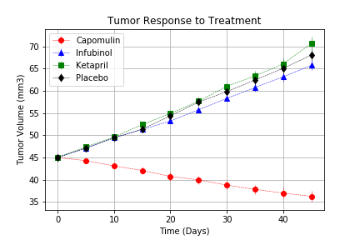

1. In the analysis of Metastatic Site spreading while undergoing treatment almost all of the drugs performed better than the placebo. Although all the drugs performed better than the placebo and there was a relatively large standard error, the Capomulin drug performed the best. The Ketapril seemed to slow the overall spread but by the end of the treatment it had nearly equal number of metastatic sites. By the end the Capomulin had produced the best outcome with less than half the number of metastatic sites.

1. When looking to the overall survival rate and overall performance of the drugs in question there is no doubt that the drug with the best results is Capomulin. Also based on the overall trends of these drugs performance when considering tumor size and metastatic site spread it seems that all the other drugs do not affect the overall outcome of the patient. Capomulin provides a survival rate of nearly 85% which is about 45-55% better than the rest of the drugs.

