Mapping Service — System Architecture
How raw source data is transformed into a validated, structured entity record
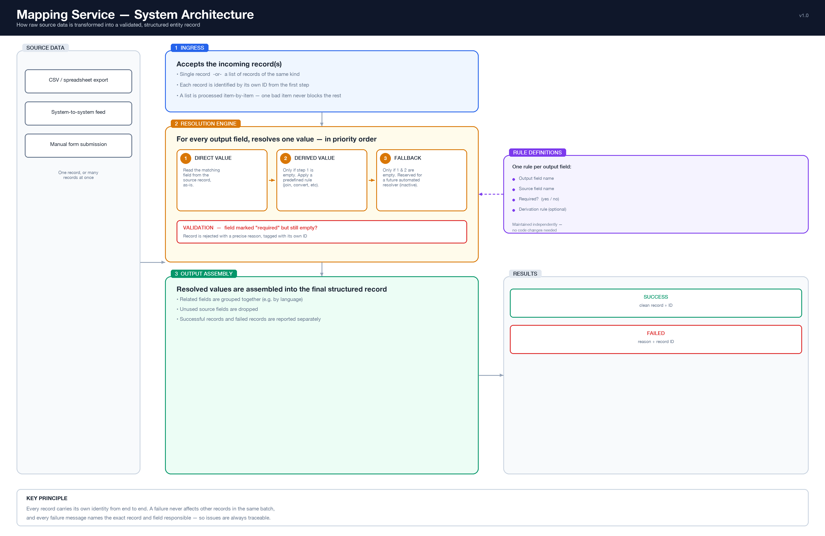

Summary
The Mapping Service converts raw, inconsistent source records (CSV exports, external system feeds, manual submissions) into clean, validated, structured entities, driven entirely by configuration rather than code. Each target field is resolved through an ordered pipeline — direct field mapping, then a configurable derivation rule, then a reserved automated fallback — and any field marked mandatory is enforced before the record is accepted. The service accepts a single record or a batch; within a batch, each record is evaluated independently so one failure never affects the rest.

Key Characteristics
Configuration-driven | Field mappings and validation rules are stored as data, not code — changes require no deployment.
Deterministic resolution order | Direct value → derived value → fallback, evaluated in that fixed order for every field.
Batch-safe isolation | A malformed or invalid record in a batch is reported individually; it does not abort the batch.
Full traceability | Every success and every failure is tagged with the source record's identifier.

