**Problem 1 SQL Querying**

All SQL script may be found in the **SQL_Problem** folder

**A.**

SELECT (SELECT count(*) FROM driver WHERE NOT is_test_account) * 100 / count(*) AS not_test_driver_percentage

FROM driver

**B.**

SELECT count(*)

FROM trips

WHERE 1 = 1

AND status = 'completed'

AND completed_at >= '2016-01-01 00:00:00'

AND completed_at <= '2016-12-31 23:59:59'

AND driver_uuid NOT IN (SELECT uuid FROM driver WHERE is_test_account)

**C.**

SELECT 1.0 * count(tc_filter.uuid) / count(distinct(driver_uuid)) AS average_trip_per_driver, tc_filter.city_name

FROM

(SELECT * FROM

(SELECT t.uuid, t.driver_uuid, t.request_at, c.timezone, c.city_name, c.country_name

FROM trips AS t

INNER JOIN city AS c ON t.city_uuid = c.uuid

WHERE 1 = 1

AND c.country_name = 'United State') AS tc

WHERE 1 = 1

AND CONVERT(timestamp, SWITCHOFFSET(tc.request_at, DATENAME(TzOffset, tc.timezone))) >= '2017-01-01 00:00:00'

AND CONVERT(timestamp, SWITCHOFFSET(tc.request_at, DATENAME(TzOffset, tc.timezone))) <= '2017-01-31 23:59:59') AS tc_filter

GROUP BY tc_filter.city_name

HAVING count(tc_filter.uuid) > 100000

**D.**

CREATE TABLE cancellation_rate AS

SELECT t.driver_uuid, t.uuid AS trip_uuid,

1.0 *

(SELECT count(*)

FROM trips

WHERE 1 = 1

AND t.driver_uuid = trips.driver_uuid

AND t.request_at >= trips.request_at

AND status = 'cancelled' )

/

(SELECT count(*)

FROM trips

WHERE 1 = 1

AND t.driver_uuid = trips.driver_uuid

AND t.request_at >= trips.request_at) AS pct_cancelled,

1.0 *

(SELECT count(*)

FROM (SELECT *

FROM trips

WHERE 1 = 1

AND t.driver_uuid = trips.driver_uuid

AND t.request_at >= trips.request_at

ORDER BY trips.request_at

LIMIT 100) AS t1

WHERE t1.status = 'cancelled')

/

(SELECT count(*)

FROM (SELECT *

FROM trips

where 1 = 1

AND t.driver_uuid = trips.driver_uuid

AND t.request_at >= trips.request_at

ORDER BY trips.request_at

LIMIT 100) AS t2) AS pct_cancelled_last100

FROM trips AS t

WHERE t.driver_uuid NOT IN (SELECT uuid FROM driver WHERE is_test_account)

**Problem 2 Data Quality / Data Analysis**

Language: Python

Package: pandas, numpy, matplotlib, statsmodels, sklearn, seaborn

Source code file: **Problem2.py**

**A.**

Data cleaning is performed by function ﻿***filter_raw_data(data)***. The following steps have been done:

**Step 1 Reformat Data and Transform Data Type:** 1) Reformat data in ‘Miles’ column, i.e. number string ‘19,380’ is reformatted to ‘19380’; 2) Transform data type in ‘Miles’ from string to integer type. Transform ‘Month_Ending’ column from string to pandas.Timestamp; 3) Using integer type to represent categorical data in ‘Product’ and ‘City’ column for better sorting and modeling purposes.

**Step 2 Filter Invalid Values:** Remove rows has **zero values** in ‘Miles’ column and **negative values** in ‘﻿Reported_Accidents’ column

**Step 3 Remove Outliers:** Using quantile, remove rows has more than 2000 accidents per million miles, since 2000 accidents are too large to be true. However, these rows need to be double checked for correctness, because some of them might be true value. For example, row 6541

|  |  |  |  |  |  |
| --- | --- | --- | --- | --- | --- |
| 11/30/16 | Segment F | City 57 | Product 9 | 8,885 | 255 |

has too many accidents to be believed in.

**B.**

Four figures are provided as follows. Figure 1 is the overall accident rate per million miles per month. Figure 2 shows accident rate by each segment. Figure 3 is the accident rate by city. Figure 4 is a box plot showing the distribution of accident rate across all product. All figures could be reproduced by **Problem2.py.**

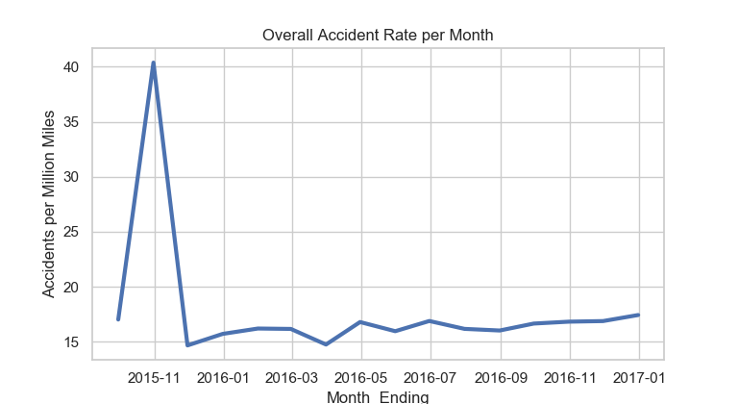

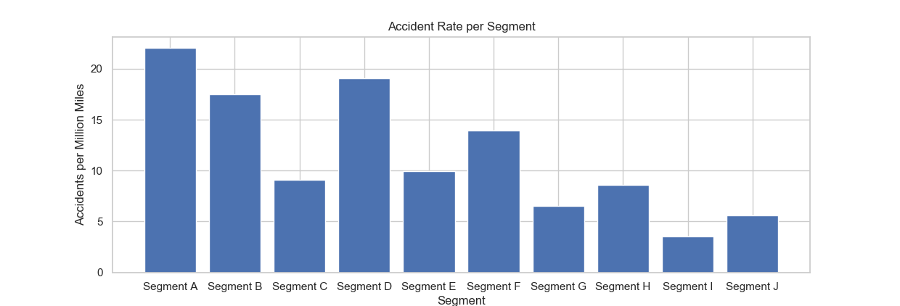

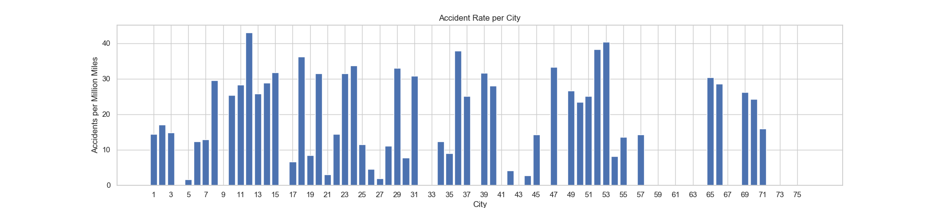

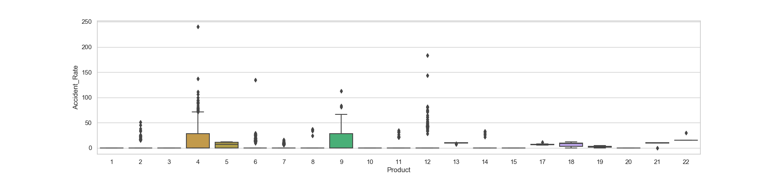

**C.**

An Autoregressive model is developed to predict the accident rate for Jan 2017. The prediction function in the code is ﻿***auto_regressive(data, p = 6)***. The prediction is made using the accident rate in the past 6 months.

**Predicted accident rate of Jan 2017 is: ﻿17.3079 accidents per million miles**

Plotting the predicted data together with the previous month:

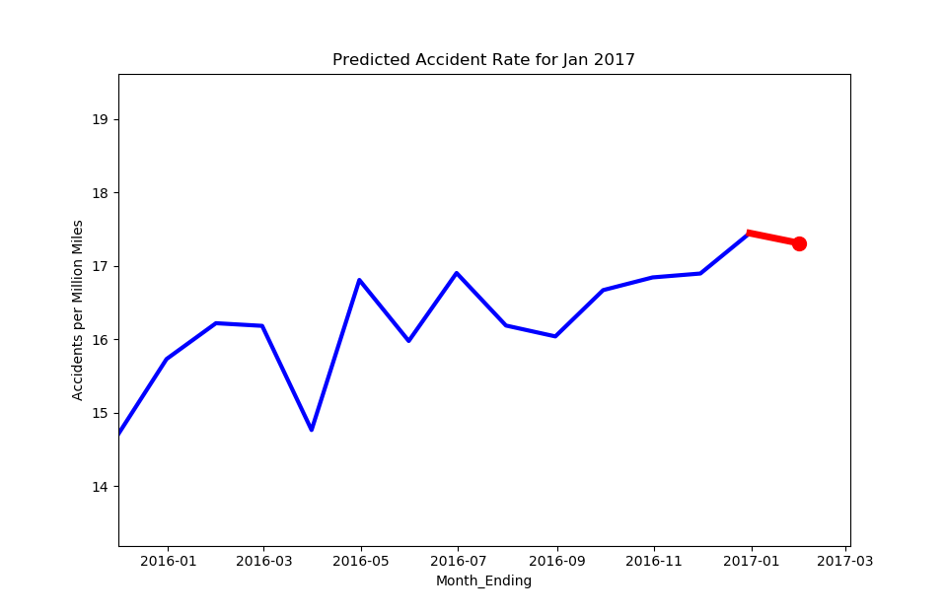

**D.**

A machine learning model is built to fit the data. 85% of the data is used for training and k-fold cross validation, while 15% of data is used for testing. Scikit-learn package is applied for the modeling, training, and testing. The model **evaluation metric is R2**.

1. A Ridge Regression with 3-fold cross validation is built in **Problem2.py** from line **125 to line 166**. Since the volume of data and number of features are small, a first order linear model is sufficient.
2. **1) Feature Selection:** Selecting features that are independent, relevant to the output, and have a greater variance. My approach is to start with ‘City’ as the first feature. Once adding or reducing a new feature, re-train and re-evaluate the model using R2. If the R2 value increases by adding the new feature, thus this new feature could increase the predicting power. For example, by adding and removing ‘Month_Ending’, R2 does not change across the testing data, then ‘Month_Ending’ is not a good feature. The final features are: ‘﻿Segment’, ‘City’, and ‘Product’.

**2) Feature Encoding:** Since all selected features are categorical features, they must be encoded using one-hot encoding. One-hot encoding is performed by scikit-learn ﻿preprocessing.OneHotEncoder.

1. The model is evaluated by R2. By shuffling the data, **R2 of the testing data is ranging from: 0.40 – 0.49.** Meaning that 40% to 49% of the information in the data could be represented by the model. Because there are only 3 categorical features without any continuous features, 0.49 is the best R2 result I could get. The predicting power could be better if there are more features. The following figure is a segment from the testing data showing the predicting power.

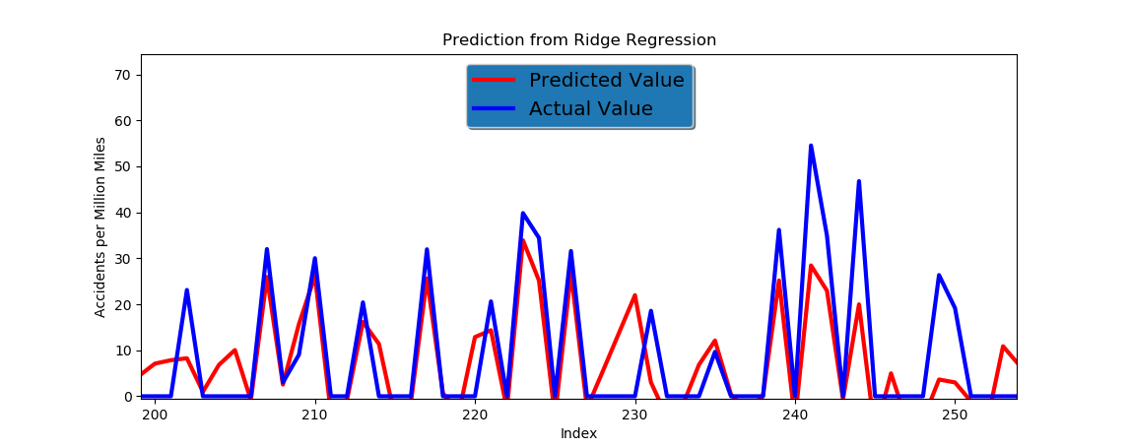

**E.**

The initial problem was asking for testing accident **per mile**. Since the number is so small, I am still using accident **per million mile** in here.

1. For Segment G: ${\overline{X}}_{G}=﻿6.9717, s_{G}=﻿1.3036, n_{G}=﻿16$

For Segment A: ${\overline{X}}_{A}=﻿﻿7.1405, s_{A}=﻿﻿16.093, n_{A}=﻿5535$

Our hypothesis is: $H_{0}: {}_{A}={}_{G}, H_{1}: {}_{A}≠{}_{G}$

Assuming $H_{0}$ is true, the level of significance is $α=0.05$, so the critical values of z are -1.96 and +1.96.

Z score is: $z=\frac{{(\overline{X}}_{A}- {\overline{X}}_{G}) - ({}_{A}-{}_{G})}{\sqrt{{σ_{A}^{2}}/{n_{A}}+{σ_{G}^{2}}/{n_{G}}}}=\frac{\left(7.1405-6.9717\right)-0}{\sqrt{{{16.093}^{2}}/{5535}+{{1.3036}^{2}}/{16}}}=0.43154$

-1.96 < 0.43154 < 1.96. Fail to reject $H_{0}$. Accident rate of Segment G and Segment A is the same (no difference).

1. For Segment G: ${\overline{X}}_{G}=﻿6.9717, s_{G}=﻿1.3036, n_{G}=﻿16$

For Segment A: ${\overline{X}}_{B}=﻿﻿4.2798, s_{B}=﻿﻿﻿9.2424, n_{A}=﻿596$

Our hypothesis is: $H_{0}: {}_{B}={}_{G}, H_{1}: {}_{B}≠{}_{G}$

Assuming $H_{0}$ is true, the level of significance is $α=0.05$, so the critical values of z are -1.96 and +1.96.

Z score is: $z=\frac{{(\overline{X}}_{G}- {\overline{X}}_{B}) - ({}_{B}-{}_{G})}{\sqrt{{σ_{G}^{2}}/{n_{G}}+{σ_{B}^{2}}/{n_{B}}}}=\frac{\left(4.2798-6.9717\right)-0}{\sqrt{{{1.3036}^{2}}/{16}+{{9.2424}^{2}}/{596}}}=-﻿5.3888$

﻿-5.3888 < -1.96. Reject $H_{0}$. Accident rate of Segment G and Segment B is different.

1. For Segment G: ${\overline{X}}_{G}=﻿6.9717, s_{G}=﻿1.3036, n_{G}=﻿16$

For Segment A: ${\overline{X}}_{A}=﻿﻿7.1405, s_{A}=﻿﻿16.093, n_{A}=﻿5535$

Our hypothesis is: $H_{0}: {0.6}_{A}>{}_{G}, H_{1}: {0.6}_{A}≤{}_{G}$

Assuming $H_{0}$ is true, the level of significance is $α=0.05$, so the critical values of z are -1.96 and +1.96.

Z score is: $z=\frac{{(0.6\overline{X}}_{A}- {\overline{X}}_{G}) - ({}_{A}-{}_{G})}{\sqrt{{σ_{A}^{2}}/{n_{A}}+{σ_{G}^{2}}/{n_{G}}}}=\frac{\left(0.6*7.1405-6.9717\right)-0}{\sqrt{{{16.093}^{2}}/{5535}+{{1.3036}^{2}}/{16}}}=﻿﻿-6.8704$

﻿-6.8704 < -1.96. Reject $H_{0}$. Accident rate of Segment G is not 40% lower than Segment A.

**Problem 3 Spatial Analysis**

Language: Python

Package: pandas, googlemaps, numpy, folium, geopandas, multiprocessing

Source code file: **Problem3.py**

**A.**

For **raw data**:

Mean: ﻿**1446.825**

Median: ﻿**872.002**

Absolute difference of 75th and 25th percentile: ﻿**1330.085**

For **filtered** **data**:

Mean: ﻿ ﻿**1393.443**

Median: ﻿ ﻿**866.585**

Absolute difference of 75th and 25th percentile: ﻿**1308.206**

**B.**

The data is filtered based on the widgets quantile. The **maximum** value of the widgets is ﻿**532006.925**. However, the **99.5%** quantile is only **9288.831**, meaning the data is long tailed and majority of the values are below **9288.831**. So, the widgets values above **99.5%** quantile could be discarded.

Similarly, the **0.05%** quantile appears ﻿at **0.10538**, while the **minimum** widgets value is **﻿-0.888099**. Considering the mean value is **1393** and median value is **866**, values below **0.05%** quantile have negligible contribution in Problem C and the negative widgets values could also be noises as well.

Therefore, the filtered data only preserve widgets values between **0.05% (0.10538)** and **99.5% (9288.831)** quantile. Deleting data from the head and tail will have counter affects towards mean and medium. However, the large values at the tail contributes more to the mean and median. Both mean and medium shift to smaller values in the filtered data.

**C.**

**Big Data Approach:**

Since the data volume is very large, a **MapReduce** design pattern is employed. Data set is split into **16** chunks and run by **16** parallel processes in function *﻿****parallelize_dataframe(df, func, num_partitions, num_threads)***. Each process works on a chunk of data and calculate the state total widgets on that single chunk. Finally, the master merger summarizes the 16 results into the final result.

To accelerate the process, the code was deployed to an AWS EC2 cloud computing server with 16 cores and 128GB memory.

**Geo Location Querying:**

I implemented two methods for coordinate-to-state query. (1) Using Reverse Geocoding from Google Map in function***﻿get_state_count_google(data)***; (2) Using point-in-polygon search in function ﻿***get_state_count(data)***.

Both (1) and (2) works for this problem, however, I finally applied method (2) because method (1) was IO bounded, and required constant Internet traffic to Google server.

1. ﻿**South Dakota** has the minimum total widgets at ﻿**9903.68**.
2. **New Mexico** has the 4th highest total widgets at **213280521.41**.
3. The table to total widgets by state is as below. It could also be found in: **state_widgets_count.csv.**

A choropleth is attached as below. The interactive choropleth map is in: **State_Total_Widgets.html**

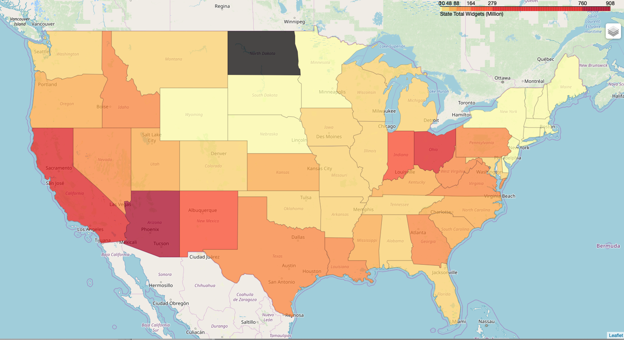

|  |  |
| --- | --- |
| state | total_widgets |
| Alabama | 21516533.2 |
| Arizona | 908227710 |
| Arkansas | 15670532 |
| California | 600450851 |
| Colorado | 38266531.4 |
| Connecticut | 262525.819 |
| Delaware | 8829184.28 |
| District of Columbia | 219152.492 |
| Florida | 41727423.6 |
| Georgia | 124275730 |
| Hawaii | 367774.546 |
| Idaho | 87536593.3 |
| Illinois | 33568196.6 |
| Indiana | 189354517 |
| Iowa | 12286172.8 |
| Kansas | 83483735.7 |
| Kentucky | 71199648 |
| Louisiana | 107832139 |
| Maine | 55980.2564 |
| Maryland | 42117649.3 |
| Massachusetts | 5049437.46 |
| Michigan | 25175804.5 |
| Minnesota | 2872221.36 |
| Mississippi | 60188112.4 |
| Missouri | 16936523.7 |
| Montana | 40169063.5 |
| Nebraska | 560656.387 |
| Nevada | 158101728 |
| New Hampshire | 67912.876 |
| New Jersey | 8824739.47 |
| New Mexico | 213280521 |
| New York | 6638641.02 |
| North Carolina | 80763532.7 |
| Ohio | 322087816 |
| Oklahoma | 29186074.1 |
| Oregon | 71474928.7 |
| Pennsylvania | 93920668.4 |
| Rhode Island | 292112.95 |
| South Carolina | 79306536.1 |
| South Dakota | 9903.68379 |
| Tennessee | 21964961.1 |
| Texas | 148795191 |
| Utah | 48899767.5 |
| Vermont | 32415.7107 |
| Virginia | 107499817 |
| Washington | 29574436.7 |
| West Virginia | 133604484 |
| Wisconsin | 17502276.7 |
| Wyoming | 2601794.57 |