Ramapo College of New Jersey
School of Contemporary Arts
MUSI 650 - 20 : Creative Musical Coding
Fall 2026

Course Repository: https://github.com/dfict/MUSI-650-20

Daniel Fishkin
Assistant Professor of Music (Production)
Office: H-108
Phone: (201-684) x7233
Email: dfishkin@ramapo.edu
Office Hours: Tuesday (2:00—4:00)
Wednesday (3:00—5:00)

SYLLABUS IS SUBJECT TO REVISION DURING THE SEMESTER

Course Description: This course provides a foundational introduction to music programming languages. SuperCollider, Max, Arduino, p5js and straight C will be explored through hands-on and creative applications. Students will gain experience with interactive visual art, audio/music signal processing, and machine learning.

This course does not provide a thorough introduction to any single computing language. Rather, it expects an encourages a humanistic approach translating higher level concepts of art to lower and very low levels of applications specific to your intent.

Course Instructor: Daniel Fishkin

Lecture Time: Wednesdays, 6:05 pm — 9:35 pm

Lecture Location: Electronic Music Lab, H-Wing 204 or remote.

Instructor: Daniel Fishkin
Office Hours: by appointment (IRL or Remote)
E-mail: daniel.fiction@gmail.com
dfishkin@ramapo.edu

Materials Fee: $25
Textbooks: Bruno Ruviaro, A Gentle Introduction to Supercollider https://ccrma.stanford.edu/~ruviaro/texts/A_Gentle_Introduction_To_SuperCollider.pdf
Valle, Andrea. Introduction to Supercollider. Logos Verlag Berlin. 2016. 3832540172
Shiffman, Daniel. The Nature of Code. Creative Commons. 2012. 0985930802

Software Max
https://cycling74.com/
Max is an object-oriented programming language that makes easy prototyping of sound environments/instruments accessible without needing to learn to code on levels like JS or C. It is a type of coding language in its own way, but the coding is done primarily with virtual representations of wires. It’s very fun and many of my class demos will get you excited about what’s possible—download it and see what you can get working off the bat!
Note: you can try Max for free for 30 days, and thereafter you’ll need to purchase it, or sign up for a monthly or yearly student subscription. It is affordable. Conn College has Max on every machine in the computer lab!
Max comes with an extensive body of educational materials, tutorials, help files, and project examples that can easily be copy/pasted into your own sketches. Students will be expected to read and study Max / MSP tutorials on their own
Enter the MAX file browser and search:
collection:"Tutorials/Max Tutorials@cycling74"
collection:"Tutorials/MSP Tutorials@cycling74"

Supercollider
https://supercollider.github.io/downloads.html
Supercollider is a platform for audio synthesis and algorithmic composition, used by musicians, artists and researchers working with sound. It is code-based, completely free, light in size, and a little hard to work with.

Spear
https://www.klingbeil.com/spear/
Spear performs Fourier Analysis in sound files. This is free software that allows you to turn recordings into individual sine waves and edit/select them.

Python
Extremely powerful code based platform
https://www.python.org/downloads/
Arduino (Processing)
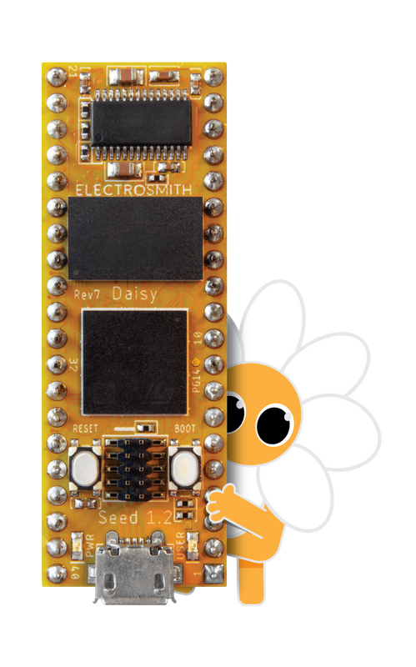
Hardware coding 101!

Hardware: Daisy ElectroSmith
https://electro-smith.com
Small low powered microcontroller
“Daisy is an embedded platform for music. It features everything you need for creating high fidelity audio hardware devices. Just plug in a USB cable and start making sound! Programming the Daisy is a breeze with support for a number of languages including C++, Arduino, and Max/MSP Gen~. To get started, simply upload an example program over USB, and start tweaking!”

Course Repository: https://github.com/dfict/MUSI-650-20
Since this is a coding class, we use Git for version tracking. I am constanting updating, refining, refactoring, and revising code bases throughout the semester and many times throughout the week. Please learn to use Github! Download Github Desktop and make an account asap.

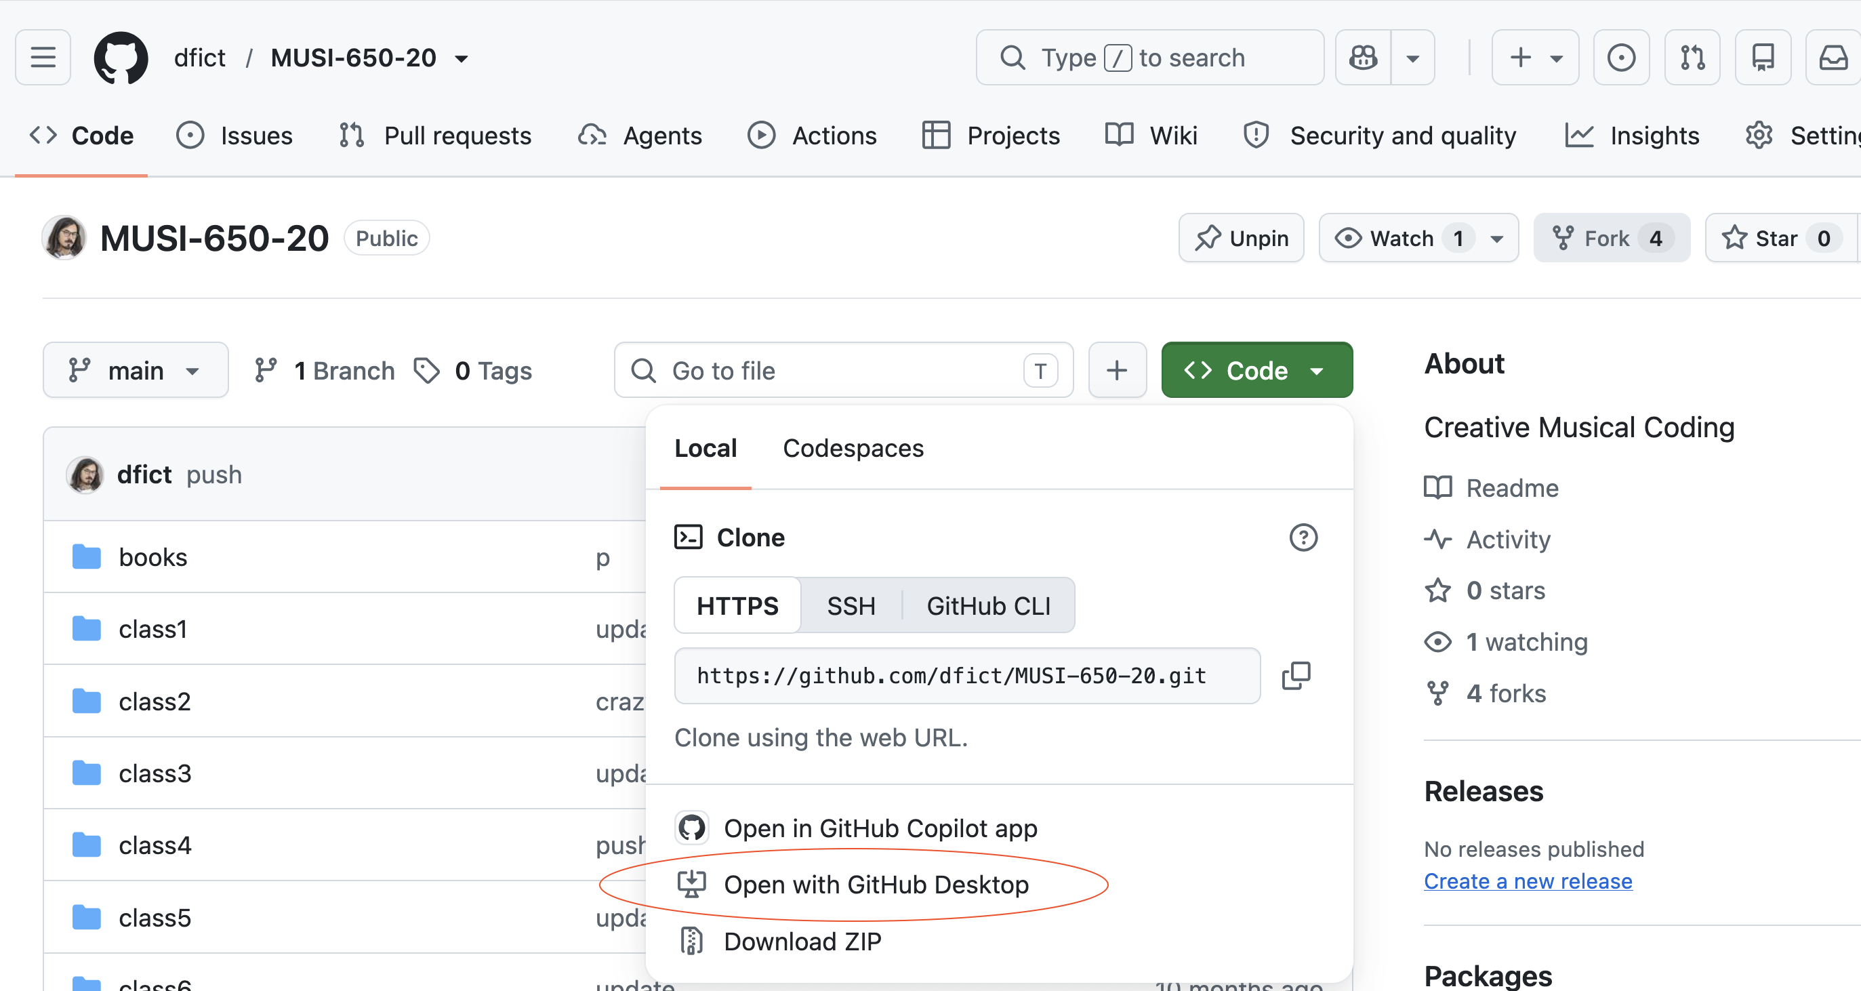
1: Download Github desktop, Go to the link above, and click "open with github desktop". It will automatically download the class repository locally. You must check this every week, and see if I have pushed any changes.

Course Objectives:

● Production Techniques: evaluate and apply advanced techniques in music production, synthesis, recording, programming, editing, and mastering;
● Theoretical Foundations: identify and interpret core theoretical foundations of audio;
● Context: analyze and articulate the importance of context in diverse practices within music technology;
● Musicianship and Production: integrate traditional, non-Western, and experimental approaches to musicianship and composition with music production skills;
● Collaboration: collaborate with others effectively and demonstrate leadership in professional situations; and
● Innovation: recognize and formulate innovative approaches to music technologies and careers.

Course Goals
● Understanding the relationship between computer programming, music, and digital audio
● Developing core proficiencies relevant to algorithmic composition, interface design, computer programming, analysis and signal processing
● Gaining the ability to read, write, and modify computer code related to music.

Measurable Student Learning Outcomes
● Comprehend the importance of music programming in improvised and notated contemporary music (Projects)
● Demonstrate the ability to create programs in SuperCollider, Python, Processing and C++ in the production of compositions and performances (Projects)
● Understand the fundamentals of computer programming languages for music and be able to implement them to build original Audio Unit & VSTplugins (Projects)
Grading Rubric
Class Participation / Attendance 25%
Etudes / Projects/ 35%
Presentation 15%
Final Project 25%

Class Participation / Attendance 25%
Class attendance is mandatory. We work and experiment in class. Discussions, critiques lectures and demonstrations provide the basis for the successful completion of projects, and they are difficult to re-create outside of class. In order to participate, you must be in attendance.

You have one unexcused absence permitted for the semester. Your final grade will drop by 4 points for each further unexcused absence. More than four absences will result in a failing grade for the course. You are expected to participate actively in class by asking questions, bringing energy to discussions, and arriving with prepared homework/projects. Independent motivation is expected.

The following classes will be online
(that does not mean cancelled)
9/9
9/16
10/14
11/11

Etudes / Homework 25%
Short reading assignments or creative prompts will be assigned each week. Students will be expected to complete them and come to class ready to discuss their progress. You cannot catch up!—they are meant to be part of a weekly practice that is customized to the flow of the class.

Presentation 25%
Do a short research presentation on an artist, or an instrument, or piece of art that inspires you, taking into note how computation / programming is used as an integral part.
It’s not enough to merely talk about a musician you like, and some synths they use.
You have to identify and explain a technological process.
It should be appropriately cited, referenced. You should not just link to Youtube videos and let the video do the talking.
The purpose of this assignment is to aid the development of your final project by creating an opportunity to research something that interests you for your own creative purposes and research agenda.
25 min.

Final Project 25%
Make a creative thesis and execute it. The project may include video, audio, and may somehow utilize a computational process. You can use synthesis, sampling. You can also pursue something mentioned in class but not explicitly explored. You are invited not to merely make a demo—Make a piece! I would even accept a project in Max MSP. You can use your recorded corpus or create a new one. Students may work collaboratively. The project must be proposed and accepted by instructor.

AI Policy
The use of Machine Learning tools such as ChatGPT and Claude are permitted, generally. In some cases we will explore them deliberately. In some instances you will be discouraged from using these tools. AI represents a sea change for humanity. It also represents a paradigm shift for pedagogy in digital literacy.

I expect you will want to use AI (ChatGPT and image generation tools, at a minimum), in this class. In fact, some assignments will require it. Learning to use AI is an emerging skill—be aware of its limits. If you provide minimum effort prompts, you will get low quality results. You will need to refine your prompts in order to get good outcomes. This will take work.

Don’t trust any code that your AI provides you. You will be responsible for any errors or omissions provided by the tool. AI is a tool, but one that you need to acknowledge using. Please include a paragraph or citation on any assignment that uses AI explaining what you used the AI for and what prompts you used to get the results. Failure to do so is in violation of the academic honesty policies. Remember: it’s valuable to flow from functional code to interesting code and sharing that evolution shares your thought process.

A Note on Sexual Misconduct
Ramapo College is committed to fostering a safe, productive learning environment. Title IX and our college policy prohibit discrimination on the basis of sex or gender. Sexual misconduct — including harassment, domestic and dating violence, sexual assault, and stalking are prohibited. The College encourages anyone experiencing sexual misconduct to talk to someone about what happened, so they can get the support they need and our college can respond appropriately.

If you wish to speak confidentially about an incident of sexual misconduct, please contact the Counseling Center at 201-684-7522 or 201-684-6666 during nights and weekends. If you wish to report sexual misconduct or have questions about policies and procedures regarding sexual misconduct, please contact the College’s Title IX Coordinator at 201-684-7540.

The College is legally obligated to investigate reports of sexual misconduct, and therefore it cannot guarantee the confidentiality of a report, but it will consider a request for confidentiality and respect it to the extent possible.

As a faculty member, I am also required by our College to report incidents of sexual misconduct and thus cannot guarantee confidentiality, but I will respect your privacy and only share the information with those who have a duty to respond. Should I become aware of an incident involving sexual misconduct, I must provide our Title IX Coordinator with relevant details such as the names of those involved in the incident.

SCHEDULE

Class 1 Wednesday 8/26

Introduction to Instructor, me, Daniel Fishkin
Introduction to Course and to the syllabus
Introduction to course topics
Introduction to the SuperCollider 3 environment
Server and Language
Reading:
A gentle Introduction to Supercollider
https://ccrma.stanford.edu/~ruviaro/texts/A_Gentle_Introduction_To_SuperCollider.pdf
Pages 1-22
SC tutorial: Getting Started With SC: sections 1 – 5
https://doc.sccode.org/Tutorials/Getting-Started/00-Getting-Started-With-SC.html

Etude 1 (due 9/3 next week):
Go shopping!
Try out all examples from 3_SC2-examples_1
Or
Go to http://sccode.org/
Or
https://ccrma.stanford.edu/~kermit/website/sctweets.html
Try out at least 10 sound examples.
Select one that you would like to understand better and modify it.
Using Claude or ChatGPT, Modify it so it sounds like something you are excited about.
Submit the original code, the modified code, and your conversation.

Nice videos to get you started:
Live Coding in SuperCollider: a Tutorial with Eli Fieldsteel https://www.youtube.com/watch?v=rlf8XBxLfRM
https://www.youtube.com/playlist?list=PLPYzvS8A_rTaNDweXe6PX4CXSGq4iEWYC
Watch one or two of these each week

Class 2 Wednesday 9/2

Reviewing Supercollider syntax
Learning NodeProxy—The simplest and most direct way to recycle and utilize code in instruments, live, in Supercollider.
Learning Synthdef—the standard way to program synths for global programming concepts in SC

Reviewing Etude 1

Etude 2 Assigned:
Prepare 3 synthesis tools in Supercollider that work with NodeProxy OR synthdef, building in arguments, potentially for utilizing with the simple gui.
You can use your favorite exercise from the SC examples from week 1 to have something that you know works, to work off from.
or you can use an SC tweet.
Or make something new!
Bring to class these working instruments and prepare by learning how to use them. We will improvise together!

Class 3 Wednesday 9/9 CLASS WILL BE ONLINE

Etude 2 Review: class improv!...delay class improv until week 5.

Etude 3: Harvesting
Record some sounds or bring sound sound files, trimmed and normalized, to be used as audio clay.
Sounds should be wav….can be stereo OR mono, up to you.
bring 5 short sounds and 3 longish sounds.
Short means…like drum sounds.
Long means like 20-60 seconds.
Sound sources can be field recordings…or music…should and could be something you recorded…
But think about DJ culture and remember it doesn’t have to be recorded, you can just be the DJ…

Class 4 Wednesday 9/16 CLASS WILL BE ONLINE

Introduction to Sampling Tools in SC

Etude 4:

Now that you’ve learned how to play samples inside Supercollider,
Write two NodeProxy instruments from that uses this technique.
One approach that could be meaningful would be take an existing instrument you’ve made and modify it so it plays samples instead of synthesis!
Another way to do it is to use the Chat assistant such as Claude or ChatGPT to engineer some machine

The technical thing:
Make something you can improvise with, using arguments in via NodeProxy technique for all the parameters you’d want to change in a jam session
The creative aspect:
It should sound the way you want it to sound!

Class 5 Wednesday 9/23 Back in person!

Class Improvisation!
Bring Sounds you like and we will improvise with computers.
~synths as nodeproxy tools
~now also using sample-based instruments.
~prepare a toolkit or a template of cool sounds you wanna use!

Etude 5:
Make a SynthDef using one of the NodeProxy Instruments and build a piece that uses patterns to make interesting patterns, melodies, changes in time.

Homework:
Matteo and Adrian will compose a piece each for our ensemble to play next week

Class 6 Wednesday 9/30

Introduction to Multichannel soundmaking with Supercollider.

https://dollchan.net/bytebeat/#4AAAA+kUzNNDSKLGzM68pqQFSZpraJkC+GpBpaAwRAAA
bytebeat composer…this is fun, check it out!

We play Adrian and Matteo’s Pieces today

We also play Terry Riley’s In C!
https://teropa.info/blog/2017/01/23/terry-rileys-in-c.html

Class 7 Wednesday 10/7

Soldering Session!
We begin soldering
and testing our guitar pedals

Class 8 Wednesday 10/14

First batch of artist presentations

Class online

Class 9 Wednesday 10/21

Second batch of artist presentations!

Soldering day redux!

Daisy ElectroSmith
https://github.com/bkshepherd/DaisySeedProjects?tab=readme-ov-file
We begin making digitally coded guitar pedals.
Exploration of Daisy Electrosmith and
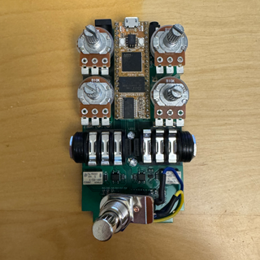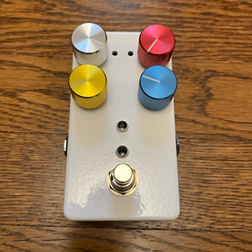

Etude 9:
Get some sounds working on your electrosmith guitar pedal.

Class 10 Wednesday 10/28
Project / Tinker Day.

Etude 10
Final Project Proposal.

Class 11 Wednesday 11/4

Machine Learning Tools in Supercollider and Max
https://www.flucoma.org/
The Fluid Corpus Manipulation project (FluCoMa) instigates new musical ways of exploiting ever-growing banks of so und and gestures within the digital composition process, by bringing breakthroughs of signal decomposition DSP and machine learning to the toolset of techno-fluent computer composers, creative coders and digital artists.

These potent algorithms are currently partially available in closed bespoke software, or in laboratories, but not at a suitable level of modularity within the main coding environments used by the creative researchers, namely Max, Pd and SuperCollider, to allow groundbreaking sonic research into a rich unexploited area: the manipulation of large sound corpora. Indeed, with access to, genesis of, and storage of large sound banks now commonplace, novel ways of abstracting and manipulating them are needed to mine their inherent potential.

Class 12 Wednesday 11/11

Gui Revisited: Module.sc in Supercollider
Artist Presentation (Ron Kuivila)

Class 13 Wednesday 11/18
TBA

THANKSGIVING BREAK 11/25–11/29 NO CLASS

Class 14 Wednesday 12/2
TBA

Class 15 Wednesday 12/9
Final Exam

