# Lecture 1: Introduction to Blueprints

# Exercise 1

In this exercise, you will practice executing some basic steps in the Blueprint Editor by creating a simple Blueprint that will print a message on the screen.

## Directions

1. In the **Content Browser**, click the green **Add New** button and select “**Blueprint Class**” to create a new Blueprint class.
2. In the **Pick Parent Class** window, choose “**Actor**” as the parent class. Name the Blueprint “**BP_Hello**”.
3. Double-click on **BP_Hello** to open the **Blueprint Editor**.
4. In the **Event Graph**, drag a wire from the **BeginPlay** event’s output execution pin and release the mouse button to open the **context menu**.
5. Search for “**print**” and choose “**Print String**”. Write the string to be displayed, such as “**Hello Blueprints**” (see Figure 1).
6. Press the **Compile** button.
7. Drag and drop the Blueprint from the **Content Browser** into the **Viewport** or **World Outliner** to add it to the Level.
8. Press the **Play** button in the **Level Editor**.

## Outcome

After pressing the **Play** button, you should see your message displayed in the **Viewport** and in the **Output Log** window.

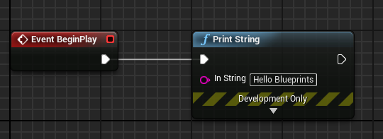

*Figure 1: Print String*