# Lecture 1: Introduction to Blueprints

# Exercise 2

In this exercise, you will modify the Blueprint created in the previous exercise so that it uses a Text Render component and a variable to display a message. You will use the Components panel, Details panel, Viewport, Event Graph, and My Blueprint panel.

## Directions

1. Double-click on **BP_Hello** (the Blueprint created in the previous exercise) to open the **Blueprint Editor**.
2. In the **Event Graph**, remove the **Print String** action, but keep the **BeginPlay** event.
3. In the **Components** panel, click the **Add Component** button, search for “**text**”, and choose the **Text Render** component.
4. Select the **Text Render** component. In the **Details** panel, set the **Z** value of **Location** to “**100**” and change **Text Render Color** to a green color (see Figure 1).
5. In the **My Blueprint** panel, click the “**+**” button in the **Variables** category to add a new variable.
6. Select the variable created, and in the **Details** panel change **Variable Name** to “**Message**” and **Variable Type** to “**Text**”. Compile the Blueprint, and then under the **Default Value** category set the **Message** variable’s default value to “**Hello**”.
7. In the **Event Graph**, drag out the **Text Render** component and drop it near the **BeginPlay** event. Then drag and drop the **Message** variable and choose the **Get** option.
8. Drag a wire from the **Text Render** component and release the mouse button to open the **context menu**. Search for “**text**” and choose “**Set Text**”.
9. Connect the **BeginPlay** event’s output execution pin to the **Set Text** action’s input execution pin, and connect the **Message** variable to the **Set Text** action’s **Value** pin (see Figure 2).
10. Compile the Blueprint, and then drag and drop it from the **Content Browser** into the **Viewport** or **World Outliner** to add it to the Level.
11. Press the **Play** button in the **Level Editor** and move your character to where the Blueprint was placed.

## Outcome

After pressing the **Play** button and moving your character to where the Blueprint was placed, you should see the message “Hello” as 3D text in the Level.

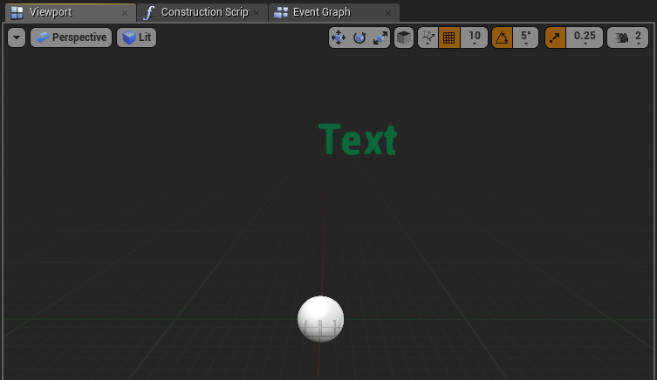

*Figure 1: Viewport*

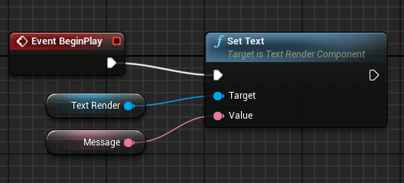

*Figure 2: Set Text*