# Lecture 2: Basic Blueprint

# Programming Concepts

# Exercise 1

In this exercise, you will create a Blueprint with variables of various types that can be modified in the Level Editor.

## Directions

1. In the **Content Browser**, click the green **Add New** button and select “**Blueprint Class**” to create a new Blueprint class.
2. In the **Pick Parent Class** window, choose “**Actor**” as the parent class. Name the Blueprint “**BP_Variables**”.
3. Double-click **BP_Variables** to open the **Blueprint Editor**.
4. In the **My Blueprint** panel, click the “**+**” button in the **Variables** category to add a new variable.
5. Select the variable created, and in the **Details** panel change **Variable Name** to “**BooleanVar**” and **Variable Type** to “**Boolean**”. Check the **Instance Editable** property.
6. Create an **Integer** variable named “**IntegerVar**” and check **Instance Editable**.
7. Create a **Float** variable named “**FloatVar**” and check **Instance Editable**.
8. Create a **Text** variable named “**TextVar**” and check **Instance Editable**.
9. Create an **Integer** variable named “**ArrayInteger**” and set **Variable Type** to “**Integer**”. Click the button to the side of “**Variable Type**” and choose “**Array**”. Check **Instance Editable**.
10. See Figure 1, which shows the variables created.

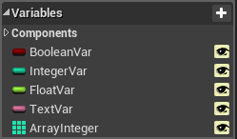

*Figure 1: Exercise 1 Variables*

1. Press the **Compile** button. In the **Level Editor**, drag and drop the Blueprint into the Level.
2. Select the instance of the Blueprint in the Level and edit the values of the variables in the **Level Editor**’s **Details** panel (see Figure 2).

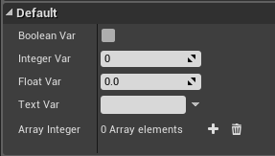

*Figure 2: Editable Variables*

## Outcome

After adding Actor instances of **BP_Variables** to the Level, it is possible to set the values of their editable variables using the **Details** panel. Each Actor instance can have unique values.