# Lecture 2: Basic Blueprint

# Programming Concepts

# Exercise 2

In this exercise, you will create a function that calculates an attack value based on an input parameter. Operators and the Branch node will also be used.

## Directions

1. In the **Content Browser**, click the green **Add New** button and select “**Blueprint Class**” to create a new Blueprint class.
2. In the **Pick Parent Class** window, choose “**Actor**” as the parent class. Name the Blueprint “**BP_Attack**”.
3. Double-click **BP_Attack** to open the **Blueprint Editor**.
4. Create an **Integer** variable named “**Strength**” and check **Instance Editable**.
5. In the **Details** panel under the **Variable** category, set the **Value Range** property from “**1**” to “**10**”. Compile the Blueprint and then under the **Default Value** category set the variable’s default value to “**5**”.
6. In the **My Blueprint** panel, click the “**+**” button in the **Functions** category to create a function. Change the name of the function to “**Calculate Attack**”.
7. Use the **Details** panel for this function to create an input parameter named “**Strength Value**” of **Integer** type and an output parameter named “**Attack Value**” of **Integer** type.
8. The function will calculate the following expression:

*Attack Value = (Strength Value x 5) + 10*

1. Double-click the function to edit it and create the expression seen in Figure 1.

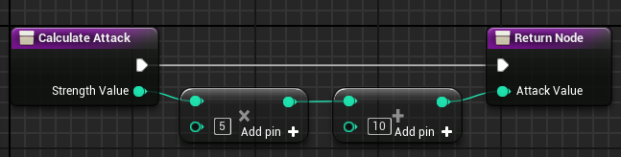

*Figure 1: Function Calculate Attack*

1. In the **Event Graph**, add a **BeginPlay** event and create the nodes seen in Figure 2. These actions will calculate the attack value based on the value of the **Strength** variable. If the attack value is equal to or greater than 40, then the message “STRONG ATTACK” will be printed on screen; if it is less than 40, then the message “WEAK ATTACK” will be printed.

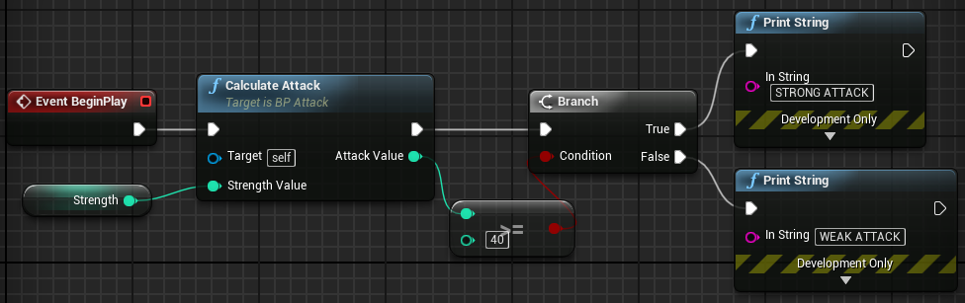

*Figure 2: Event BeginPlay*

1. Compile the Blueprint. In the **Level Editor,** drag and drop the Blueprint into the Level.
2. Modify the value of the **Strength** variable using the **Details** panel in the **Level Editor**. Play the Level to see the message.

## Outcome

After pressing the **Play** button, you should see the message “STRONG ATTACK” or “WEAK ATTACK” displayed in the **Viewport**. The message displayed depends on the value of the **Strength** variable.