# Lecture 3: Building and Using

# Actor Classes

# Exercise 1

In this exercise, you will create a Blueprint that will use the Construction Script to change the Material of a Static Mesh component based on a parameter that can be modified in the Level Editor.

## Directions

1. Create a new project or use an existing one with **starter content**.
2. In the **Content Browser**, click the green **Add New** button and select “**Blueprint Class**” to create a new Blueprint class.
3. In the **Pick Parent Class** window, choose “**Actor**” as the parent class. Name the Blueprint “**BP_****Construction**”.
4. Double-click **BP_Construction** to open the **Blueprint Editor**.
5. In the **Components** panel, click the **Add Component** button and choose the **Static Mesh** component.
6. Select the **Static Mesh** component, and in the **Details** panel choose “**Shape_Cylinder**” (path: /Game/StarterContent/Shapes/) as the Static Mesh.
7. In the **My Blueprint** panel, click the “**+**” button in the **Variables** category to add a new variable.
8. Select the variable created, and in the **Details** panel change **Variable Name** to “**Material Type**” and **Variable Type** to “**Material**”. Check the **Instance Editable** property. (See Figure 1.) This will allow the value of this variable to be changed in an instance that has been placed in the Level.

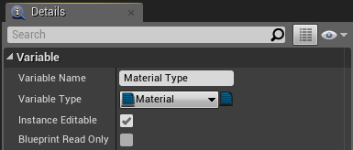

*Figure 1: Material Type Variable variables*

1. Click the **Construction Script** tab. Drag and drop the **Static Mesh** component into the graph, and then drag and drop the **Material Type** variable into the graph using the **Get** option. Drag a wire from the **Static Mesh** reference pin and release the mouse button to open the **context menu**. Select the **Set Material** function. Connect the **Material Type** variable to the **Material** parameter of the function. (See Figure 2.)
2. Compile the Blueprint. Add an instance of the Blueprint to the Level and change the value of the **Material Type** variable in the **Level Editor**’s **Details** panel.

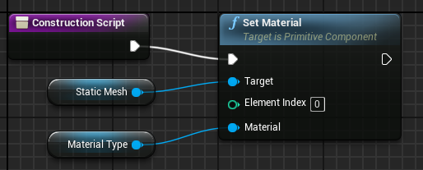

*Figure 2: Construction Script*

## Outcome

After adding instances of **BP_ Construction** to the Level, it is possible to change the Material of the Static Mesh of an instance by changing the value of the **Material Type** variable in the **Level Editor**’s **Details** panel.