# Lecture 3: Building and Using

# Actor Classes

# Exercise 2

In this exercise, you will create a Blueprint with a box that will explode when overlapped.

## Directions

1. In the **Content Browser**, click the green **Add New** button and select “**Blueprint Class**” to create a new Blueprint class.
2. In the **Pick Parent Class** window, choose “**Actor**” as the parent class. Name the Blueprint “**BP_Explosion**”.
3. Double-click **BP_Explosion** to open the **Blueprint Editor**.
4. In the **Components** panel, click the **Add Component** button and choose the **Static Mesh** component.
5. Select the **Static Mesh** component, and in the **Details** panel choose “**Shape_Cube**” as the Static Mesh and “**M_Wood_Oak**” as the Material. Set the **Collision Presets** property to “**OverlapAll**”.
6. In the **Event Graph**, use the **ActorBeginOverlap** event and add the actions shown in Figure 1. On the **SpawnActor** function, choose “**Blueprint Effect Explosion**” in the **Class** parameter.

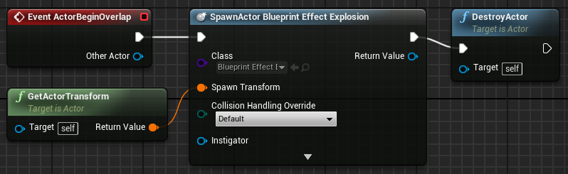

*Figure 1: Spawn Explosion*

1. Compile the Blueprint and add an instance to the Level. Play the Level and overlap the Blueprint.

## Outcome

After pressing **Play**, you can move your character so that it overlaps an instance of **BP_Explosion**. An explosion effect will be spawned and the **BP_Explosion** instance will be removed from the Level.