# Lecture 4: UE4 Gameplay

# Framework Classes

# Exercise 1

In this exercise, you will create a Level containing three characters that can be possessed by the Player Controller using the “**1**”, “**2**”, and “**3**” keys.

## Directions

1. Create a new project using the **Third Person** template.
2. Add to the Level two more instances of the **ThirdPersonCharacter** Blueprint, which is in the folder “**Content > ThirdPersonBP > Blueprints**”.
3. In the **Details** panel, rename the **ThirdPersonCharacter** instances in the Level “**Character1**”, “**Character2**”, and “**Character3**”.
4. Click the **Blueprints** button on the **Toolbar** and select “**Open Level Blueprint**”.
5. Select the **Character1** Actor in the Level, and in the Level Blueprint right-click in the **Event Graph** and choose “**Create a Reference to Character1**” (see Figure 1).

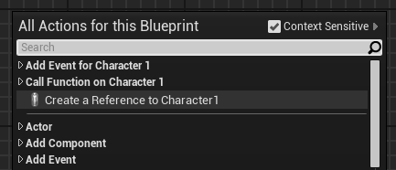

*Figure 1: Creating a Reference*

1. Repeat the previous step to create a reference to **Character2** and another to **Character3**.
2. Right-click in the **Event Graph** and create **keyboard events** for the “**1**”, “**2**”, and “**3**” keys.
3. Add the **Get Player Controller** function to the **Event Graph**.
4. Drag a wire from the **Get Player Controller** output execution pin and release the mouse button to open the **context menu**. Select the **Possess** function.
5. Complete the script in the Level Blueprint as shown in Figure 2.
6. Compile and play the Level. Use the “**1**”, “**2**”, and “**3**” keys to change the character being controlled.

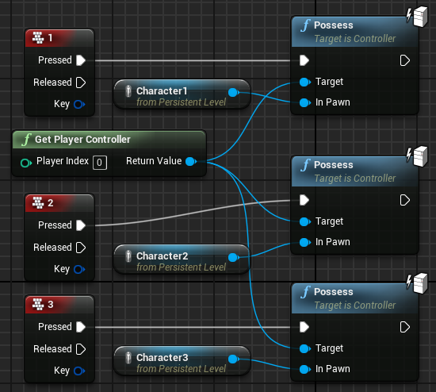

*Figure 2: Level Blueprint*

## Outcome

After pressing **Play**, you can control each of the third-person characters in the Level by using the “**1**”, “**2**”, and “**3**” keys.