# Lecture 4: UE4 Gameplay

# Framework Classes

# Exercise 2

In this exercise, you will create a simple HUD and a new Game Mode that will use the new HUD as the default HUD class.

## Directions

1. Create a new project using the **Third Person** template.
2. In the **Content Browser**, create a new folder named “**BPGuide**” to use for storing the new Blueprints that will be created.
3. Next, click the green **Add New** button in the **Content Browser** and select “**Blueprint Class**”.
4. In the **Pick Parent Class** window, expand the **All Classes** section and search for “**hud**”. Choose “**HUD**” as the parent class (see Figure 1).

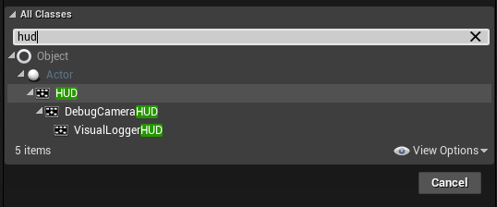

*Figure 1: Parent Class: HUD*

1. Rename the new HUD Blueprint “**BP_HUD_Timer**”.
2. Double-click **BP_HUD_Timer** to open the **Blueprint Editor**.
3. Create an **Integer** variable named “**Time**”.
4. Right-click in the **EventGraph** and search for “**draw hud**”. Add the **Receive Draw HUD** event.
5. Add a **BuildString (int)** function and a **Draw Text** function. Create the script seen in Figure 2.

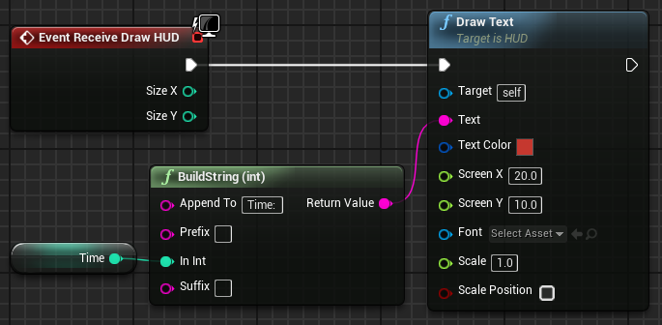

*Figure 2: Drawing the Time Variable*

1. Right-click in the **Event Graph** and search for “**custom event**”. Select “**Add Custom Event**” and rename it “**Count**”.
2. Add the **Set Timer by Event** function. Set the **Time** parameter to “**1.0**”, check the **Looping** parameter, and connect the red square of the **Count** custom event to the **Event** input parameter of the **Set Timer by Event** function. (See Figure 3.)
3. Add the **BeginPlay** event and complete the script seen in Figure 3.

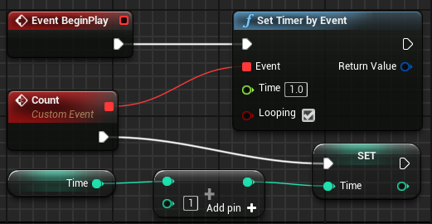

*Figure 3: Drawing the Time Variable*

1. Create a new Blueprint class and choose “**Game Mode Base**” as the parent class. Rename it “**BP_GameMode_HUD**”.
2. Open **BP_GameMode_HUD** in the **Blueprint Editor** and click the **Class Defaults** button on the **Toolbar**. Set the **HUD Class** property to “**BP_HUD_Timer**” and the **Default Pawn Class** property to “**ThirdPersonCharacter**” (see Figure 4).

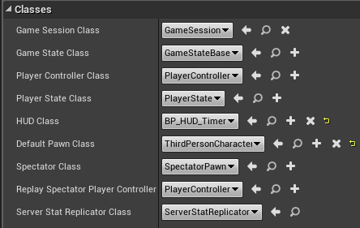

*Figure 4: Game Mode Classes*

1. To change the **Game Mode** of the current Level, click the **Settings** button in the **Level Editor** and choose “**World Settings**”.
2. In the **World Settings** panel, select “**BP_GameMode_HUD**” in the **GameMode Override** property.
3. Play the Level to see the **BP_HUD_Timer** Blueprint in action.

## Outcome

After pressing **Play**, a text like “Time: 1” will be drawn on the screen, and the number will increase and be updated on the screen every second.