# Lecture 5: Simple Game Example

# Exercise 1

In this exercise, a visual effect using a Particle System will be added to the **BP_Statue** Blueprint created in Lecture 5.

## Directions

1. Open the project created in Lecture 5.
2. Open **BP_Statue** in the **Blueprint Editor**.
3. In the **Components** panel, add a **Particle System** component.
4. In the **Details** panel of the **Particle System**, set the **Template** property to “**P_Sparks**”.
5. Set the **Location** property of the **Particle System** to “**0.0, 0.0, 80.0**”.
6. Play the Level.

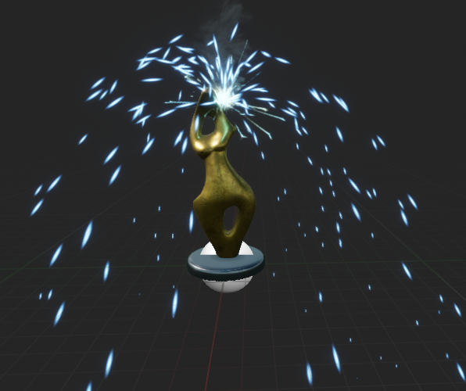

*Figure 1: BP_Statue with Particle System*

# Outcome

After pressing **Play**, you will see that all the instances of **BP_Statue** in the Level have an active Particle System effect, with sparks coming out of the top, as seen in Figure 1.