# Lecture 5: Simple Game Example

# Exercise 2

In this exercise, the player rank will be shown on the Game Over screen of the game created in Lecture 5. The rank is based on the Level the player has reached.

## Directions

1. Open the project created in Lecture 5.
2. Open **BP_Guide_GameMode** in the **Blueprint Editor**.
3. In the **My Blueprint** panel, add a **String** variable named “**Rank**”.
4. In the **Event Graph**, look for the **Clock** custom event. After the last action, add the actions seen in Figure 1. These actions will set the value of the **Rank** variable based on the value of the **Level** variable when the game is over.

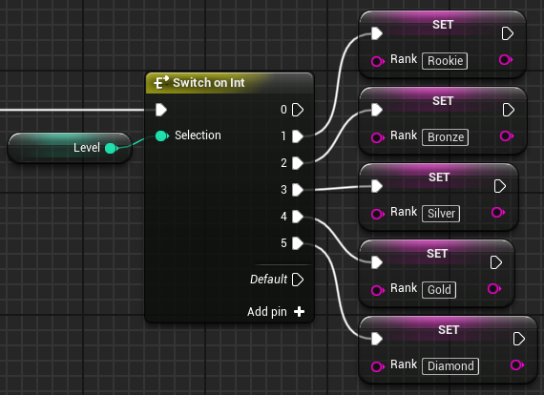

*Figure 1: Setting the Rank Value*

1. Open **BP_Guide_HUD** in the **Blueprint Editor**.
2. In the **Event Graph**, look for the **Receive Draw HUD** event. After the last action, add the actions seen in Figure 2. These actions will draw the value of the **Rank** variable on the screen.

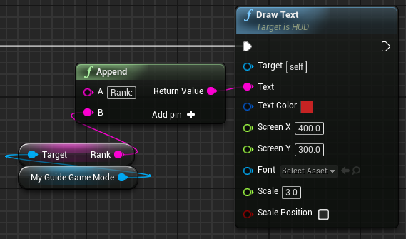

*Figure 2: Drawing the Rank Value*

## Outcome

When the Game Over screen is displayed, a text representing the rank of the player will appear. This rank is based on the Level the player has reached.

*Figure 2: Level Blueprint*