# Lecture 6: Advanced Blueprint Concepts 1

# Exercise 1

In this exercise, an array will be used to manage a group of Point Lights. The actions will be executed in the Level Blueprint. When the player overlaps a Trigger Box, the Point Lights will toggle their visibility.

## Directions

1. Create a new project using the **Third Person** template.
2. Add a **Static Mesh** Actor to serve as a wall.
3. Add four **Point Light** Actors to the Level and place them near each other on the wall. The Point Lights can be found in the **Lights** section of the **Modes** panel.
4. In the **Details** panel under the **Transform** section, set the **Mobility** property of the Point Lights to “**Movable**”.
5. Add a **Trigger Volume** to the Level, which can be found in the **Volumes** section of the **Modes** panel. Place it near the Point Lights.
6. Click the **Blueprints** button on the **Toolbar** and select “**Open Level Blueprint**”.
7. Create a variable called “**Lamps**”. For its variable type, use “**Point Light > Object Reference**”. Click the button next to the **Variable Type** drop-down and choose “**Array**”. (See Figure 1.)

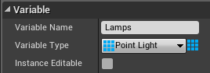

*Figure 1: Array of Point Lights*

1. Compile the Blueprint. In the **Default Value** section, add four elements to the array. Then select the four Point Lights that were added to the Level. (See Figure 2.)

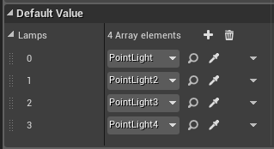

*Figure 2: References to the Point Lights*

1. In the **Level Editor**, select the **Trigger Volume** that was added to the Level.
2. Right-click in the **Event Graph** of the **Level Blueprint** to open the **context menu.** Go to **Add Event for Trigger Volume > Collision** and choose “**Add On Actor Begin Overlap**”.
3. Create the actions seen in Figure 3. These actions will toggle the visibility of each Point Light when the Trigger Volume is overlapped.
4. Play the Level and move your character to the location of the **Trigger Volume**.

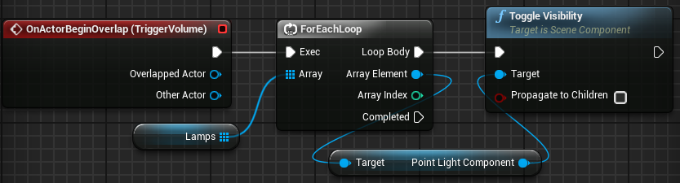

*Figure 3: OnActorBeginOverlap (TriggerVolume)*

## Outcome

After pressing **Play**, every time your character overlaps the Trigger Volume the visibility of the four Point Lights will be toggled.