# Lecture 6: Advanced Blueprint Concepts 1

# Exercise 2

In this exercise, you will create an enumeration that will allow the user to choose in the Level Editor the Static Mesh that should be used by a Blueprint.

## Directions

1. In the **Content Browser**, click the green **Add New** button and in the **Blueprints** submenu select “**Enumeration**” to create a new enumeration. Rename it “**EMeshType**”.
2. Double-click **EMeshType** to edit it. Add the values shown in Figure 1.

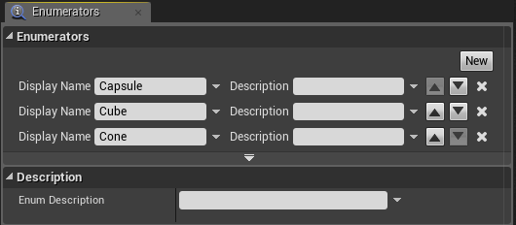

*Figure 1: Enumeration*

1. In the **Content Browser**, click the **Add New** button and select “**Blueprint Class**” to create a new Blueprint class.
2. In the **Pick Parent Class** window, choose “**Actor**” as the parent class. Rename the Blueprint “**BP_Enum**”.
3. Double-click **BP_Enum** to open the **Blueprint Editor**.
4. In the **Components** panel, click the **Add Component** button and choose the **Static Mesh** component.
5. Create a new variable called “**MeshTypeEnum**” and set the **Variable Type** to “**EMeshType**”, which is the enumeration that you created. Set the **Instance Editable** property to “**true**”. (See Figure 2.)

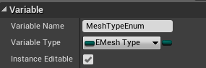

*Figure 2: EMeshType Variable*

1. Click the **Construction Script** tab and in the graph create the actions seen in Figure 3. These actions will change the Static Mesh based on the value of the **Mesh Type Enum** variable.

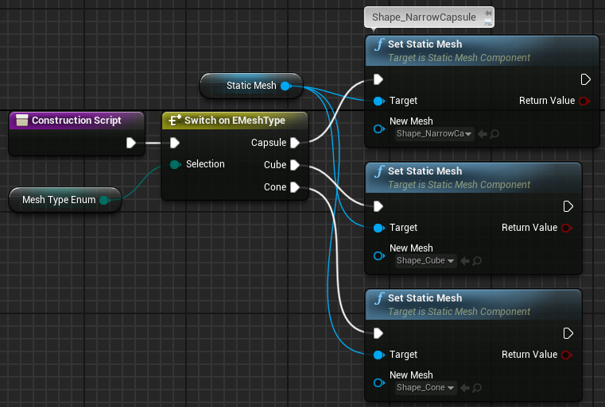

*Figure 3: Construction Script*

1. Compile the Blueprint.
2. Add some instances of **BP_Enum** to the Level. Select one of them, and in the **Details** panel choose a setting from the **Mesh Type Enum** drop-down (see Figure 4).

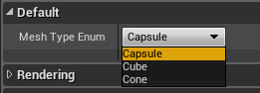

*Figure 4: Mesh Type Enum*

## Outcome

After adding instances of **BP_ Enum** to the Level, it is possible to change the Static Mesh of an instance by changing the value of the **Mesh Type Enum** property in the Level Editor’s Details panel.