# Lecture 7: Advanced Blueprint Concepts 2

# Exercise 1

In this exercise, you will use random number functions to simulate the throw of two dice to calculate the value of an attack. The Append node will be used to create the resulting message that will be printed on screen.

## Directions

1. Create a new project or use an existing one.
2. Click the **Blueprints** button on the **Toolbar** and select “**Open Level Blueprint**”.
3. Create an **Integer** variable called “**Attack Value**”.
4. Add the **Enter** keyboard event.
5. Add the actions shown in Figure 1.

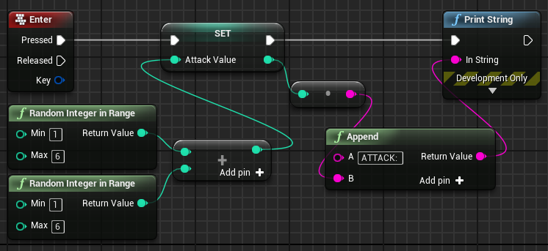

*Figure 1: Using Random Number Functions*

1. When the user presses the **Enter** key, two random integer values between “1” and “6” will be generated and added together. The resulting value will be set in the **Attack Value** variable. The **Append** function concatenates the message “ATTACK: ” with the value of the **Attack Value** variable.
2. Play the game and press the **Enter** key to see the attack value.

## Outcome

When playing the game and pressing the **Enter** key, you should see the message “ATTACK: ” displayed in the Viewport, with a number following the colon indicating the attack value.

.