# Lecture 7: Advanced Blueprint Concepts 2

# Exercise 2

In this exercise, you will add an object to the Level. The Level Blueprint will be used to display various Materials for the user of this object each time the space bar is pressed. A MultiGate node is used to define a different Material at each execution.

## Directions

1. Create a new project or use an existing one.
2. Add a **cube** to the Level. The cube can be found in the **Basic** section of the **Modes** panel.
3. In the **Details** panel for the cube, rename the cube **MaterialDisplay** and set the **Mobility** property to “**Movable**”.
4. With **MaterialDisplay** selected, click the **Blueprints** button on the **Toolbar** and select “**Open Level Blueprint**”.
5. Right-click in the **Event Graph** and select “**Create a Reference to MaterialDisplay**”.
6. Add the **Space Bar** keyboard event.
7. Add a **MultiGate** node. Add one more output pin and check the **Loop** parameter.
8. Drag a wire from the **MaterialDisplay** pin and release the mouse button. In the **context menu**, choose “**Set Material**”. Add two more **Set Material** nodes. Choose different Materials for each **Set Material** node.
9. Complete the script as shown in Figure 1.
10. Play the game and press the **space bar** several times to see how the Material of **MaterialDisplay** is modified.

## Outcome

When playing the game and pressing the **space bar**, the Material of **MaterialDisplay** will change. After the third Material is displayed, the **MultiGate** node will loop back to the first Material because the **Loop** parameter is checked.

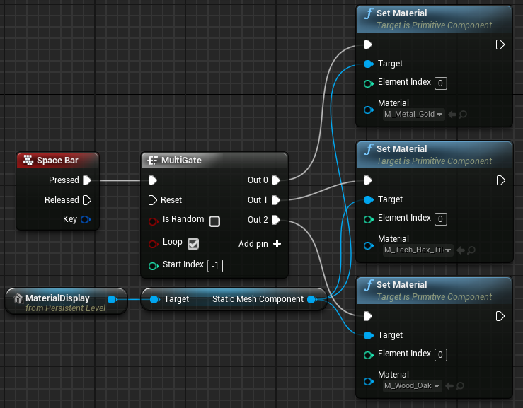

*Figure 1: Changing Materials with MultiGate*