# Lecture 8: Blueprint Communication

# Exercise 1

In this exercise, you will create a Blueprint that will use a Timer to periodically change the Material of some Static Mesh Actors that are in the Level. Direct Blueprint Communication will be used to reference the Static Mesh Actors.

## Directions

1. Create a new project or use an existing one with **starter content**.
2. In the **Content Browser**, click the green **Add New** button and select “**Blueprint Class**”. In the **Pick Parent Class** window, choose “**Actor**” as the parent class. Rename the Blueprint “**MaterialChanger**”.
3. Double-click **MaterialChanger** to open the **Blueprint Editor**.
4. Create a new variable named “**StaticMeshes**” and set the **Variable Type** property to “**Static Mesh Actor**”. Click the button to the side of “**Variable Type**” and choose “**Array**”. Check the **Instance Editable** property. (See Figure 1.)

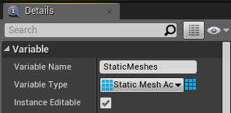

*Figure 1: Array of Static Meshes*

1. In the **Event Graph**, create the events and actions shown in Figure 2.

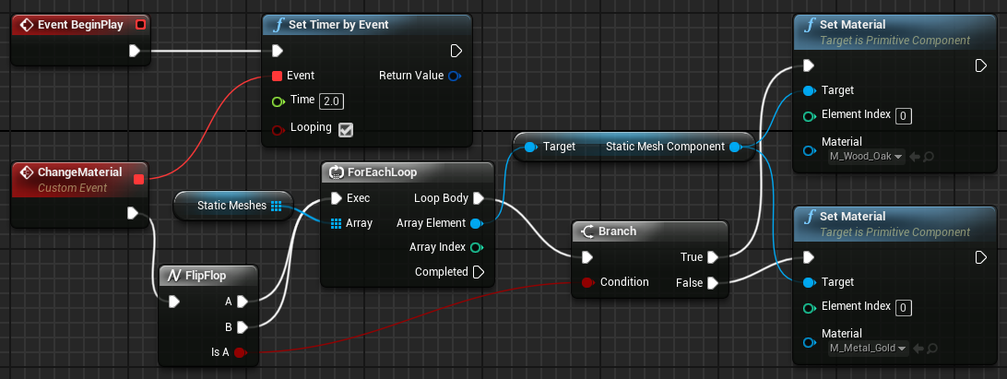

*Figure 2: MaterialChanger Event Graph*

1. In the **Level Editor**, add some Static Meshes to the Level (path: /Game/StarterContent/Shapes/). The Static Meshes used in this exercise are **Shape_Cone**, **Shape_Tube**, **Shape_Torus**, and **Shape_NarrowCapsule**.
2. Add an instance of the **MaterialChanger** Blueprint to the Level. Select it, and in the **Details** panel add some elements to the **StaticMeshes** array. For each element, select a different Static Mesh Actor from the Level (see Figure 3).

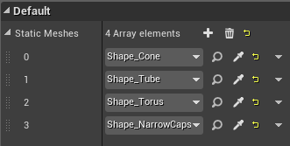

*Figure 3: References to Static Mesh Actors*

1. Press the **Play** button and move your character to the location where the Static Meshes were placed.

## Outcome

After pressing **Play** and moving your character to the location where the Static Meshes were placed, you should see the Material of the Static Meshes change every two seconds as seen in Figures 4 and 5.

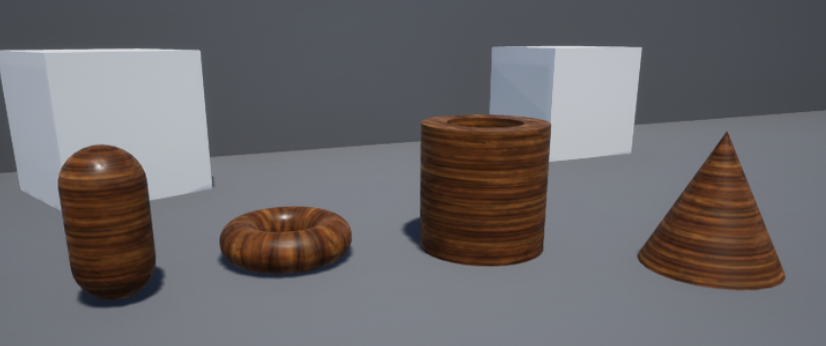

*Figure 4: M_Wood_Oak Material*

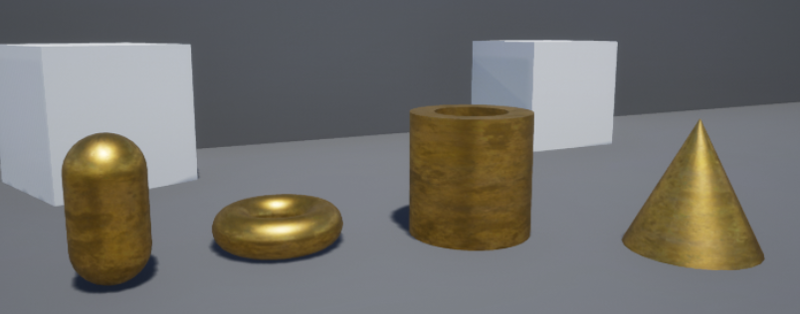

*Figure 5: M_Metal_Gold Material*