# Lecture 8: Blueprint Communication

# Exercise 2

In this exercise, you will create a Blueprint that will use an event dispatcher to inform the Level Blueprint when the player overlaps it. After that, the Level Blueprint will spawn an explosion.

## Directions

1. Create a new project using the **Third Person** template with **starter content**.
2. In the **Content Browser**, click the green **Add New** button and select “**Blueprint Class**”. In the **Pick Parent Class** window, choose “**Actor**” as the parent class. Rename the Blueprint “**TriggerDetonation**”.
3. Double-click **TriggerDetonation** to open the **Blueprint Editor**.
4. Add a **Box Collision** component.
5. In the **My Blueprint** panel, add a new **event dispatcher**. Rename it “**Detonate**”.
6. In the **Event Graph**, add the **Event ActorBeginOverlap** node and a **Call** node to call the **Detonate** event dispatcher (see Figure 1).

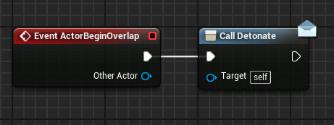

*Figure 1: Event Dispatcher*

1. Add an instance of the **TriggerDetonation** Blueprint to the Level.
2. Add an **empty Actor** to the Level and rename it “**ExplosionPlace**”. The empty Actor can be found in the **Basic** section of the **Modes** panel.
3. Select the **TriggerDetonation** Actor and open the **Level Blueprint**.
4. Add the **Detonate** event for the **TriggerDetonation** Blueprint (see Figure 2).

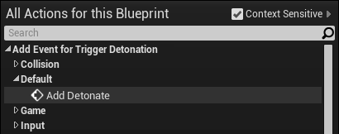

*Figure 2: Detonate Event*

1. Select the **ExplosionPlace** Actor in the Level, and in the **Level Blueprint** right-click in the **Event Graph** and create a **reference** to it.
2. Add the **Spawn Actor from Class** function and set the **Class** property to “**Blueprint Effect Explosion**”. Complete the script shown in Figure 3.
3. Press the **Play** button and move your character so that it overlaps the instance of the **TriggerDetonation** Blueprint.

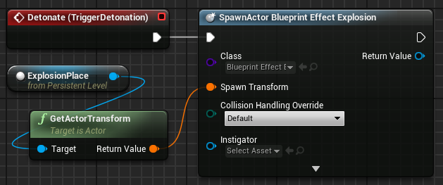

*Figure 3: Spawn the Explosion*

## Outcome

After pressing **Play** and moving your character to overlap the instance of the **TriggerDetonation** Blueprint, an explosion effect will be spawned at the location of the **ExplosionPlace** Actor**.**