# Lecture 9: UMG 101

# Exercise 1

In this exercise, you will create an About screen and see how to switch between the Title screen and the About screen.

## Directions

1. Create a new project or use an existing one.
2. In the **Content Browser**, click the green **Add New** button and in the **User Interface** submenu select “**Widget Blueprint**”. Create two **Widget Blueprint** classes, one for the Title screen and another for the About screen. Name them “**TitleUMG**” and “**AboutUMG**”.
3. Double-click the **TitleUMG** Blueprint to open it in the **UMG Editor**.
4. Add an **Image** or **Text** widget for the Title screen to the **Designer** panel. Add a **Button** widget and place a **Text** widget inside it. Set the value of the **Text** widget’s **Text** property to “**About Screen**” and rename the **Button** widget “**Btn_About**”. (See Figure 1.)

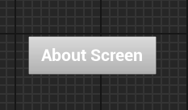

*Figure 1: About Screen Button*

1. Select **Btn_About**, and in the **Details** panel expand the **Events** category and add an **OnClicked** event. In the **My Blueprints** panel, create a variable named “**AboutUMGVar**” of type “**AboutUMG**”. In the **Event Graph**, add the functions shown in Figure 2.

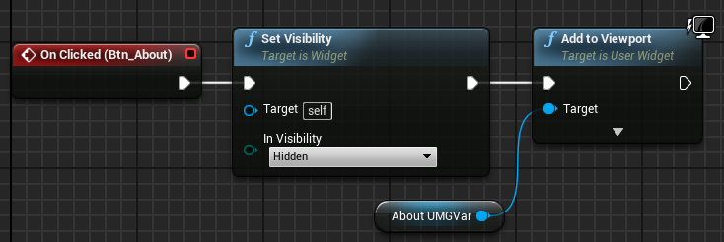

*Figure 2: Show About Screen*

1. Double-click the **AboutUMG** Blueprint to open it in the **UMG Editor**.
2. Add an **Image** or **Text** widget for the About screen to the **Designer** panel. Add a **Button** widget and place a **Text** widget inside it. Set the value of the **Text** widget’s **Text** property to “**Return**” and rename the **Button** widget “**Btn_Return**”.
3. Select **Btn_Return**, and in the **Details** panel expand the **Events** category and add an **OnClicked** event. In the **My Blueprints** panel, create a variable named “**TitleUMGVar**” of type “**TitleUMG**”. In the **Event Graph**, add the functions shown in Figure 3.

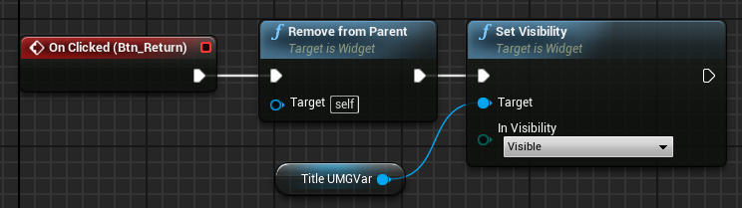

*Figure 3: Return to Title Screen*

1. In the **Level Blueprint**, create a variable named “**TitleUMGVar**” of type “**TitleUMG**” and a variable named “**AboutUMGVar**” of type “**AboutUMG**”. Add the functions shown in Figure 4. The graph will create the Widget Blueprint objects and save the references to the **TitleUMGVar** and **AboutUMGVar** variables in the **Level Blueprint**. The reference to **TitleUMGVar** is saved in the **AboutUMG** widget and the reference to **AboutUMGVar** is saved in the **TitleUMG** widget.

## Outcome

After pressing **Play**, the Title screen will be added to the Viewport. It contains a button named “**Btn_About**” with a label that reads “About Screen”. When the **Btn_About** button is pressed, the Title screen is hidden and the **About UMG** widget is added to the Viewport.

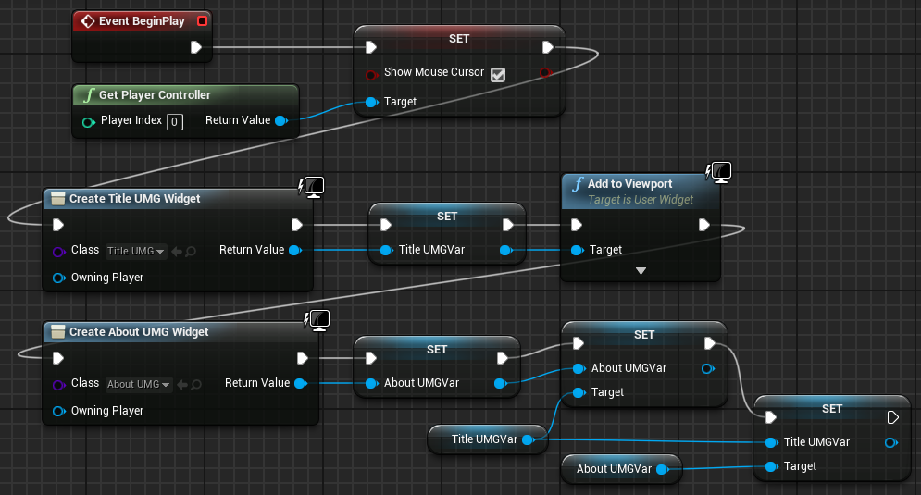

*Figure 4: Add Screens to Viewport*