# Lecture 9: UMG 101

# Exercise 2

In this exercise, you will use a Widget component to display a UMG screen inside the game world. The Widget component will be used in the Player Character. When the player presses the **Enter** key, a status panel will appear in front of them.

## Directions

1. Create a new project using the **First Person** template.
2. In the **Content Browser**, click the green **Add New** button and in the **User Interface** submenu select “**Widget Blueprint**”. Rename it “**StatusUMG**”.
3. Double-click **StatusUMG** to open the **UMG Editor**.
4. In the **Fill Screen** drop-down menu, select “**Custom**” to change the screen size. Set **Width** to“**500**” and **Height** to“**500**” (see Figure 1).

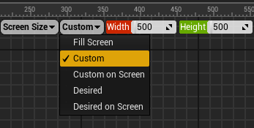

*Figure 1: Widget Screen Size*

1. Add a **Text** widget to the **Designer** panel. Set the widget’s **Text** property to “**Status Panel**”.
2. Open the **FirstPersonCharacter** Blueprint (path: /Game/FirstPersonBP/Blueprints). In the **Components** panel, click the **Add Component** button and choose the **Widget** component. Rename it “**Widget3D**”. In the **Details** panel, set the **Widget Class** property to “**StatusUMG**” (see Figure 2). Set the **Location** property to “**400.0**, **0.0**, **0.0**” and the **Rotation** property to “**0.0**, **0.0**, **180.0**”.

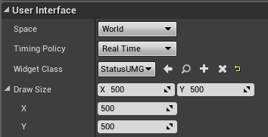

*Figure 2: Widget Details*

1. In the **Event Graph**, add the nodes shown in Figure 3.

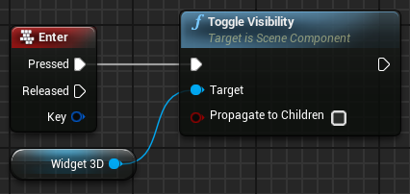

*Figure 3: Toggle the Widget*

1. Play the Level and press the **Enter** key.

## Outcome

When playing the game and pressing the **Enter** key, the widget that represents a status panel will appear in the Level in front of the player. If the **Enter** key is pressed again, the status panel will be hidden.