# Lecture 10: Blueprints in Action 1

# Exercise 1

In this exercise, you will create a Blueprint that contains two Static Mesh components. One of the Static Meshes will be the root component, and the second Static Mesh will have a relative location based on the location of the root component. The second Static Mesh will also rotate around the root Static Mesh.

## Directions

1. Create a new project or use an existing one.
2. In the **Content Browser**, click the green **Add New** button and select “**Blueprint Class**” to create a new Blueprint class. In the **Pick Parent Class** window, choose “**Actor**”. Rename the Blueprint “**BP_Rotation**”.
3. Double-click **BP_Rotation** to open the **Blueprint Editor**.
4. In the **Components** panel, click the **Add Component** button and choose the **Static Mesh** component. Drag the **Static Mesh** component onto the default root component to make it the new root component. In the **Details** panel, choose “**Shape_Cone**” for the **Static Mesh** property and choose any Material asset for the **Material** property.
5. Add another **Static Mesh** component and choose “**Shape_Sphere**” as the Static Mesh. In the **Transform** section, set the **Location** property to “**60.0, 0.0, 80.0**”. These are local coordinates relative to the position of the root component. Set the **Scale** propertyto“**0.5, 0.5, 0.5**”. (See Figure 1.)

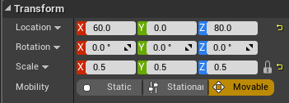

*Figure 1: Sphere Static Mesh Transform*

1. Add a **Rotating Movement** component. The default settings will keep the Blueprint rotating around the Z axis.
2. Add an instance of the Blueprint to the Level. Play the Level and move your character to the location where an instance of “**BP_Rotation**” was placed.

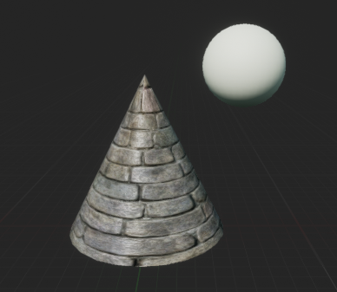

*Figure 2: Two Static Meshes in a Blueprint*

## Outcome

After pressing **Play** and moving your character to the location where an instance of the “**BP_Rotation**” Blueprint was placed, you should see the two Static Meshes rotating. When the root component is rotating, the other Static Mesh is rotating around it to keep its local coordinates relative to the coordinates of the root component. Figure 2 shows the two Static Meshes in the Viewport.