# Lecture 11: Blueprints in Action 2

# Exercise 1

In this exercise, the Player Character will use a line trace to find and interact with another Blueprint.

## Directions

1. Create a new project using the **First Person** template.
2. In the **Content Browser**, click the green **Add New** button and select “**Blueprint Class**” to create a new Blueprint class. In the **Pick Parent Class** window, choose “**Actor**”. Rename the Blueprint “**BP_Interactive**”.
3. Double-click **BP_Interactive** to open the **Blueprint Editor**.
4. In the **Components** panel, click the **Add Component** button and choose the **Static Mesh** component. In the **Details** panel, assign a Static Mesh asset to the component.
5. In the **My Blueprint** panel, click the “**+**” button in the **Functions** category to create a function. Rename the function “**Use**” and add a **Print String** function node (see Figure 1). Compile the Blueprint and add an instance of **BP_Interactive** to the Level.

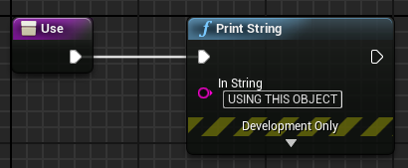

*Figure 1: “Use” Function*

1. Open the **FirstPersonCharacter** Blueprint (path: /Game/FirstPersonBP/Blueprints). In the **Event Graph**, add an input event for the “**E**” key. Add the actions shown in Figures 2 and 3 and compile the Blueprint.
2. Add an instance of the **BP_Interactive** Blueprint to the Levelandthen play the Level. Move your character close to the instance of **BP_Interactive**, look at it, and press the “**E**” key.

## Outcome

After pressing **Play**, moving your character close to the instance of **BP_Interactive**, looking at it, and pressing the “**E**” key, the **Use** function of the **BP_Interactive** Blueprint will be called. It will print the message “USING THIS OBJECT” in the Viewport.

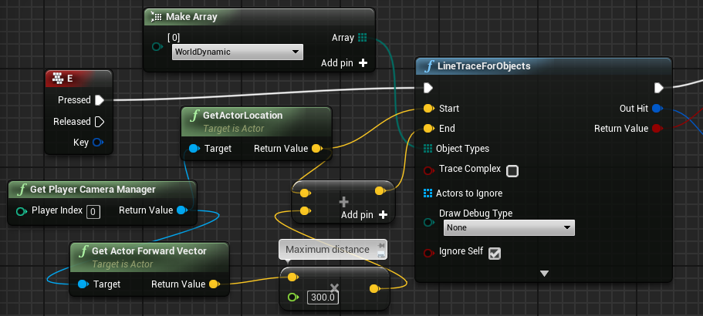

*Figure 2: “E” Key Event, Part 1*

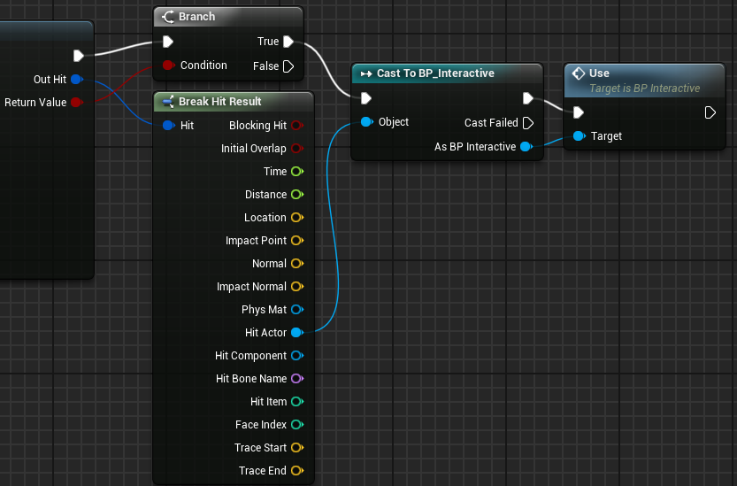

*Figure 3: “E” Key Event, Part 2*