# Lecture 11: Blueprints in Action 2

# Exercise 2

In this exercise, you will create a simple elevator in the Level and use a Timeline to control its movement.

## Directions

1. Create a new project or use an existing one with **starter content**.
2. Add the Static Mesh asset **Floor_400x400** to the Level. Rename it “**Elevator**” and set the **Mobility** property to “**Movable**.”
3. Select the **Elevator** Actor and open the Level Blueprint. Right-click in the **Event Graph** and choose “**Create a Reference to Elevator**”.
4. Right-click in the Event Graph and choose “**Add Timeline…**”. Rename the Timeline “**Timeline_Elevator**”. Double-click the Timeline to edit it. Click the first button on the left to add a **Float** track. Rename the track “**Z_Position**”.
5. Right-click in the center of the Timeline and choose “**Add Key**”. For this key, use **Time** =“**0.0**” and **Value** =“**190.0**”. Add another key using **Time** = “**5.0**” and **Value** = “**750.0**”. (See Figure 1.)

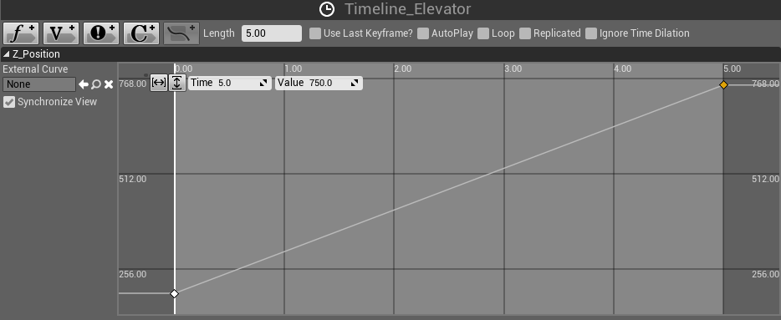

*Figure 1: Editing the Timeline*

1. In the **Event Graph**, add a **BeginPlay** event and re-create the node graph shown in Figure 2. On the **GetActorLocation** and **SetActorLocation** nodes, right-click on the **Vector** parameter and choose “**Split Struct Pin**”.
2. Compile the Blueprint. Play the Level and move your character to the location where the **Elevator** Actor was placed.

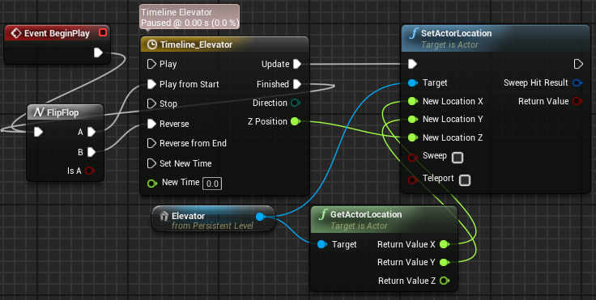

*Figure 2: Actions to Move the Elevator*

## Outcome

After pressing **Play** and moving your character to the location where the **Elevator** Actor was placed, you should see the elevator moving up and down.