# Lecture 12: Blueprints in Action 3

# Exercise 1

In this exercise, you will create a Blueprint named “**BP_Lamp**”. The Enable Input node will be used so the player can toggle the light using the “**E**” key, but only when the player is near the Blueprint.

## Directions

1. Create a new project using the **First Person** template with **starter content**, or use an existing one.
2. In the **Content Browser**, click the green **Add New** button and select “**Blueprint Class**”. In the **Pick Parent Class** window, choose “**Actor**”. Rename the Blueprint “**BP_Lamp**”.
3. Double-click **BP_Lamp** to open the **Blueprint Editor**.
4. In the **Components** panel, click the **Add Component** button and choose the **Static Mesh** component. In the **Details** panel, set the **Static Mesh** property to “**SM_Lamp_Wall**”.
5. Add a **Point Light** component. Set the **Location** property to “**0.0, 0.0, 25.0**”. Add a **Box Collision** component. Set the **Scale** property to “**3.0, 3.0, 3.0**”. Figure 1 shows the components of **BP_Lamp**.

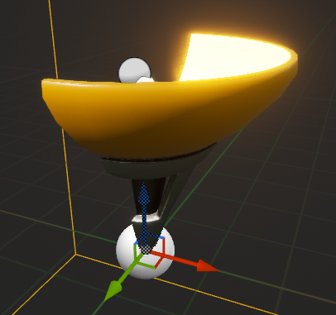

*Figure 1: BP_Lamp Components*

1. In the **Event Graph** of **BP_Lamp**, replicate the script seen in Figure 2. It will enable input when the player is near the Blueprint and disable it when the player moves away. To create the **Cast To** **FirstPersonCharacter** nodes, drag a wire from the **Other Actor** pin on the **ActorBeginOverlap** and **ActorEndOverlap** event nodes and release the mouse to open the **context menu**, and then search for “**Cast To FirstPersonCharacter**”.

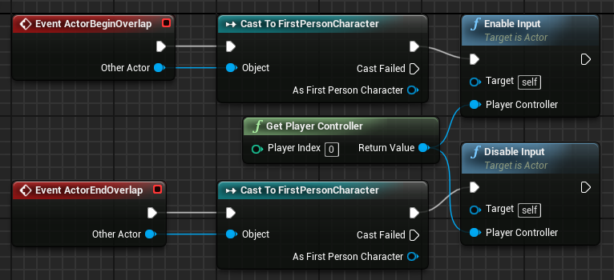

*Figure 2: BP_Lamp Events*

1. In the **Event Graph** of **BP_Lamp**, add an input event for the “**E**” key. Replicate the script seen in Figure 3 and compile the Blueprint.

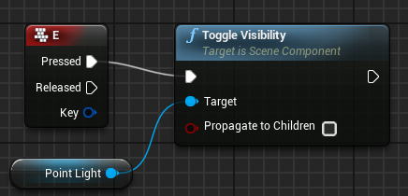

*Figure 3: Toggle the Light*

1. Add one or more instances of the **BP_Lamp** class to the Level and then play the Level. Move your character close to an instance of **BP_Lamp** and press the “**E**” key.

## Outcome

After pressing **Play**, moving your character close to an instance of **BP_Lamp**, and pressing the “**E**” key, the light will be toggled.