# Lecture 12: Blueprints in Action 3

# Exercise 2

In this exercise, you will create a spawn area in the Level represented by a Box Trigger. In the BeginPlay event of the Level Blueprint, several game items will be spawned in random positions in the spawn area.

## Directions

1. Create a new project or use an existing one with **starter content**.
2. In the **Content Browser**, click the green **Add New** button and select “**Blueprint Class**”. In the **Pick Parent Class** window, choose “**Actor**”. Rename the Blueprint “**BP_GameItem**”.
3. Double-click **BP_GameItem** to open the **Blueprint Editor**.
4. In the **Components** panel, click the **Add Component** button and choose the **Static Mesh** component. In the **Details** panel, set the **Static Mesh** property to “**SM_Statue**”. Set the **Simulate Physics** property to “**true**”.
5. In the **Level Editor**, add a **Box Trigger**. It can be found in the **Basic** section of the **Modes** panel. Rename it “**SpawnArea**”. Resize the **X** and **Y** dimensions of the Box Actor to define the area where the game items can be spawned. (See Figure 1.)

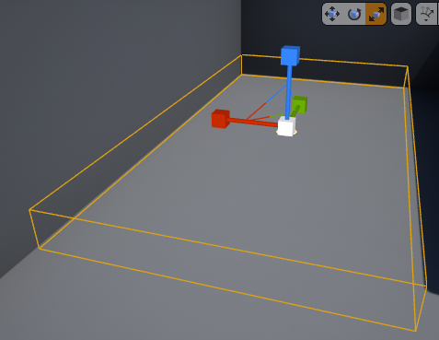

*Figure 1: SpawnArea (Box Trigger)*

1. Select the **SpawnArea** Actor, and in the Level Blueprint right-click in the **Event Graph** and choose “**Create a Reference to SpawnArea**”. Add a **BeginPlay** event and replicate the script seen in Figure 2.

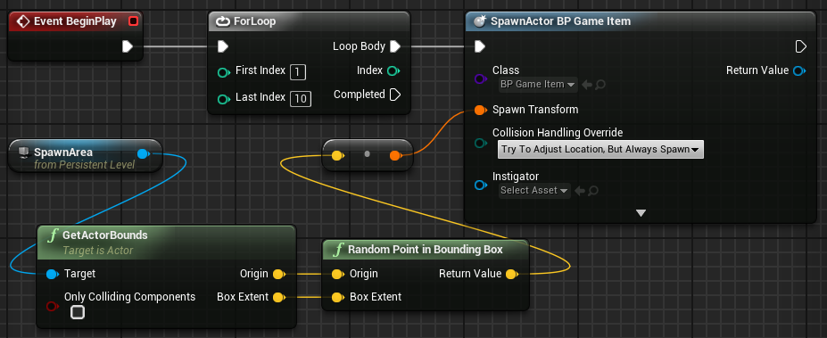

*Figure 2: Level Blueprint*

1. Compile the Blueprint. Play the Level and move your character to the location where the Box Trigger was placed.

## Outcome

After pressing **Play** and moving your character to the location where the Box Trigger was placed, you should see 10 statues in random positions inside the Box Trigger.