# Lecture 13: Blueprints in Action 4

# Exercise 1

In this exercise, the **FirstPersonProjectile** Blueprint will be modified to spawn an emitter representing a fire effect and attach it to the component that was hit.

## Directions

1. Create a new project using the **First Person** template with **starter content**, or use an existing one.
2. Open the **FirstPersonProjectile** Blueprint (path: /Game/FirstPersonBP/Blueprints).
3. In the **Event Graph**, remove the nodes from the **Hit** event and add the nodes shown in Figure 1. (Set the **Emitter Template** parameter to “**P_Fire**”. The emitter will be attached to the component that was hit.)

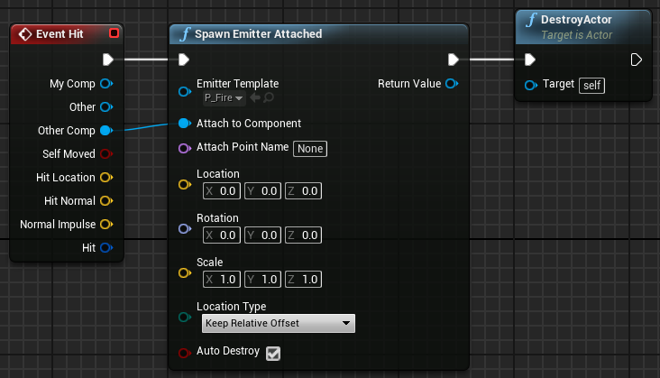

*Figure 1: Spawn Emitter Attached*

1. Compile the **First Person Projectile** Blueprint. Play the Level and shoot at some objects.

## Outcome

After pressing **Play** and shooting at the objects in the Level, the objects hit will display a fire effect (see Figure 2).

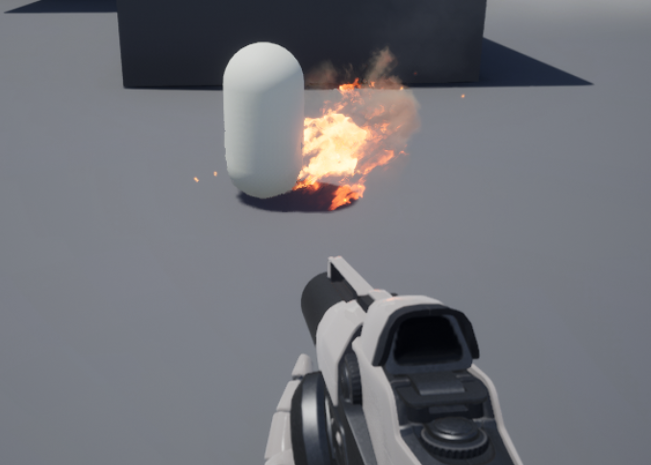

*Figure 2: Fire Effect*